Blueprint Reading – PRE-TEST
440-823-6759

The purpose of the No Sweat Blueprint Reading Pre-Test is to help determine your current understanding and working knowledge of blueprints.

The Pre-Test will help uncover your areas of weakness so that appropriate training can be prescribed which will eliminate the weakness. Do not take an undue amount of time trying to figure out the correct answer. Typically, you will either know the answer, or you won't. If you do not know the answer, your natural instinct will be to "guess." In the long run, this will not help you. Simply pass over the question and go on to the next.

Finally, this test is not intended to either qualify or disqualify you for a particular job. It simply provides a starting point from which training can be prescribed.

If you will be grading your own test, your instructor will provide you with the answer sheet when you're finished.

Unless otherwise instructed, place an “X” next to the answer that best completes the following questions or statements.

1. How many views, or projections, are possible on the simple box shown
at right below?

a. 3  b. 6  c. 9 | 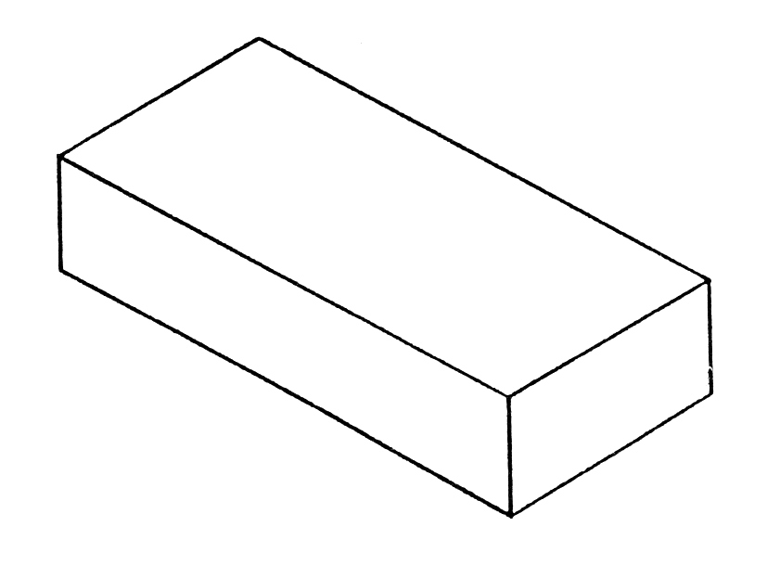

2. The projection shown at right below has three views, numbered 1, 2,
and 3. Match the view to its appropriate description.

a. Top View  b. Right Side View  c. Front View | 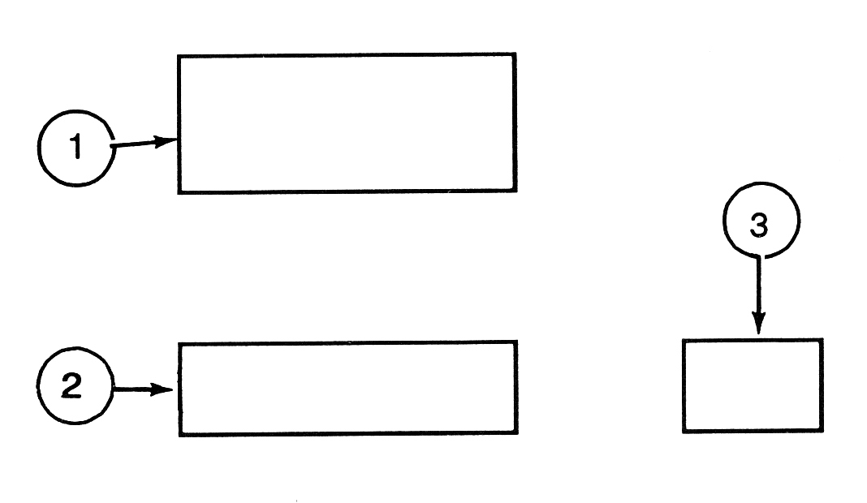

3. A full, heavy line on a blueprint indicates a:

a. Visible Line or Object Line

b. Centerline

c. Internal Thread

4. Match the numbers 1, 2, and 3 below with their appropriate
descriptions.

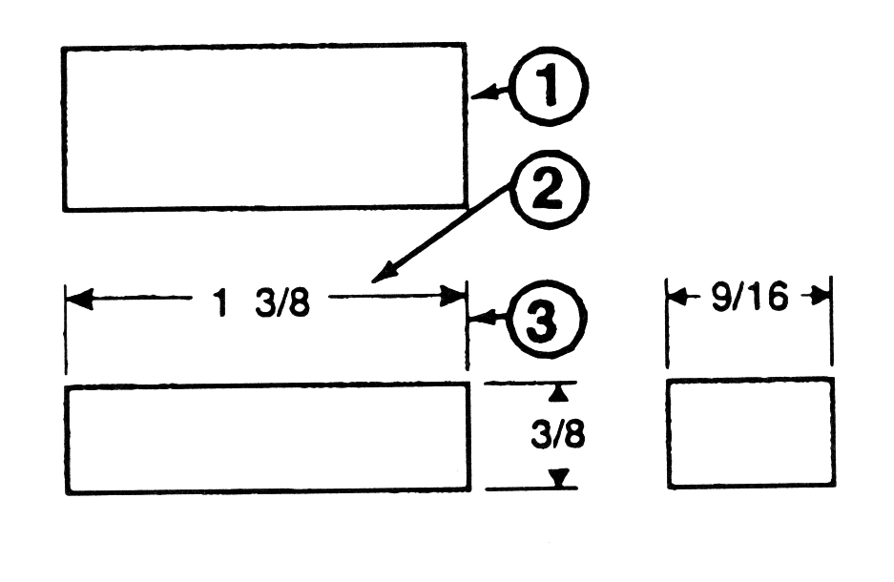 | a. Extension Line  b. Visible Line or Object Line  c. Dimension Line

5. If the tolerance on your drawing is + .005, and the specified length of a
part is 1.000, which of the following describes the acceptable lengths
for the part?

a. 0.995 - 1.005

b. 1.005 only

c. 1 .004 - 1.006

6. Write the names of the features or types of lines labelled at right below:

a.  b.  c.  d.  e. | 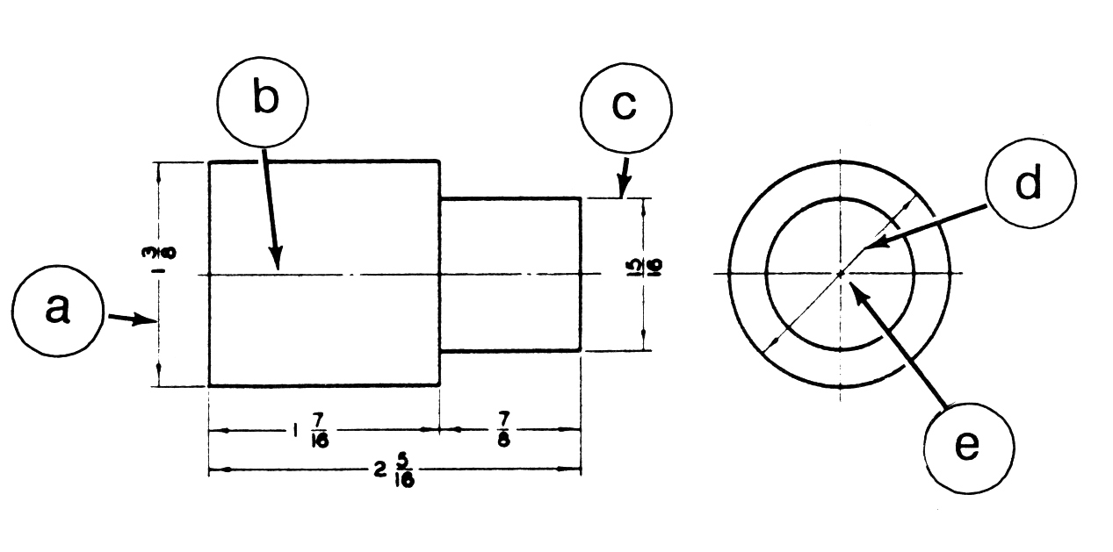

7. The scale, 1/2 = 1, on a drawing means:

a. 1/2 of the drawing is equal to 1 part.

b. The part on the drawing is between 1/2" and 1" in size.

c. The actual part is twice as big as the drawing.

8. The drawing at right below shows a/an:

a. Internal thread  b. Full section view  c. Off-center diameter | 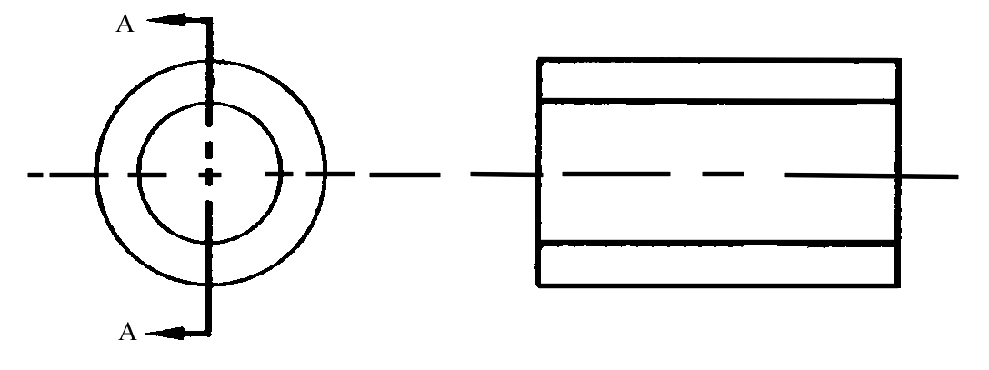

9. Match the words listed on the right below with their appropriate definitions.

a. A uniform change in the diameter of Groove
a part along its length

b. A recess cut in the diameter of a part Round

c. A rounded corner of a part that
curves outward Fillet

d. A flattening of an outside corner of a
part edge Chamfer

e. A rounded inside corner of a part
Taper

10. Match the words listed on the right below with their appropriate definitions.

a. Two of the most common types are Flat
"T" and dovetail

b. Prevents relative motion between a Key
shaft and a part

c. A flat area cut on a shaft to provide a Boss
surface on which a set screw can
rest

d. A cylindrical projection used as a Slot
bearing surface to prevent rocking of
parts

e. Typically oval in shape, they are used Pad
as a bearing surface to prevent
locking of parts

11. A surface finish requirement is indicated by the following symbols:

.002
a. V or 63 I

b. ± or >

c. °, ", or '

12. The drawing at right below shows a:

a. Threaded hole  b. Countersunk hole  c. Through hole  d. None of the above | 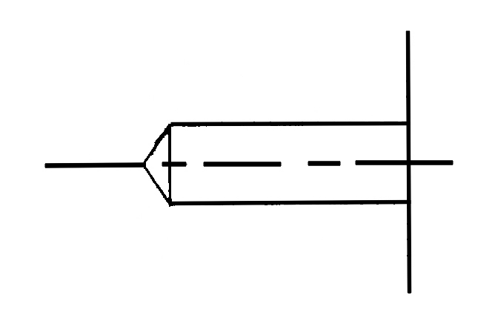

13. The drawing at right below shows a:

a. Countersunk hole  b. Tapped hole  c. Spotfaced hole | 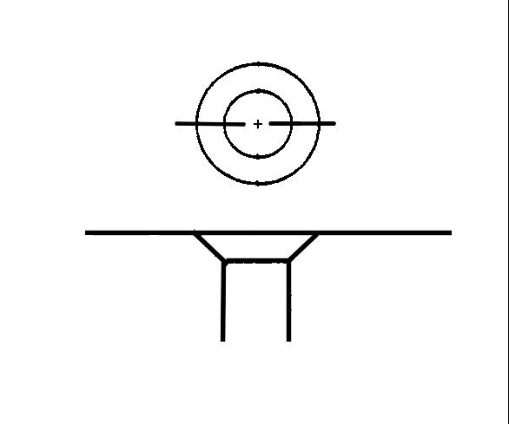

14. The drawing at left below shows a:

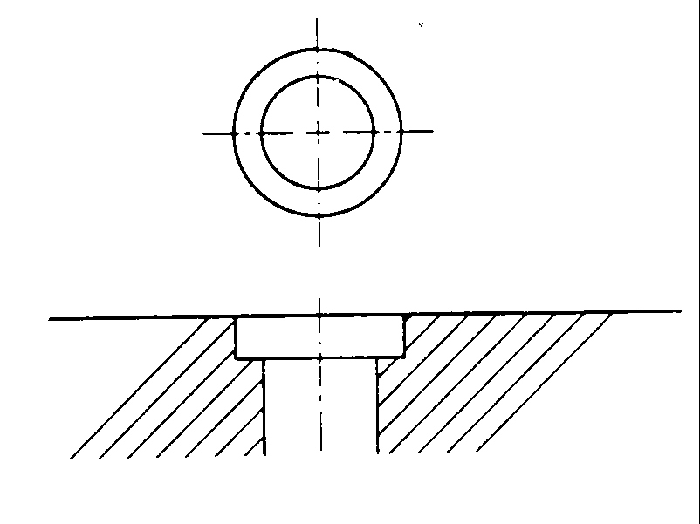 | a. Threaded hole  b. Countersunk hole  c. Counterbored hole  d. None of the above

15. The drawing at left below shows a:

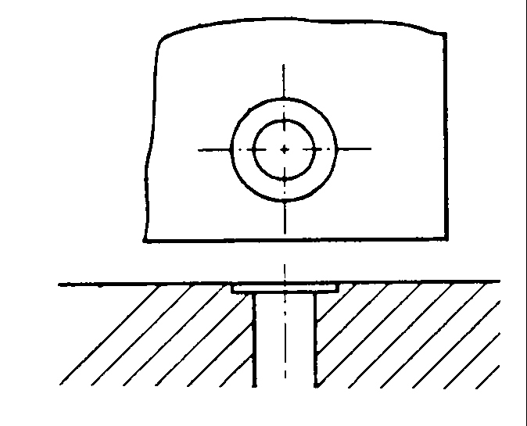 | a. Spotfaced hole  b. Countersunk hole  c. Counterbored hole  d. None of the above

16. Look at the thread callout shown at right below. Then, next to each
thread characteristic listed at left, write the numbers or letters in the thread callout that define it.
Major thread diameter  Thread  Class of fit  Thread pitch | 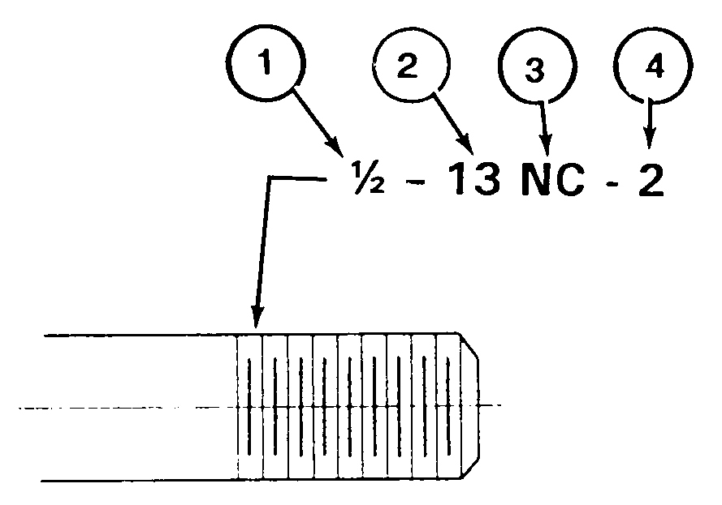

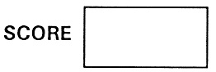

ANSWER KEY FOLLOWS

Listed below are the answers to the No Sweat Blueprint Reading Pre-Test questions and the points earned by answering each question correctly. Yhe total number of points that can be earned is 100

1. b (2 points)

2a. 1 (2 points)
2b. 3 (2 points) 9. b,c,e,d,a (3 points each,
2c. 2 (2 points) maximum 15 points)

3. a (2 points) 10. c,b,d,a,e (3 points each,
Maximum 15 points)

4a. 3 (3 points) 11. a (3 points)
4b. 1 (3 points)
4c. 2 (3 points) 12. d (3 points)

5. a (3 points) 13. a (3 points)

6a. Dimension Line (3 points)
6b. Centerline (3 points) 14. c (3 points)
6c. Extension Line (3 points)
6d. Diameter (3 points) 15. a (3 points)
6e. Centerline (3 Points)

7. c (3 points) 16. ½, NC, 2, 13 (3 points
each, maximum 12 points)
8. b (3 points)

Pre-Test courtesy of www.nosweattraining.com

