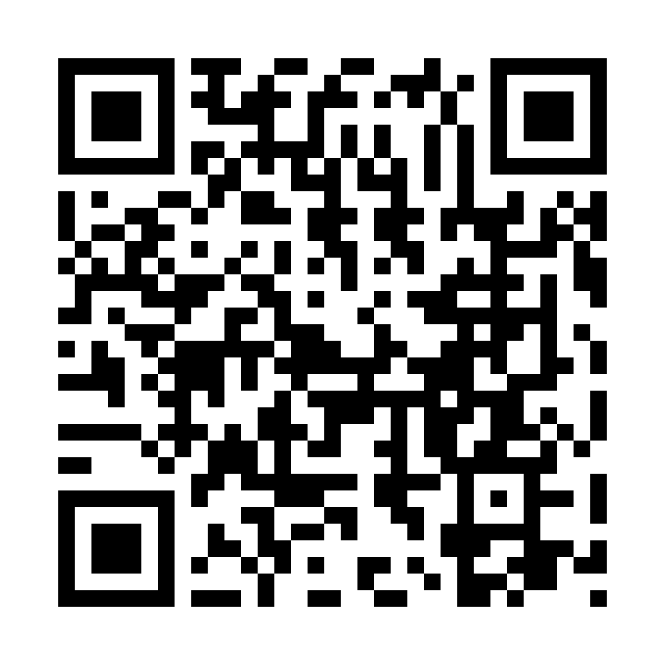

Catholic Church *cluster* of Davenport

St. Francis of Assisi – Harrington

Immaculate Conception Catholic Church – Davenport

St. Michael Catholic Church – Reardan

St. Kateri Tekawitha Catholic Church – Ford

Sacred Heart Catholic Church – Wellpinit

***Mailing Address***: Immaculate Conception Catholic Church - Davenport

1310 Adams St., Davenport, WA 99122-9454

(509)725-1761

***Office manager***: Jackie – [icdavenport@dioceseofspokane.org](mailto:icdavenport@dioceseofspokane.org)

Send me bulletin updates by Mondays 5pm

Office hours Tuesdays 9:30 – 12

Immaculateconceptiondavenport.org

***Pastor*** - Fr. Sean Thomson  [sthomson@dioceseofspokane.org](mailto:sthomson@dioceseofspokane.org)

Sacramental requests:Call Fr. Sean (509)688-5784

**The Holy Sacrifice of the Mass**

**Daily** Tue./Wed./Fri. Davenport at 9:00am, Thurs. Reardan at 9:00am

**Saturday**  Harrington mass will be suspended for Sept. and Oct **Sunday** Rosary at 8am in Davenport

Davenport at 8:30am**,** Reardan at 10:30am, Ford 12:30pm (1st-2nd-3rd Sunday in Ford) (4th Sunday in Wellpinit)

**Confessions** (Before Mass at all mission parishes) or by appointment.

**Saturday** Davenport at 9:00am to 9:30am, 3:00pm to 3:30pm

**Tuesday** Davenport at 5:30pm to 6:00pm, with Eucharistic Adoration.

**Catechism of the Catholic**   **Charity** **1829** The fruits of charity are joy, peace, and mercy; charity demands beneficence and fraternal correction; it is benevolence; it fosters reciprocity and remains disinterested and generous; it is friendship and communion:  
Love is itself the fulfillment of all our works. There is the goal; that is why we run: we run toward it, and once we reach it, in it we shall find rest.

**1831** The seven gifts of the Holy Spirit are wisdom, understanding, counsel, fortitude, knowledge, piety, and fear of the Lord. They belong in their fullness to Christ, Son of David. They complete and perfect the virtues of those who receive them. They make the faithful docile in readily obeying divine inspirations.

**Faith formation: contacts to call for First Communion prep is Scott Hansen 509-559-9091. Lorin Lathrop is 360-991-8585. For on-line classes for 10 yrs and up, including adults, is Michael Crow 509-379-8027.**

AED training in Davenport at 9:30am October 13. Reardan the 27th October at 11:30am.

Lectors and alter servers needed! Please contact Paula Tesch at 509-725-0061.

**Harrington mass** will be suspended for Sept. and Oct. until substitutes can be found.

Time to update Parish registry! Please fill out the form in back of church with updated phone numbers and emails.

**Mass Intentions:** Sept. 14 Sat. (5:00pm) For Fr Sean’s recovery Sept. 15 Sun. (8:30am) For Fr Sean’s recovery (10:30am) For Fr Sean’s recovery (12:30pm) For Fr Sean’s recovery Sept. 17 Tues. (9:00am) For Fr Sean’s recovery Sept. 18 Wed. (9:00am) For Fr Sean’s recovery Sept. 19 Thur. (9:00am) For Fr Sean’s recovery Sept. 20 Fri. (9:00am) For Fr Sean’s recovery