
SUNSHINE GROUP DAYCARE CENTRES INC
5570 Sooke Rd, Sooke BC V9Z 0C7
sunshinegdcinc@gmail.com

November Newsletter

General News:

Please turn off your vehicle at drop off and pick-up times, and please try not to park in the Bus spots!

We will only be using Cheques written out in 6 month increments or Direct Deposit for payments!
Direct Deposit will only be taken out each month on the 1st or the 20^{th.}

For payment information, problems, or questions please contact us at: sunshinegdcinc@gmail.com Please provide all names for child in e-mail.

Sea Horses Class:

Happy November Families!
We have had a busy month and are getting much more used to our classroom and routines! We’ve had lots of fun learning new songs, talking about thanksgiving and what we are thankful for and of course Halloween! Our classroom has looked so great with all our friend’s artwork on display. When we take it down and put it in your child’s cubby, we ask you please take it home! November we will be focusing on outer space and winter! Speaking of winter, please make sure your child has all the appropriate gear packed everyday (that fits!!)
- Jacket
- Rain paints/Muddy buddy
- Boots
- Toque/gloves
- Full set of spare clothes!
We are working hard on getting out on the bus more often now that things are getting settled. PLEASE arrive daily by 9:15 so when we can get out on the bus. Waiting for late arrivals makes our outings much shorter.
Some upcoming dates to be aware of!
- Thursday November 11th – CLOSED for Remembrance Day
- Thursday November 18th – early dismissal preschool only runs 9-11:15)
- Friday November 19th – Pro-day (NO PRESCHOOL PROGRAM)
SICK POLICY – I know this is a challenging time for us all, rules are constantly changing, and we are all doing our best to adjust. Our policy states HEALTHY KIDS ONLY, even with a provided negative covid test, 24 hours SYMPTOM free is required before return to care. If you have an ongoing symptom, please provide us a doctors note stating it is a non communicable illness/symptom and they can return to care on doctor’s recommendations. We hate to have to message you guys about kids being brought in with symptoms, we feel guilty and uncomfortable so please do your best to assess your child daily and make the appropriate decision.
If you will be away, please let us know! (Call or text) 250-480-8327
- Megan, Amber, and Kim

Eco Adventurers Sea Dragon Class:

eco.seadragonclass@gmail.com 778-677-5481
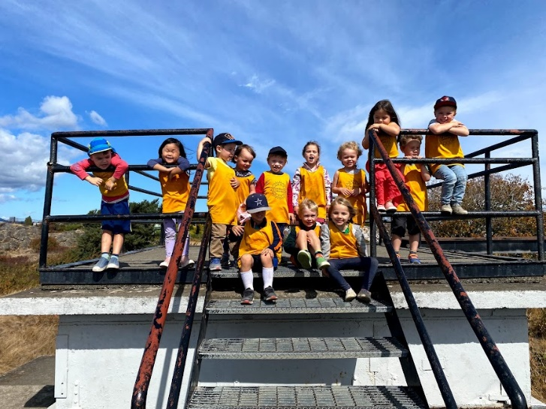
Things we will be working on This month we will be focusing on personal responsibility of their belongings, and of their behaviors. Here are a few things you can help us with:
- Go over the items they are bringing with them so they know what to look for when packing and unpacking their bags
- Label with their name (we both are working on name recognition!)
- Communicate accountability and consequence.
- Chores and cleaning up after themselves
- Acknowledging when they do things that are kind and unexpected!
We are looking forward to our daily adventures and growth!
We go out every day, rain or shine; please bring proper attire. Have all your child’s belongings labeled and please check lost and found in both sea dragon and sea horse classrooms regularly.

Important Dates & reminders for November
- November 1st – Fish Hatchery Field Trip $3
- November 10th – Military Museum Field Trip $3
- November 11th – Remembrance Day *CLOSED*
- November 18th – Early dismissal 9-11am (9-2:15 program children only)
- November 19th – Pro D Day (no 9-2:15 program)

What to look forward to
Hello Sea dragon families! This month we will be learning about habitats and the ecosystems we visit regularly - we are learning to be nature protectors! We will have lots of trips to learn about the life cycle of our salmon, and hopefully have some opportunities to see them up close in nature! November 10th our trip to the military museum will give us the opportunity to discuss commemoration for our veterans in an age and educationally appropriate way.

Teachers Message
We are working hard at our independence skills, and we are doing great! I love seeing Your children feel the pride in themselves as they accomplish tasks and gain more confidence every day. Keep up the good work on these skills at home and giving your child as many opportunities to complete tasks on their own such as dressing, packing their bags and lunch kits!

Eco Adventures Sea Otter Class:

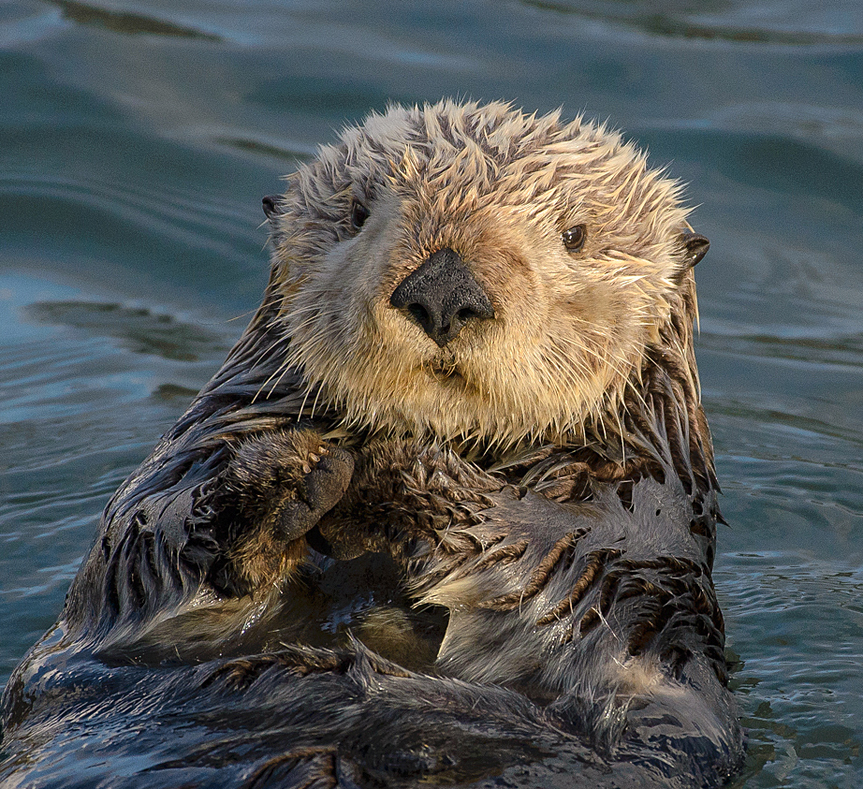
 Sunshinegdc.com

