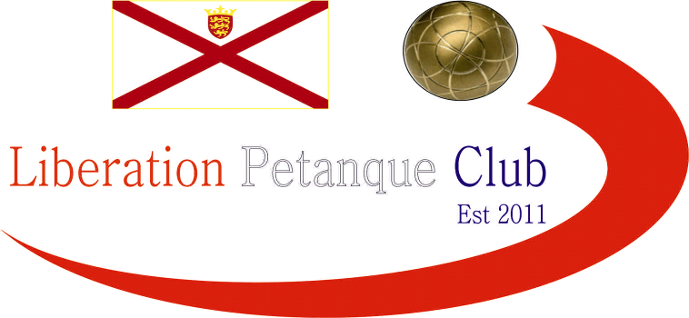

**SUMMER 2025 SEASON**

**WEEK 10 – 4th June 2025**

**DOUBLES LEAGUE**

# Where back at the Weighbridge for the re start to the leagues.

# Andrew & Callum made it three straight wins as they picked up where they left off before the break to give Graeme & Keith their first loss.

# Neil & Ross extended their unbeaten run to 18 matches with a win over Brian & Colin and will likely be challenging Andrew & Callum again this season.

# Island Doubles champions, Geoffroy & James got off the mark with a win over Jean & Laurent to move up the table.

# No matches played in Division 1.

# NEXT WEEK - CLUB DOUBLES CUP

# Club email address - [liberationpc@gmail.com](mailto:liberationpc@gmail.com)

# Club Website - [www.liberationpetanque.co.uk](http://www.liberationpetanque.co.uk)

# Kind Regards

# Toby Northern

# Chairman

# Liberation Petanque Club