Pleasant Township Board of Trustees Meeting Highlights
Date _June 10, 2025______________ Next Resolution No._ 32 —06-10-2025_ _

- Call to Order -- The meeting tonight will also be on WebEx.
- Please stand for a moment of silence. --Pledge of Allegiance--Roll Call
- Visitors –
- Minutes to approve- No minutes
- Financial Reports – Paula
  - 26 checks totaling $39,131.24. payroll was $89,221.04 this included longevity pay. The longevity was for fulltime, nothing turned in for long-term part-timers.
  - Motion to pay expenditures.
- Department Reports
- Franklin County Sheriff’s Dept-Community Liaison, Deputy Adkins, 1120- Cell: 614-809-5843
  - None
- Road Department- Robert Bausch, Superintendent
- Oakhurst seeding done
- Cemetery mowing
- Ditch mowing
- Equipment repair-line blew on the backhoe.
- Hauling stone for the sidewalk replacement due to be done Thursday.
- Fire Dept. – Chief Whiting
- Firefighter Safety Stand Down June 15- 21st
  - Theme: “Break the Stigma, Behavioral Health Reset”
- Apparatus
  - General maintenance & repairs
- Personnel
  - Hire Emma Crace – Resolution__32_____ to hire Emma Crace for part time firefighter/EMT.
- Equipment
  - Numerous repairs
- Training
  - The State Fire Academy is providing training at our location.
    - Fire Behavior Lab
    - Driving Simulator
- Station
  - The concrete walkway.
    - Construction is scheduled to start on Thursday, June 12, weather permitting.
  - Water softener issue- the plumber has been contacted.
- Community Risk Reduction
  - Building inspections
  - Flushing Hydrants
- Billing
  - No issues
- Dispatching
  - The locution meeting is scheduled for Thursday, June 12, 2025.
- Hose testing has started.
- Chief is going to contact AEP to do an assessment of electric usage at the station to see if/where we could save money.

- Old Business-none
- New Business –none
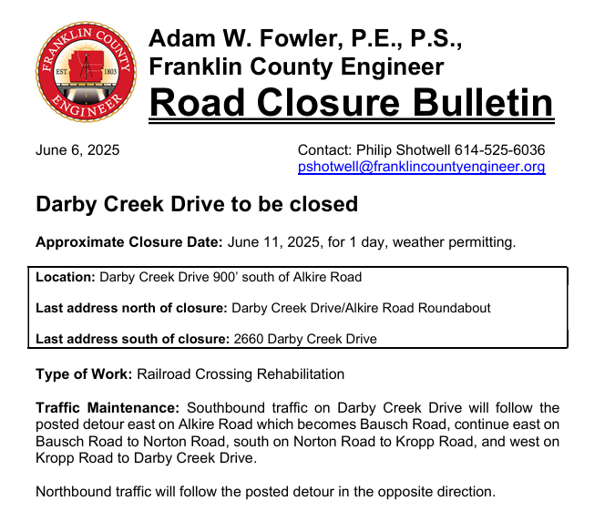
- Announcements -.

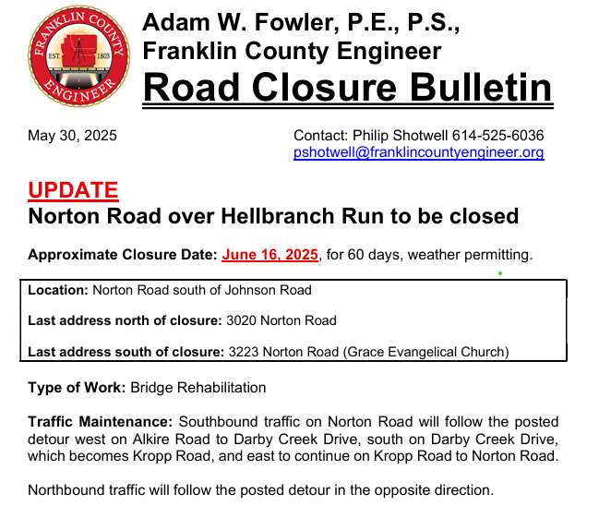

- Tim Helsel and Don Murnane will be collecting fans donated at the fire station for The Beat the Heat Fan Campaign that benefits Central Ohio’s most vulnerable residents during periods of extreme heat. Since this annual drive began, LifeCare Alliance has collected and distributed more than 22,000 fans! Older adults, people with a chronic illness, and homebound individuals are more susceptible to heat exhaustion and heat stroke. A simple box fan can lower a room’s temperature by 10 degrees and save lives. We thank Tim and Don for their work. Anyone wishing to help can drop off a fan at any fire station for distribution at LifeCare Alliance.

- Clerk Updates- Paula
- Are we all good on the payroll issue that happened last week that appears to be a scam? Working with the bank on this. The employee has gotten paid.
- Received the title for the fire engine.
- Miscellaneous correspondence

- Speaker Sheets- (come to the podium to be heard on WebEx)

- Executive Session-requested by Nancy
“I move to go into Executive Session according to Ohio Revised Code Section 121.22 (G)(1) for the purpose of discussing _personnel issues__ Do I have a second?” ROLL CALL VOTE
- Reconvene
Under the Ohio Revised Code Section 121.22(G), I move to come out of Executive Session, do I have a second? ROLL CALL VOTE

- Adjourn

