The Gift of Health
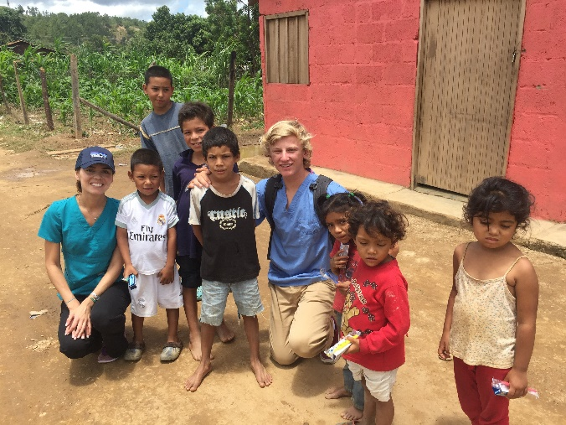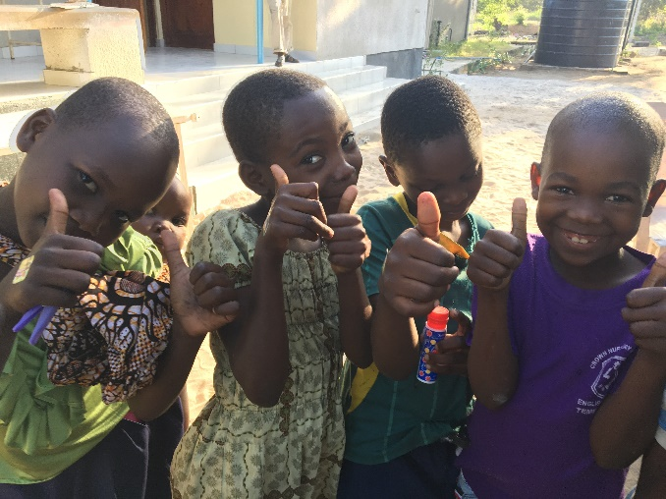
Healthy Bodies - Healthy Minds
The donation of a one year supply of vitamins for a family of four in Honduras/Tanzania will provide the necessary nutrients they need to grow and develop normally. Vitamins will help provide a healthier life for those who receive them.

A year’s supply of vitamins will be given to a family of four in your name.

