CATARACT SURGERY STEPS/DATES - DR’s CRICHTON and FORD
*consent video available on website: www.glaucomacalgary.com
Questions: Call our office surgery line at 403-245-3730, ext 2

- A-Scan (1 to 12 Months Prior to Surgery): This is a measurement of your eye needed to determine the type and power of the artificial lens that will be placed in your eye at surgery.
- Where: Dr. Crichton’s and Ford’s office: #102, 49 Richard Way SW, Calgary, AB
- When: _________________________________________________ :takes about 45 min, no dilation, a family member is welcome to join you to listen to discussion/options
- 1 WEEK PRIOR TO ASCAN: begin instilling artificial tears (eg. Refresh,Systane,Theoloz) 4 times per day in both eyes (continue any other drops already taking); please do not instill any drops 1 hour before exam. Artificial tears are available over the counter or alternatively, you can purchase a surgical bag from our office which contains preservative-free Theoloz-Duo drops as well as surgical tape and sunglasses.
- If you wear contact lenses, soft contacts must be removed 1 week prior, Rigid Gas Permeable contacts must be removed 2-3 weeks prior to the ASCAN
- MEDICAL FORM: This form is for YOU to complete IN FULL and return at AScan; please ensure you have seen your doctor within the year prior to surgery
- If you are having any health changes within the 3 months prior to your surgery date or a glaucoma surgery is added to your cataract surgery, please call our office to discuss as a more detailed medical exam may be needed by your family doctor

- 2 days before surgery - EYE DROPS: see instruction sheet in package, the prescription with refills will be faxed to your pharmacy). Bottles can be open for ~4-5 weeks. (Continue any other drops you already use for glaucoma, dry eye, etc)

- SURGERY (Time is tentative and may need to change):
- ____________EYE: _____________________________Arrival time: __________________
- ____________EYE: _____________________________Arrival time:___________________
- WHERE? Holy Cross Surgical Services: Room 101, 2210 2nd St SW,
Calgary, Alberta (see enclosed street and building maps), pay parking is available
- Nothing to eat after midnight the night prior (or a minimum of 8 hours), clear fluids permitted up to 3-6 hours prior
- HOW LONG? You will be at the surgery center for approximately 1.5 to 2.5 hours
- BRING current picture ID and your Alberta health care card
- FEES? IF you chose a specialized lens or do not have Alberta HealthCare, you must prepay part of the lens fee at our office and the balance at the surgery center on the day of surgery; you may pay with Debit/VISA/Mastercard although there is a small percentage added at the surgery center for credit cards (AHC pays for surgery with standard lens)
- Somebody else must drive you home from surgery; taxi is acceptable if no other option and no sedation is given, you are not legal to drive for a minimum of 24 hours

- AFTER SURGERY Follow-Up appointments; will be booked automatically at our office, although you may choose to arrange with your optometrist if preferred
- 1 Day after surgery:
- ~2-3weeks after surgery:

ASCAN/CATARACT DISCUSSION HIGHLIGHTS
PLEASE LISTEN TO VIDEOS ON WEBSITE IF POSSIBLE;
www.glaucomacalgary.com

CATARACT SURGERY: A cataract is a clouding of the natural lens of your eye. Cataract surgery breaks up your natural lens (cataract) using a blade, ultrasound and fluid (not laser). This lens is then replaced with an implanted, artificial lens (IOL). The type/power of the IOL depends on the A-Scan measurements and your preferred outcome.

RISKS OF SURGERY: There is approximately a 1% risk factor associated with cataract surgery, with the majority of the potential risks being treatable. Risks include, but are not limited to; unexpected visual outcome requiring full-time use of glasses, inflammation, corneal irritation, increased light sensitivity, infection, retinal detachment, additional surgery needed and blindness. Some risks occur several weeks after surgery so please discuss with staff if you have any travel plans within 6 weeks after surgery. Advise staff if you have ever taken Flomax/Hytrin/Avodart or Risperdal/Invega medications OR if you have ever had eye surgery before.

LENS (IOL) RANGE TARGETS:
A.Distance Target: Aims to eliminate distance glasses. Glasses will be required for any near activities within arms length (ie. reading, looking at watch or in mirror, cutting fingernails), over the counter reading glasses are often helpful
B. Near Target: Aims to eliminate reading glasses. Glasses will be required for any activities beyond arms length (ie. driving, tv). This scenario is typically for people who currently remove distance glasses to read (and wish to keep this scenario)
C. Intermediate Target: helpful for reading larger print at arms length, computer monitors, etc but will likely need glasses for sharp distance vision (driving, reading guide on TV) as well as for detailed near work (ie. reading, looking at watch)

LENS (IOL) OPTIONS AVAILABLE (ANY FEES TO BE PAID PRIOR TO SURGERY, divided between office and surgery center)
1.“Standard”/Monofocal IOL: This lens is paid by Alberta Health Care, it corrects one range only (see options above) and does not correct for astigmatism (part of your prescription). If you have significant astigmatism, you would still require glasses at all ranges to correct this.
2. Toric IOL: cost ~$1000.00 per eye. This lens aims to correct one range only (see options above) but also corrects astigmatism.
3. Trifocal IOL or Extended Vision IOL: cost: ~$2,100.00 per eye. These lenses are newer technology and are designed to limit the need for glasses. A trifocal lens is likely to provide better uncorrected near vision but does have an increased risk of decreased quality of vision, particularly at night, with halos/glare around lights. An extended range lens does not provide as good near vision (will likely still need reading glasses for finer print) but does not have the increased risks of glare and halos.

NOTE: Individual healing responses vary and we cannot guarantee the exact outcome of your surgery or requirement for glasses regardless of your lens choice
PRE-SURGERY MEDICAL INFORMATION
PLEASE COMPLETE IN FULL
RETURN AT LEAST 1 MONTH BEFORE SURGERY OR AT ASCAN
DR. A. CRICHTON and DR. B. FORD
Please complete the following information and bring/mail/fax to our office:
#102, 49 Richard Way, Calgary, AB, T3E 7M8
Attn: Surgery Department (OR FAX TO 403-245-1058)

Patient’s Name ___________________________ Date of Birth _____________
Date of Surgery ____________________________Height ___________________
Allergies _________________________________Weight ___________________
Approx. Date of Last Health Check-Up? _________________________________
Name and Phone Number of Family Doctor? _____________________________
(**Please book routine health exam if you have not seen doctor within past 6-12 months)

1) Do you take any medications? Yes No
a) If YES, please attach pharmacy-generated list or write down names and dosages
b) If you are on bloodthinners requiring bloodwork/INR please have done 1 wk prior to surgery

2) Have you ever been told you have/may have diabetes? Yes No
a) Any changes within the last 2 months? Yes No
b) Are your sugars well controlled? Yes No
c) Ave Blood Sugar reading (if known)? ______________

3) Have you ever been told you have high blood pressure? Yes No
a) Any changes within the last 2 months? Yes No
b) Last Blood Pressure (if known)? ________/_________

4) Do you have any difficulties breathing? Yes No
a) Diagnosis? COPD ASTHMA SLEEP APNEA OTHER
b) Any changes within the last 2 months? Yes No
c) Do you require supplemental Oxygen? Yes No

5) Have you ever had or been told of heart problems? Yes No
a) Diagnosis? ATRIAL FIBRILLATION ANGINA CONGESTIVE HEART FAILURE
b) Any history of heart attack? If yes, WHEN? ___________________________
c) Any history of heart surgery? If yes, WHEN? __________________________
d) Do you have a pacemaker? Yes No

6) Can you lie flat for 15 to 20 minutes? Yes No

7) Do you suffer from diagnosed Anxiety or Claustrophobia? Yes No

8) Anything else you feel we should know about your health?

I confirm that the above is true to the best of my knowledge:

_________________________________ _______________________ ___________________
(print name) (signature) (date)

Dr. Crichton and Ford - Surgery Eye Drop Schedule
(separate prescription to be taken to pharmacy)
Vigamox (Moxifloxacin) 3x/day; start 2 days prior, stop 1 week after
Prolensa (Bromfenac) 1x/day; start 2 days prior, stop 4 weeks after
Durezol (Difluprednate) 2x/day; start the day after, stop 2 weeks after
(NOTE: If Durezol is substituted with Maxidex it should be 4x/day)

Note: once per day just needs to be consistent with time; twice per day ideally means 12 hours apart; three times per day means morning, mid-afternoon and bedtime; four times per day means morning, lunch, supper and bedtime. Wait five (5) minutes between types of drops. Glaucoma drops (if you use any) carry on as per normal. If you have questions, call our office 403-245-3730 ext 2.

Start 2 Days BEFORE Surgery Day of Surgery
 | Day1 | Day 2
VIGAMOX | ☐ ☐ ☐ | ☐ ☐ ☐ |  | VIGAMOX | ☐ ☐ ☐
PROLENSA | ☐ | ☐ |  | PROLENSA | ☐
 |  |  |  | *instill 1st doses before surgery, 2nd and 3rd
Notes: |  |  |  | doses not needed if have eye patch on

1st Week After Surgery
 | Day1 | Day 2 | Day 3 | Day 4 |  | Day 5 | Day 6 | Day 7
VIGAMOX | ☐ ☐ ☐ | ☐ ☐ ☐ | ☐ ☐ ☐ | ☐ ☐ ☐ | ☐ ☐ ☐ |  | ☐ ☐ ☐ | ☐ ☐ ☐
PROLENSA | ☐ | ☐ | ☐ | ☐ |  | ☐ | ☐ | ☐
DUREZOL | ☐ ☐ | ☐ ☐ | ☐ ☐ | ☐ ☐ |  | ☐ ☐ | ☐ ☐ | ☐ ☐
Notes:

2nd Week After Surgery
 | Day1 | Day 2 | Day 3 | Day 4 | Day 5 | Day 6 | Day 7
PROLENSA | ☐ | ☐ | ☐ | ☐ | ☐ | ☐ | ☐
DUREZOL | ☐ ☐ | ☐ ☐ | ☐ ☐ | ☐ ☐ | ☐ ☐ | ☐ ☐ | ☐ ☐
Notes:

3rd Week After Surgery
 | Day1 | Day 2 | Day 3 | Day 4 | Day 5 | Day 6 | Day 7
PROLENSA | ☐ | ☐ | ☐ | ☐ | ☐ | ☐ | ☐
Notes:

4th Week After Surgery
 | Day1 | Day 2 | Day 3 | Day 4 | Day 5 | Day 6 | Day 7
PROLENSA | ☐ | ☐ | ☐ | ☐ | ☐ | ☐ | ☐
Notes:

HOLY CROSS SURGICAL CENTER
2210 – 2nd St SW, Room 101

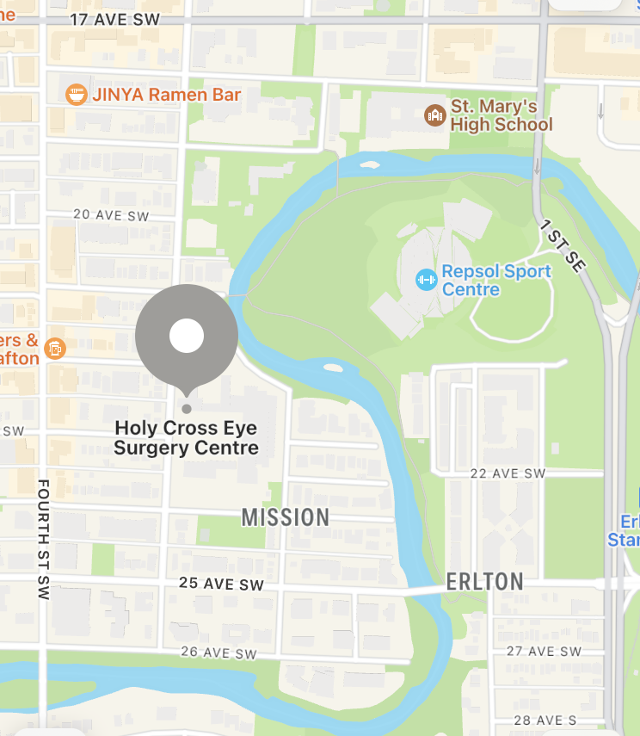

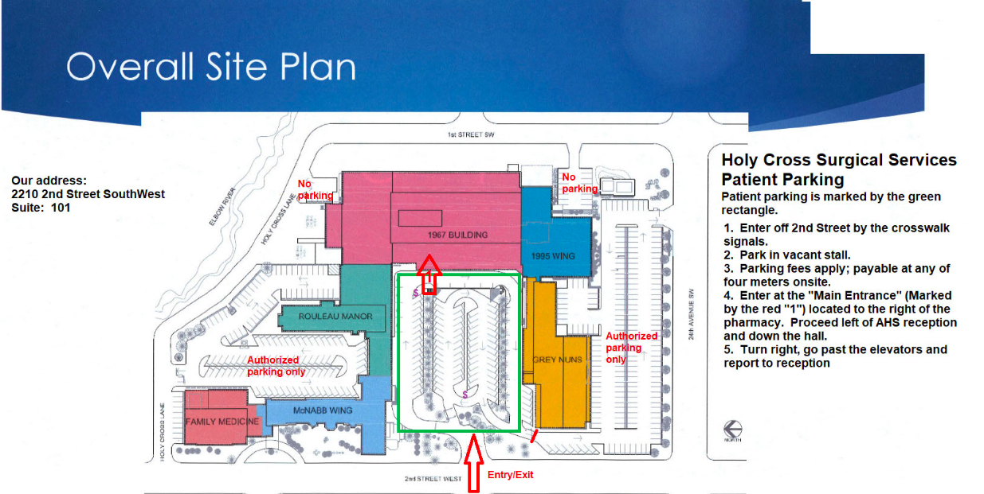

FREQUENTLY ASKED QUESTIONS – PLEASE READ CAREFULLY

1. Do I take all my general health and other eye medications before surgery?
A. Yes, take anything as you normally would, including any glaucoma and surgery drops, with the following exception;
- any medications recommended to take with food, including diabetic medications

2. Do I continue to take my bloodthinner?
A. If you take Coumadin/Warfarin, you should have your INR checked approx 1-2 weeks prior to surgery
- Continue any bloodthinners as you normally would unless scheduled for a GATT glaucoma surgery (ensure staff are aware)

3. Can I eat and drink before surgery?
A. It is recommended to drink 3 cups of fluids (NO alcohol) the evening prior.
B. Do NOT eat anything after midnight (MINIMUM 8hours) the night before surgery (including gum/candies). You can drink up to 1 cup of CLEAR fluids (water/apple juice/clear sports drink/BLACK tea or coffee without sweeteners) up to 4 hours prior, then NOTHING. Anesthesia or stronger sedation may require 6 hours without fluids; morning medications can be taken with a sip of water if needed

4. What if I get sick before surgery?
A. You should contact the office immediately if you have an uncontrollable or new cough, fever, vomiting, possible eye infection, or sudden health changes (403-245-3730)

5. Can I drive after surgery?
A. You are not allowed to drive yourself for 24 hours after surgery. It is preferred that a friend/family member drive you home after surgery; a taxi is permitted if no sedation is taken. Bus or walking by yourself is NOT permitted. You may ask a staff member at your follow-up appointment if you are legal to drive or if you need to update your driver’s license.

6. What can I expect on the day of surgery?
*Ensure to wear loose-fitting clothing; nothing tight or restricting. Do not wear contact-lenses, make-up or jewelry. Continue your surgery drops (and glaucoma drops if prescribed) on the morning of surgery.
A. Check-in at Surgery Center Reception: you will need your current PICTURE ID and healthcare card. You may need to sign a consent form for surgery. Your driver may wait in the waiting room or return to pick you up after your surgery (~2 hours).
B. Anesthetist: The anesthetist will offer a mild sedative if you prefer and only if you have somebody who will be with you the remainder of the day. He/She will discuss your health, monitor your blood pressure and instill drops to “freeze” and dilate your eye. Rarely a needle may be used to freeze the eye; this will be discussed prior to surgery if needed.
C. Surgery Room: You will need to lie down on the surgery table; the nurses will make you as comfortable as possible with knee or neck support. A drape will be placed over you leaving only your surgery eye exposed. You will need to listen to instructions regarding where to look; if needed, a translator may accompany you into the surgery suite. The surgery will take about 15 minutes and is generally painless. A shield will be either taped over your eye or given to you to tape over the eye before sleeping for the first 1-2 weeks (you will need to have your own medical tape to replace shield when sleeping)
D. Recovery Room: The nurse will take you back to the waiting room and ensure you are stable and comfortable prior to allowing you to go home. Your driver will need to come in to pick you up.

7. Are there restrictions after surgery?
A. You should rest quietly the day of surgery.
B. If you leave the surgery center with a patch over your surgery eye, you may remove the shield (discard the gauze) the morning after surgery. You should keep the shield and purchase some medical tape to tape it back over your eye whenever sleeping for the first 1-2 weeks. If your skin is sensitive to tape, you may use elastic to make a “pirate patch” instead but this is not typically as secure.
C. For the first two weeks after surgery you should avoid rubbing your eye and any pools/hot tubs/dirty dusty environments. You should avoid lifting over 10 lbs, straining or potentially strenuous activities including any sports or extended periods of bending over for one week after surgery. (NO bending over if you also had a glaucoma surgery). Try to avoid squeezing or closing eyes tightly. You may shower but try to keep your head back for the first week to minimize water/soap getting in eyes; do not squeeze your eyes shut. Sunglasses are recommended outside.
D. You should avoid wearing any eye makeup or having creams/lotions near eyes for one week after surgery.

8. What should I expect?
A. Your eye may be somewhat irritated the first 24 hours after surgery; extreme pain is not expected however, keeping both eyes closed or Tylenol may help if needed. Instilling artificial tears may help any mild irritation/itching. Vision is often functional for the targeted range 24-48 hours after surgery (unless you also had a glaucoma surgery) however do not be alarmed if it is not as there are many factors involved in healing. Although your glasses will no longer be correct, you can continue to wear them if they help or you can have your optician remove the lens from in front of your surgery eye (this may not work well if you still have a high prescription in the other eye). Over the counter reading glasses may help with near work initially; it is recommended to wait about 5-6 weeks after surgery before updating glasses.

10. Can I travel after surgery?
A. Extended/international travel is not advised for the first six weeks after surgery (discuss with staff if you do have travel plans, travel insurance may be affected by surgery).

11. Are there any tips for instilling drops?
A. It is generally best to pull your lower lid down to form a “pouch”, look up and instill one drop. Some people find it easier to lie down and look up. Be careful not to touch tip of bottle to lid/lashes and always wait 5 minutes between types of drops. Drops that are to be used multiple times during the day need to be spaced out throughout the day. If you were using glaucoma drops before surgery, these should be continued. It is common for drops to sting for ~1 minute after instilling. There are refills on your prescription for the surgery drops.

12. What if I still have questions?
A. You may call our office at 403-245-3730 ext 2 or 0; we will do our best to return any messages within 24 hours. Call immediately if there is a sudden drop in vision, severe pain or discharge or if you are noticing flashes of light or a large amount of floaters; if not during office hours, you may call Healthlink at 811, see your optometrist or go to the Rockyview Hospital Emergency.

