GEN-620 120V-2000W-60Hz-7.2 kW-16yr | Geneforce Emergency Power System  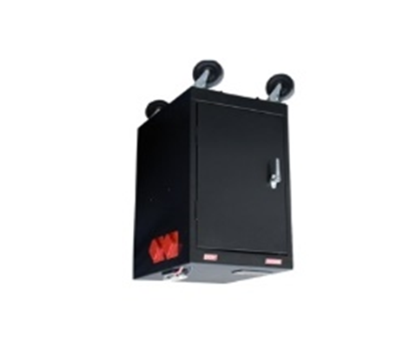
Product Features
Silent operation.
Safe for indoors. No gas or emissions.
No Installation; No Maintenance
Automatic & one-touch start.
Arrives fully charged and ready to work.
Multi-colored LED displays state of charge, AC input, DC volts and DC amperage, etc…
Overheat Temperature Sensor & Automatic Shutdown feature.
Built-in voltage regulation system for sensitive electronics.
Built-in (120V/20A) Automatic A/C Transfer Switch.
Built-in 30A solar charge controller for solar panel charging.
Electrical Specifications | GEN-620 (120V)
Output power (continuous) | 2,000 W
Surge power (AC amps) | 6,000 W
Output frequency regulation | 60 Hz
Voltage regulation | 120 V +/-5% true RMS
Output wave form | Modified Sine Wave
Service Life (No Maintenance) | 12-16 years
Stored Electrical Energy | 7.2 kW (7,200 Watts)
AC output receptacles | Four (20A/120V) outlets
12 Volt Power Outlet (optional - not included) | One 12 Volt Charger outlet (optional – not included)
AC input plug (8ft cord) | One (120V/20A) side blade plug
AC input automatic transfer switch | 20 A (included)
Charge rate | 100 A DC
AC input voltage range | 90 - 130 VAC
Geneforce Charge control | 3-stage (Bulk, Acceptance, Float)
Solar Charge Controller | 30 A (~360 W per hour of sunlight)
General Specifications
Optimal operating temperature range | 32°F – 104°F (0°C – 40°C) *derated below 0°C and above 40°C
Monitor | LED Display (reads V, DC amps, Power Share, etc.)
Dimensions (H x W x L) and Weight | (36" x 18" x 24") & (470 lbs.)
Construction | Strong Steel, Four Casters, Color-Black
Warranty & Part Number | 2.5 Yr. on Components; up to 4Yr on Batteries-GEN-620-1202000
Regulatory Approvals & Protection
Safety - UL Listing | Components UL & cUL listed to 458 Standards
Voltage Regulation | Over voltage and under voltage protection
Temperature | Over-temperature protection
Output | Overload Protection
Electrical | Short circuit protection
Price | $6,497

