Women on the Water stopped in Newark on Saturday, July 13th. These kayakers welcome others to join them as they paddle area waterways.

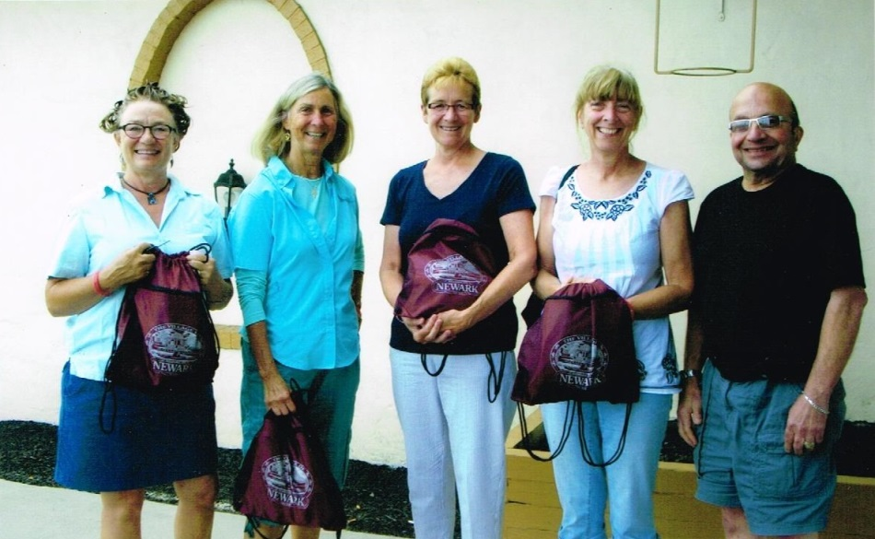

Mayor Blandino greets Women on the Water participants

