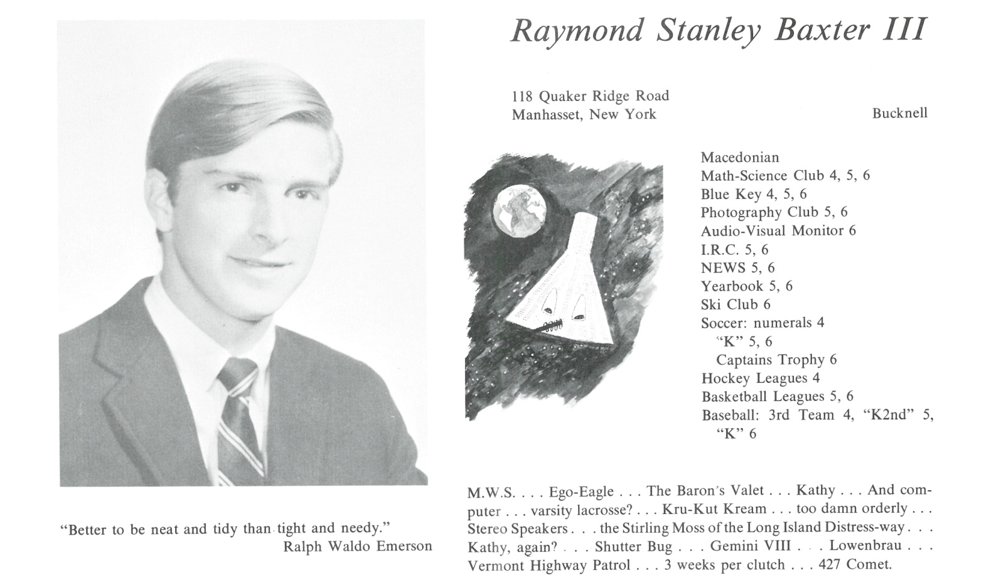

Raymond S. Baxter, III

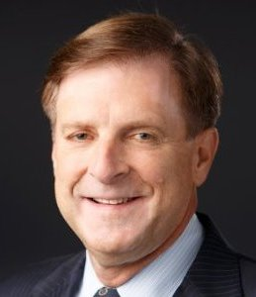The fifty year journey began by leaving Kent after graduation in a ’67 Mustang, thanks Grandma, and heading to Bucknell University in the fall with a brief stint as a lifeguard during the summer. Pledged Phi Kappa Psi fraternity, played varsity soccer with the David Armstrong and toured Europe the summer before our senior year with Randy Randall. Learned three valuable lessons while overseas; don’t order lunch using French in the Flemish part of Belgium, girls you pick up along the way only want your food and never order Swiss cheese in a French fromagerie. Successfully navigated the Vietnam era and graduated in May of 1971 with a BSEE.

Promptly started working in telecommunications for New York Telephone (anyone remember the Bell System?) and never left the industry for 46 years. Received a MBA/JD degree from New York University along the way (paid for by NYTel; remember when companies did this?) and retired last month from CenturyLink after running the gauntlet of MCI (19 years), Sprint (7 years), Qwest (8 years) and consulting services with my own company, Baxter & Associates. Lived in Westchester County, NY for 12 years then migrated and stayed in Fairfax County, VA for the remainder with side trips to Hollywood, FL. First offspring was a bicentennial baby, Kevin, followed by a second boy in 1979, Todd. Both are successful businessmen, the former a Digital Marketing executive with his own company living in Newark, DE and the latter a Fashion Industry executive with RE/DONE jeans living in Hawthorne, CA. Neither are married, so no grandkids ... yet.

Met the love of my life at MCI, Denise, while bowling (yes, a New Yorker swayed into bowling) and we were married in Las Vegas (without Elves or the Chapel of Love) 27 years ago. Now that is another whole story unto itself requiring more lines than we have on this page. Denise left MCI in 1990 to pursue a second career and graduated from the Culinary Institute of America (the other CIA) 2 years later. She worked in the industry for several years before becoming a Culinary Arts teacher for 10 years, secured her Certified Executive Chef status and was appointed the 1st female Ambassador to the CIA by the Board of Governors. During this time, we became limited partners in a restaurant chain, the Austin Grill, (BTW ... never a way to make money). Passions remain sports (particularly tennis, golf, but gave up skiing when a tree jumped out and grabbed me), jogging (5 marathons), travel (focus is on ancient cultures & civilizations), model airplanes and trains (back to my childhood) and margaritas on the beach or at the pool overlooking the Atlantic Ocean. Thank you Kent for a wonderful education that jump started my career and life. Looking forward to our 75th Reunion and those in between!



______________________________________________________________

______________________________________________________________ ______________________________________________________________ ______________________________________________________________ ______________________________________________________________ ______________________________________________________________ ______________________________________________________________ ______________________________________________________________ ______________________________________________________________

Attach Picture in .jpg Format

______________________________________________________________

______________________________________________________________

___________________________________________________________________________________ _________________________________________________________________________________________________________________________________________________________________________________________________________________________________________________________________________________________________________________________________________________________________________________________________________________________________________________________________________________________________________________________________________________________________________________________________________________________________________________________________________________________________________________________________________________________________________________________________________________________________________________________________________________________________________________________________________________________________________________________________________________________________________________________________________________________________________________________________________________________________________________________________________________________________________________________________________________________________________________________________________________________________________________________________________________________________________________________________________________________________________________________________________________________________________________________________________________________________________

___________________________________________________________________________________