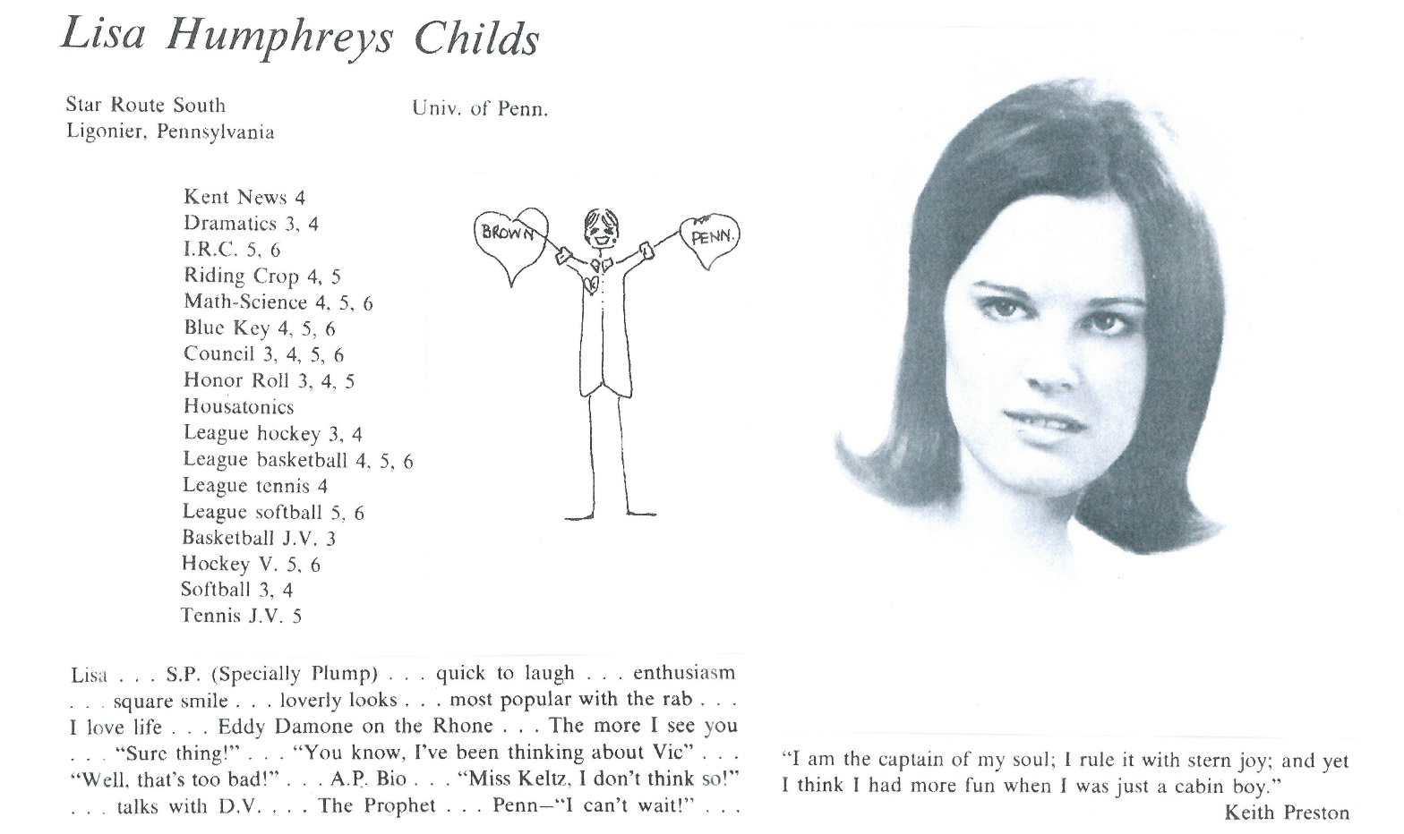

Lisa H. Childs Laskow

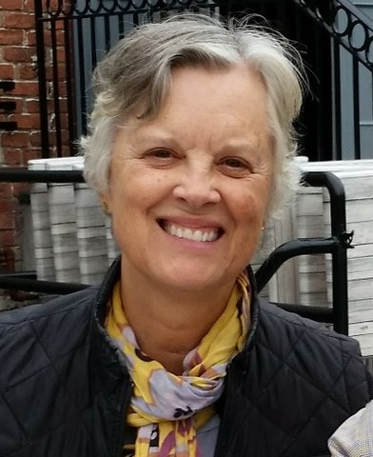There was no academic challenge too great after graduating from Kent, but I was a bit burned out academically. I loved The U of Penn. I loved the big city and being a small fish in a big pond. College was a relative breeze after Kent. I majored in Anthropology, thinking I wanted to be an archeologist, but after a hot summer in southern Illinois, I changed my mind. I spent several years as a paralegal in Denver and then Pittsburgh where I met my husband, Mark.

We married, lived in Pittsburgh with family nearby, and had two boys whom I stayed home to raise….mostly. Both have since married in 2016 to lovely women. I was a mentor for Education for Ministry at Calvary Episcopal Church for many years while volunteering at the boys' school and serving on various boards. I taught yoga briefly and then when the boys grew up, I went back to work as an abstractor researching property titles for oil and gas ownership during the Marcellus gas frenzy in western PA. I am now retired.

We moved out to the country in 2004 where we live on a 78 acre farm. I have two horses and a mini mule. I started beekeeping and have been involved in the Westmoreland County Beekeepers Association for several years. I mentor new beekeepers and try to gather some honey each year.

Mark and I spend some of the winter in Key West.

I attended a mini reunion in New York City in 2014 and reconnected with several Kent friends I had not seen in years. The reunion brought back many memories of good friends and renewed appreciation for the Kent years. I look forward to seeing more friends this June.



______________________________________________________________

______________________________________________________________ ______________________________________________________________ ______________________________________________________________ ______________________________________________________________ ______________________________________________________________ ______________________________________________________________ ______________________________________________________________ ______________________________________________________________

Attach Picture in .jpg Format

______________________________________________________________

______________________________________________________________

___________________________________________________________________________________ _________________________________________________________________________________________________________________________________________________________________________________________________________________________________________________________________________________________________________________________________________________________________________________________________________________________________________________________________________________________________________________________________________________________________________________________________________________________________________________________________________________________________________________________________________________________________________________________________________________________________________________________________________________________________________________________________________________________________________________________________________________________________________________________________________________________________________________________________________________________________________________________________________________________________________________________________________________________________________________________________________________________________________________________________________________________________________________________________________________________________________________________________________________________________________________________________________________________________________

___________________________________________________________________________________