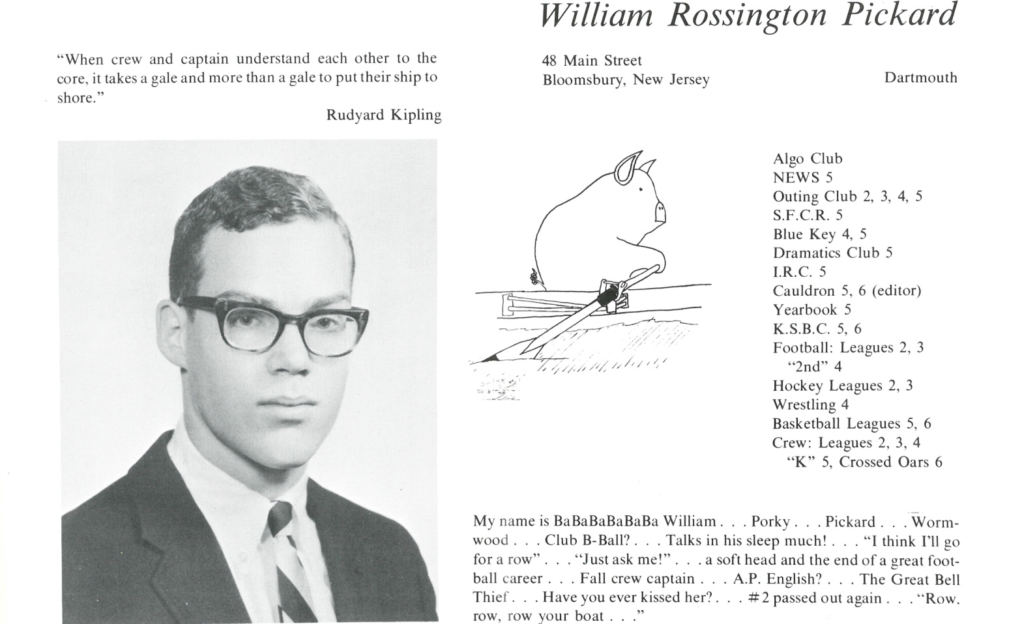

William R. Rickard, Jr.

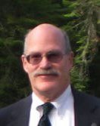Married 37 years and counting to Janet Murphy of the Bozeman, Montana Murphys, aka “Murph” or Mom. I lucked out, she deserves better. By marrying her, I acquired a huge, wonderful family. Between us we have 3 diversely talented sons, Will, Nick, and Ted – all Eagle Scouts, musicians, opinionated, sometimes appreciative, and all growing up into nice young adults. Looking forward to their supporting us in our old age. Lots of great dogs & cats along the way.

Dartmouth ’71 (what an incredible place). Rowed 4 years (with John Eaton K’66), Captain. Henley again, Vesper & Union Boat Clubs, National Team twice, see the world, etc., lost ’72 Olympic trials ☹, have stayed involved with rowing since then ☺. Business School at Dartmouth (another incredible school). Dartmouth had gone co-ed by then, and so I coached the women’s rowing team, met Murph – and 40 little sisters, 5 of whom made US National and Olympic teams. We had our 40th anniversary last November.

Graduated, moved to Seattle (which has to be the most perfect place to live in the US), bought and am still fixing up a giant fixer-upper (look at the lake and mountains every morning) and launched a long and fascinating career in management consulting w/projects ranging from starting divisions for Boeing, to tiny start-ups, to turn-arounds, in industries ranging from technology, to retail, to manufacturing, to starting an electric utility in American Samoa, to fishing in Alaska, to teaching the State of Arizona and the Country of Mexico how to find each other on the Information Highway. Played a role in inventing the Internet. Lots of projects in US from Alaska to Florida, Mexico, Philippines, American Samoa, Hopi Indian Reservation – really neat stuff, plenty of travel & many interesting people. (I have a patent for a novel use of autonomous, intelligent software agents (like ‘bots’) and did the analysis that ended the Washington Public Power Supply (aka WPPSS) of the famously failed bonds).

I’ve been a Boy Scout parent and gone on a zillion hikes and canoe trips and snow camps with a slew of kids, and now that my boys are all grown up, I hike, paddle, work out, & row with a bunch of guys and women my own age in our wonderful mountains and lakes and inland seas all over the Pacific NW. Started the Pocock Rowing Foundation, knew all the guys in *The Boys in the Boat*, and helped WGBH make the TV special, “*The Boys of ‘36*”. We teach about 10,000 middle school kids indoor rowing, build boathouses, start programs, start museums, build parks, run events, raise money, and feel great about it. Read a lot of books. Life’s been good.

*"It is not what a lawyer tells me I may do; but what humanity, reason, and justice tell me I ought to do." - Edmund Burke (1729-1797)*



______________________________________________________________

______________________________________________________________ ______________________________________________________________ ______________________________________________________________ ______________________________________________________________ ______________________________________________________________ ______________________________________________________________ ______________________________________________________________ ______________________________________________________________

Attach Picture in .jpg Format

______________________________________________________________

______________________________________________________________

___________________________________________________________________________________ _________________________________________________________________________________________________________________________________________________________________________________________________________________________________________________________________________________________________________________________________________________________________________________________________________________________________________________________________________________________________________________________________________________________________________________________________________________________________________________________________________________________________________________________________________________________________________________________________________________________________________________________________________________________________________________________________________________________________________________________________________________________________________________________________________________________________________________________________________________________________________________________________________________________________________________________________________________________________________________________________________________________________________________________________________________________________________________________________________________________________________________________________________________________________________________________________________________________________________

___________________________________________________________________________________