2nd Annual Jim Wells County Fair Association Cook-off

Benefiting the Youth of Jim Wells County
++ IBCA STATE Sanctioned ++
*************************************************

Saturday, November 1, 2025

Jim Wells County Fairgrounds
3001 S. Johnson Street

Alice, Texas

***** Cash Prizes *****

Categories: Chicken, Pork Spare Ribs, Brisket, and Beans (50/50 Jackpot)
Chief Choice (Friday) Margaritas (Friday) Trick -0-Treating for the kids

JPA KIDS QUE - HALLOWEEN SITE SHOWMANSHIP

OFFICIAL RULES

Administration
- One team per pit, maximum 5 members per team.
- The bar-b-que contest will be located at the Jim Wells County Fairgrounds 3001 S. Johnson Strret Alice Texas.
- Contestants must supply all needed equipment and supplies. The bar-b-que management will provide space only.
- The Jim Wells County Junior Fair Association and the sponsors are not responsible for any theft or damage.
- The bar-b-que chairman reserves the right to make additional rules or regulations as situations warrant.
- Decisions of the Committee Chairman and Judges are final.
- All teams must have paid their entry fee, and check in and set up their space between 12:00 p.m. and 6:00 p.m. on Friday, October 31st, 2025. The Committee Chairman must be notified for earlier or later Check-in.
- Move out time will be after Awards on Saturday, November 1, 2025 Awards at 4:30pm
- There will be trash cans and dumpsters on site, but it will be each team’s responsibility to keep their area clean and safe. YOU MUST DISPOSE OF ALL YOUR OWN TRASH INTO THE LARGE DUMPSTERS.
- Each team will be allocated an approximate space (at least 30 ft X 30 ft.) Props, trailers, motor vehicles, tents, etc. or any part of the contestant’s equipment may not exceed the boundaries of the assigned space. Each team is restricted to one (1) vehicle in the space.
- Stakes of any kind may not be driven into the pavement.
- The chief cook will be held responsible for the conduct of their team and guests.
- NOTE: State Law requires that you must be 21 years of age to consume alcohol. Anyone violating this law will be accountable for the consequences.
- Excessive use of alcoholic beverages may be grounds for disqualification.
- No rude or obnoxious behavior will be tolerated. We ask that you not blare your music and respect others’ requests to turn it down. Music volume should be kept to a minimum after 10:00 p.m. and completely shut down by midnight. Blaring music and/or rude behavior will not be tolerated. After a warning, offenders may be disqualified.
- Vehicles must fit in your assigned spot. For safety reasons, no vehicles should move within the BBQ cooking area after 8:00 a.m. Saturday morning.
- Please park vehicles in an orderly manner outside of the cooking areas to allow for the flow of traffic. Violators may be towed.
- We ask that trash be placed in the provided cans and dumpsters.
- No pets or other animals will be allowed in the contest area. (Seeing eye dogs are the only exception.)
- For safety reasons, no golf carts, ATV’s, bicycles, scooters, hover boards, skateboards, water balloons, water guns, sling shots, firearms, etc. will NOT be allowed in the contest area.
- Failure to comply with the above measures may lead to disqualification and requests to leave the premises.

Cooking/Judging
- *IBCA Contest Rules Apply - Contest Rules Available at the Link Below*
- https://ibcabbq.org/organization-documents/ 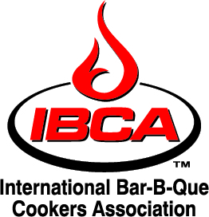

- All teams entering the brisket category will turn in Eight (8) slices.
- All teams entering the rib category will turn in Eight (8) full pork spare ribs.
- All teams entering the chicken category will turn in one (1) fully jointed complete chicken half.
- NO Pre-cooked Beans allowed. Pre-soaking of beans is permitted.
- Overall Grand and Reserve winners will be based on all three categories: chicken, ribs, brisket.
- Turn in times are: Beans: 11:00 am, Chicken: 12:00 pm, Ribs 1:30pm and Brisket: 3 pm.
- NO GARNISH is allowed in the meat tray at turn-in. Single sheet of foil only.
- All entries must be cooked over wood or wood substance fires.
- Teams may not share cooking equipment or entries. Each space must have a separate cook and equipment.
- More details at the Chief Cooks Meeting at 6:00 p.m. Friday Evening.

General Information.
- The Jim Wells County Fair Association Show Cook-off will go on rain or shine!!
- For additional information, contact Kim Scarborough (361) 537-9978 or the Show Office.

~~~~Proudly Sponsored by the Jim Wells County Fair Association
100 % Money will go towards Scholarship~~~~

Kids QUE RULES
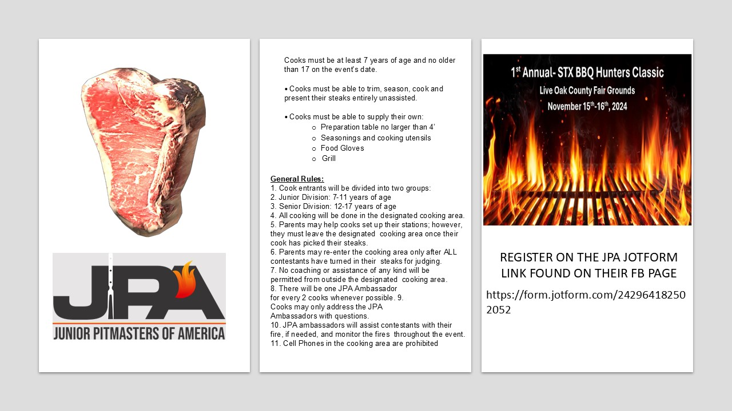

2nd Annual Jim Wells County Fair Association Cook-off

Benefiting the Youth of Jim Wells County
++ IBCA STATE Sanctioned ++
*************************************************

Friday and Saturday, October 31st – November 1st 2025

Jim Wells County Fairgrounds

Alice, Texas

***** Cash Prizes *****

Each Category pay out up to 6 places
Overall Grand entry a trophy plus CASH
Overall Reserve a trophy plus CASH
Categories: Chicken, Pork Spare Ribs, Brisket, and Beans (50/50 Jackpot)
Chief Choice (Friday) Margarita (Friday) - Trick -0- Treating,

JPA KIDS QUE (Saturday) - HALLOWEEN SITE SHOWMANSHIP

OFFICIAL ENTRY FORM ** Entry Fee $200 (All 3 Meats)

TEAM NAME

MAILING ADDRESS

CHIEF COOK CELL PHONE (S)

JACKPOT 50/50 - ENTRIES FEE
Chef Choice _______$30 (Friday) RV SPOT - _________________$100
Margarita ________$30 (Friday) Water and Electric Only
Beans ____________ $30 (Saturday)

Mail to: Jim Wells County
c/o BBQ Phone: 361-537-9978 (Kim)
P.O. Box 3664
Alice Texas 78333 Please make check payable to: JWCFA

~~~~Proudly Sponsored by the Jim Wells County Fair Association ~~~~

