January 2022 Member Program
The South Park Ghost Town
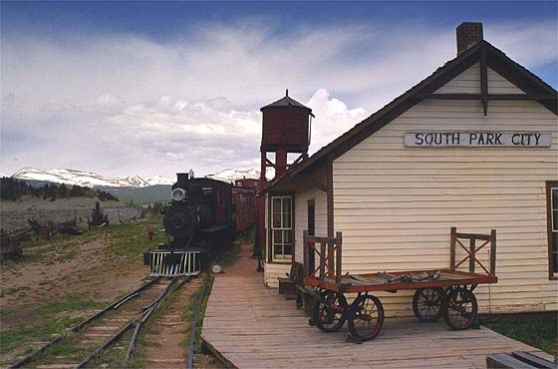
WHAT: RMGA MEMBERSHIP MEETING –
WHEN: January 10, 2022
6:00 pm – Networking
6:30 pm – Short Meeting
6:45 pm – Program: The South Park Ghost Town
WHERE: Via Zoom
To Join Zoom Meeting: https://us06web.zoom.us/j/84252873933
Meeting ID: 842 5287 3933
One tap mobile phone: +17207072699,,84252873933# US (Denver)
PROGRAM: The South Park Ghost Town in Fairplay by George Koukeas
Please join us for a presentation on the fascinating history of the South Park ghost town in Fairplay. Learn about the famous events and people of this town during the 1800s. You will learn about them in relation to the authentic 1800's buildings and houses that comprise the ghost town."
"George Koukeas is a freelance writer and history speaker. He has studied Frontier history for the last 2 decades. He has spoken extensively on ghost towns, vigilance committees, famous battles, Buffalo Bill Cody, General George Custer and other famous persons in our country’s history. His approach is factual and not politically correct. And he believes in preserving our history through careful research, respect for facts and logically supportable conclusions."
Many members will remember that George did our May, 2019 program on George Custer.
FOOD: Provide Your Own
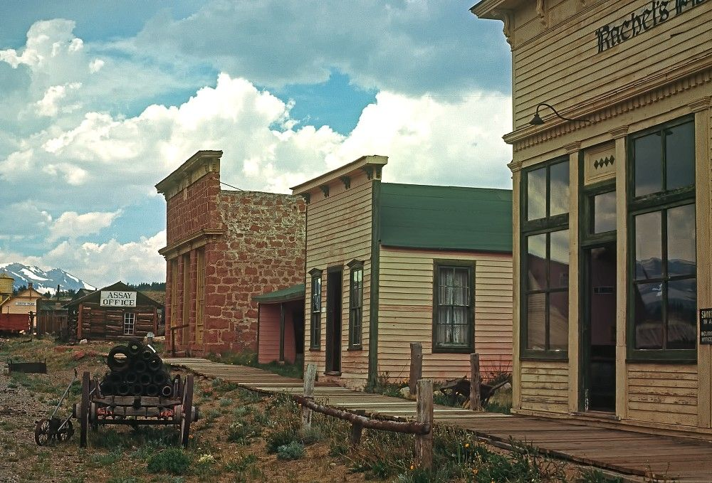
DIRECTIONS: To Join the Meeting click on the link above or copy it to your browser. You may start to join the meeting at 6:00 pm. click on “Join” in the invitation, enter the necessary codes, and wait to be admitted.

PARKING: On Your Own

GUESTS: Members are encouraged to invite potential members as a guest to the meeting.
MEETING NIGHT CONTACT: J. Mark Blaising, Program Chair 303-830-8440 (voice) 303-263-8647 (text)
