12/16/2017 The Decree Issued on 12/11/2017 to Transit the Moon

This is a follow up to the article issued on 12/9/2017 concerning the transiting of Jerusalem by First Viscount Allenby on 12/11/1917 and the transiting of the Sun by the planet venus exactly 200 years later on 12/11/2117.

Our Creator Elohim, YaHuWaH and YaHuShua His Son, have masterfully orchestrated the movements of the earth, sun, moon, planets, comets, asteroids, and stars in order to signify to us their appointed times, unlimited abilities, and love for us.
We know from Daniel 9:25 that the timing of certain events were referenced to the issuing of a decree by the King of Babylon.

A decree was issued by President Donald Trump, the highest executive authority of modern Babylon the Great, on 12/11/2017 to send men to transit the Moon. The purpose of the Moon expedition is to help prepare for future trips to Mars and other points of interest in our Solar System.

We know that the Moon is symbolic of the nation of Israel. The descendants of Jacob (Israel) were chosen to reflect the truth of YaHuWaH Elohim to the nations in the same way that the Moon reflects the light of the Sun to the world in the darkness of night.

Therefore, the decree to send men to walk the Moon with the intent of moving onward to Mars is symbolic of a decree to send men to transit Israel with the intent of future war (the planet Mars being universally symbolic of War).

Below: A graphic showing a central chiastic emphasized symbolic theme. One interpretation of the entire graphic is that Messiah Himself will transit Israel in a future war.
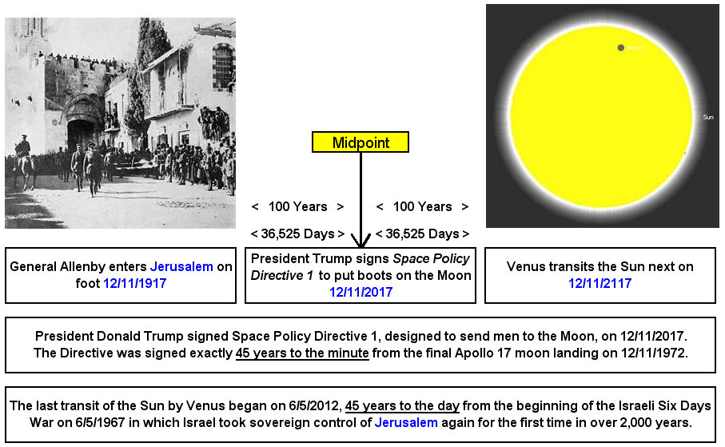

Link to NASA information on the signing of Space Policy Directive 1: https://www.nasa.gov/press-release/new-space-policy-directive-calls-for-human-expansion-across-solar-system

In the graphic above, modern Babylon the Great was able to time the 45 year signing of the Space Policy Directive 1 after the last Moon landing, but only YaHuWaH Elohim could have timed the transit of Venus across the face of the Sun 45 years after the beginning of the Israeli Six Day War.

