GEN-4811H (11,000W-48kW-50/60Hz-16yr) Hybrid 120V-240V | Geneforce Emergency Power System  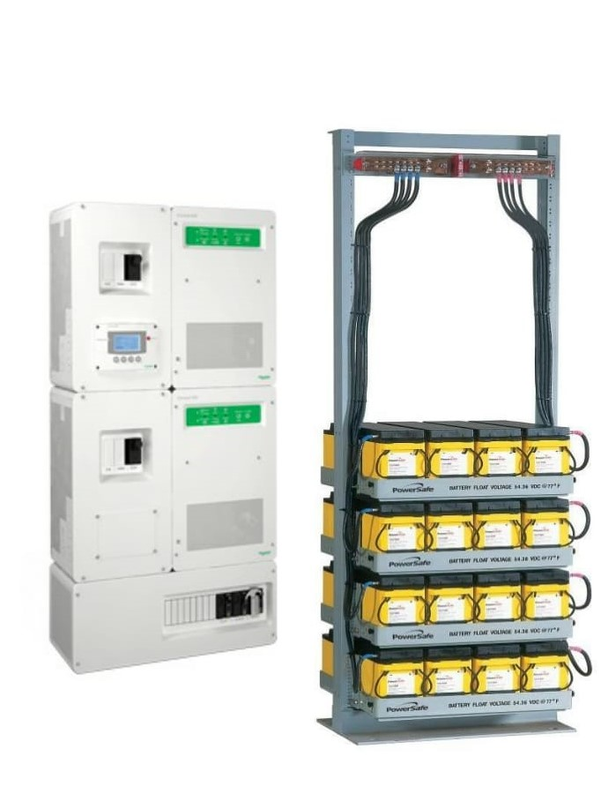
Product Features
The Power System integrates into the electrical system and seamlessly converts power from battery reserves to power critical loads such as pumps, security systems, refrigerators and electronics, when utility power is unavailable. The Power System is an adaptable single-phase inverter with grid-tie functionality and dual AC power inputs.
The Advanced System Control Panel with Graphical 128 x 64-pixel, backlit LCD display that allows for setup and monitor of entire system including multiple solar charge controllers and auxiliary battery banks. Panel displays power reserves, amp hours consumed, fault conditions, solar panel output, charging, power consumption, etc.
Features include
- An integrated web server, enabling graphical displays of system daily, monthly and lifetime energy data to be viewed using a simple web browser or Android™ tablet device.
- Silent operation, No gas or emissions, Automatic start
- Enables owners to remotely monitor a portfolio of sites from any internet connected device like a laptop or a tablet.
- System configures quickly into compact wall-mounted system
Solar rechargeable system that can be used with a solar panel array to recharge 12V - 48V DC
Dual AC inputs with capability to work with two-wire and three-wire generator starting systems
Inverter AC output | GEN-4811H (120-240V)
Continuous Output Power | 11,000 W
Overload 30 min/60 sec at 25°C | 14,000 W (overload 30 minutes) / 19,000W (60 sec at 25°C)
Output power (continuous) at 40°C | 9,000 W
Maximum output current 60 seconds (rms) | 164 A (120 V); 82 A (240 V)
Output frequency (selectable) | 50/60 Hz
Output voltage | L-N: 120 V +/- 3%; L-L: 240
Input DC voltage range | 42 to 60 V (48 V nominal)
Maximum input DC current | 150 A
Charger DC output
Maximum output charge current | 110 A
Output charge voltage range | 40 – 64 V (48 V nominal)
Charge control | Three stages, two stages, boost, custom
Charge temperature compensation | Battery temperature sensor included
AC input & output
AC 1 (grid) input current (selectable limit) | 60A/120-240V (240V default)
AC 2 (generator) input current (selectable limit) | 60A/240V (240V default)
AC 1 output | 2 - 60A/120-240V
AC input voltage requirements | 240V default *phase between L (1) and L (2) must be 180° to qualify AC
Automatic transfer relay rating/typical transfer time | 60 A/8 ms
AC input voltage limits (bypass/charge mode) | L-N: 78 - 140 V (120 V nominal) L-L: 160 - 270 V (240 V nominal)
AC input frequency range (bypass/charge mode) | 55 – 65 Hz (default) 52 – 68 Hz (allowable)
Battery rack specifications
Battery Rack dimensions | 23” W x 22” D x 84” H, base plate area is 624 in2 or 4.33 ft2
Battery Rack weight | 2,640 lbs./1,200 kg.
Battery service life | 12-16 Years on Float
Stored battery reserves | 48,000 W (48kW)
General Specifications
Component dimensions (H x W x D) / weight | Assembled (30” x 48” x 9”) / 354 lb.
IP degree of protection | NEMA Type 1 Indoor
Operating air temperature range | -25°C to 70°C (-13°F to 158°F) (power derated above 25°C (77°F))
Warranty (depending on the country of installation) | 2 or 5 years
Features
Intelligent features | Grid sell, peak load shave, generator support, prioritized consumption of battery or  external DC energy
Regulatory approval
Safety | UL1741, CSA 107.1
Interconnect | IEEE 1547 and CSA 107.
Part Number | GEN-4811H-120/240V-48KW-16
Price | $29,979
Geneforce Incorporated www.geneforcepower.com Tel: (305) 215-5443 email: sales@geneforcepower.com

