Why is One AR Coating Better Than Another?
by
Anthony Record, Optician, FNAO, ABO/OAA

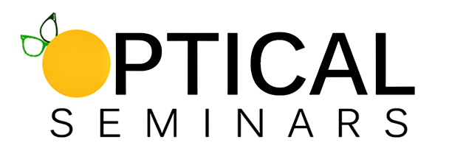

Optical Seminars, Inc.
PO Box 5445
Spring Hill, Fl 34611-5445
homestudy@opticalseminars.com
© 2025 Anthony D. Record

Learning Objectives:
After completing this two-hour home-study course, the participant will be able to:
- Explain the principles of anti-reflective (AR) coating technology, including the role of destructive interference, multi-layer construction, and refractive index manipulation in enhancing visual clarity.
- Differentiate between various AR coating manufacturing methods, such as electron beam evaporation, magnetron sputtering, and ion-assisted deposition, and assess how each impacts coating performance and durability.
- Evaluate AR coatings based on key performance metrics, including reflectance value, light transmission, scratch resistance, smudge and water repellency, static resistance, and environmental durability.
- Compare and contrast premium versus basic AR coatings, highlighting differences in material quality, functional layers, user experience, and long-term value.
- Apply patient-specific factors such as lifestyle, occupation, and environment to make personalized AR coating recommendations that improve satisfaction and lens performance.
- Communicate the benefits of advanced AR coatings effectively, addressing common patient objections, illustrating long-term value, and reinforcing trust in high-quality optical products.

Introduction
Anti-reflective (AR) coatings have evolved from a premium upgrade to a standard of quality in ophthalmic lens technology. Despite their widespread use, patients and even some optical professionals may not fully understand what makes one AR coating superior to another. This course seeks to provide dispensing opticians with a thorough understanding of the technological, functional, and aesthetic factors that differentiate various AR coatings, empowering them to guide patients with authority and confidence.
Understanding AR coatings is no longer optional. As visual demands increase due to longer screen time, diverse work environments, and patient expectations for better aesthetics, the role of the AR coating becomes central to lens performance. This course will explore the composition, application, performance metrics, and user experience of AR coatings, as well as provide guidance on how to effectively communicate their value to patients. By the end, opticians should be able to discern high-quality coatings from substandard ones, matching the right product to each individual patient’s lifestyle.
I The Science Behind AR Coatings
AR coatings work by eliminating unwanted reflections from the surface of ophthalmic lenses. This is achieved through the principle of destructive interference, a phenomenon where specific wavelengths of light are cancelled out when reflected off multiple surfaces. A properly applied AR coating allows more light to pass through the lens, improving clarity, contrast, and reducing visual fatigue.
The typical AR coating consists of several microscopic layers, each with a different refractive index. These layers are carefully calculated and deposited to neutralize specific bands of light, particularly in the visible spectrum. The number of layers can vary from brand to brand, with premium coatings often having seven or more.
Beyond the basic AR layers, modern coatings include additional functional layers such as:
- A hard coat for scratch resistance.
- A hydrophobic layer to repel water and ease cleaning.
- An oleophobic layer that resists fingerprints and smudges.
- Anti-static properties to repel dust and dirt.
Each of these contributes to the wearer's experience and the long-term performance of the lens. A coating that combines optical enhancement with environmental resistance offers tangible value to the patient.
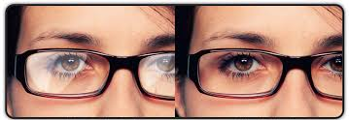

II Historical Context and Evolution
The origins of AR coatings are rooted in military applications, particularly in improving the performance of optics used in binoculars, rifle scopes, and camera lenses. During World War II, scientists refined thin-film deposition methods to reduce glare in critical equipment. These methods slowly transitioned to consumer products over the decades. The ability to reduce reflections and improve light transmission was quickly recognized as a substantial benefit, especially in fields requiring precision optics.
Early AR coatings in ophthalmic lenses began appearing in the latter half of the 20th century, largely inspired by advancements in other optics-based industries. However, these initial attempts were rudimentary by today’s standards. The coatings often lacked durability and were susceptible to peeling, scratching, and yellowing over time. This led to early skepticism among eye care professionals and patients alike. Nonetheless, the benefits were promising enough that research and development continued.
The turning point came with the advent of vacuum deposition techniques and ion-assisted processes. These allowed for much more consistent application of the coating materials, greatly enhancing the adhesion and durability of AR coatings. Optical laboratories could now apply multiple layers with nanometer-level precision, ensuring optimal performance and longevity. Coatings became more transparent, more effective at reducing unwanted glare, and much easier to clean.
As consumer demand grew—driven in part by increasing use of digital devices and a growing awareness of lens aesthetics—manufacturers responded by developing more sophisticated products. By the 1990s and early 2000s, AR coatings were no longer reserved for high-end prescriptions but were beginning to be offered as an upgrade for most lens types. The rise of high-index lenses, which reflect more light than standard materials, also played a major role in normalizing AR coatings as a necessary add-on.
Today, AR coatings are the result of highly refined nanotechnology. Engineers can manipulate atomic-level interactions to produce coatings that are not only functionally superior but also aesthetically pleasing. The precision with which these coatings are now applied allows for targeted performance—such as increased durability, reduced blue light transmission, or improved UV protection. Multi-layer designs can now exceed ten layers, each playing a specific role in the coating’s overall effectiveness.
In recent years, AR coatings have also been shaped by lifestyle and environmental trends. With the rise of remote work, people are spending more time than ever in front of screens. This has led to a surge in coatings that offer blue light protection. Meanwhile, the fashion and selfie culture (see picture below) has made lens appearance and cosmetic reflection color a major factor for many patients.


Moreover, increased focus on sustainability is beginning to influence AR coating development. Some laboratories are exploring more environmentally friendly materials and production processes, aiming to reduce their ecological footprint. As patient awareness grows in this area, coatings that are marketed as "eco-friendly" may soon become another distinguishing feature.
What began as a military innovation has transformed into a cornerstone of vision care. AR coatings have evolved dramatically over the decades—from brittle and unstable layers to high-tech, multi-functional systems that can be customized to a patient’s lifestyle, occupation, and visual environment. Understanding this evolution not only gives opticians greater appreciation for today’s technology but also prepares them to better articulate value to their patients.

III The Manufacturing Process
Producing a high-quality AR coating is a complex and controlled process. It typically involves the following steps:
- Substrate Preparation: The lens surface must be impeccably clean and smooth. Any dust, oil, or microscopic debris will compromise adhesion. Lenses are ultrasonically cleaned in multiple stages using specialized solutions and are then dried in a sterile environment. Some labs even use ionized air to remove the final traces of static and particles. Some labs even refer to this as their “clean room.”
- Vacuum Deposition: This is where the AR coating is applied. The vacuum deposition process occurs in a chamber where air and other gases are removed to create a vacuum, ensuring that the thin-film materials can be deposited evenly and without contamination. Several different techniques can be used in this step:
  - Electron Beam Evaporation: In this method, an electron beam is directed at a target material—such as magnesium fluoride or titanium dioxide—causing it to vaporize. The vapor then condenses on the lens surface in the form of a uniform thin film. Electron beam evaporation allows precise control over layer thickness and is widely used in ophthalmic lens coatings.
  - Magnetron Sputtering: This method uses a magnetic field to trap electrons near the surface of a coating target material. These electrons collide with inert gas atoms (typically argon), creating a plasma. The plasma dislodges atoms from the target, which then settle onto the lens surface. Sputtering produces highly dense and durable coatings and is especially useful for applying hard coatings or functional top layers.
  - Ion-Assisted Deposition (IAD): IAD is a hybrid technique that combines the benefits of evaporation and sputtering with the additional energy of ion beams. These beams bombard the surface during the coating process, improving film adhesion and density. This method results in highly durable and scratch-resistant coatings and is common in premium AR coating applications.
Each method offers specific advantages. Electron beam evaporation is favored for its speed and precision in depositing uniform layers. Sputtering is preferred when a harder, denser layer is needed. Ion-assisted deposition is often reserved for the highest-end coatings because of its ability to produce ultra-durable and highly adherent layers.
- Layering Materials: Multiple layers of materials are applied in specific sequences. Each material has a different refractive index, and each layer is calibrated to a specific thickness—often in the range of 80–150 nanometers—to achieve maximum destructive interference. (As a friendly reminder, a nanometer is one billionth of a meter!) The materials most commonly used include:
  - Magnesium Fluoride (MgF2): Often used in the outermost layers for its excellent light transmission properties.
  - Titanium Dioxide (TiO2): A high-index material used to achieve contrast in refractive indices.
  - Silicon Dioxide (SiO2): Used for structural layers and its stable physical properties.
These layers can number between 5 and 12, depending on the sophistication of the coating. High-end AR coatings are engineered to block a broader spectrum of light and minimize visible reflections under varying conditions.
- Functional Coatings: After the primary anti-reflective stack is applied, functional coatings are added. These include:
  - Hard Coats to improve scratch resistance.
  - Hydrophobic Layers to repel water.
  - Oleophobic Layers to resist oils and fingerprints.
  - Anti-static Layers to reduce dust accumulation.
These top layers are critical for daily wearability and ease of maintenance. They also improve the longevity of the AR coating by acting as a protective shield.
- Quality Control: After coating, lenses undergo rigorous testing. They are examined under high magnification to detect flaws, tested for light transmission and reflectance using spectrophotometers, and subjected to environmental stress tests. Some labs use adhesion tape tests and water droplet tests to assess durability and hydrophobicity.
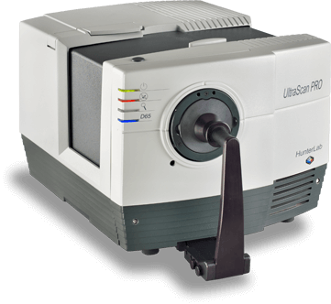(The UltraScan Pro Spectrophotometer by HunterLab)
The difference between a low-end and high-end AR coating often lies in the precision of these steps. High-end coatings use purer materials, tighter environmental controls, and more sophisticated deposition technologies. Even minute inconsistencies in thickness, contamination, or adhesion can cause a coating to fail prematurely or underperform optically.

IV Metrics of Performance
AR coatings are judged by several key metrics, each offering insight into the lens’s performance, longevity, and user satisfaction. These metrics help opticians evaluate the quality of a coating and match the best product to the patient’s unique lifestyle and visual needs.
- Reflectance Value: One of the primary goals of AR coatings is to reduce surface reflections. This is typically quantified by the percentage of light reflected off the lens. Premium AR coatings can reduce reflectance to less than 0.5%, creating lenses that appear almost invisible. In contrast, more basic coatings may allow up to 1.5% of light to reflect, which can still result in glare or ghost images, particularly in night driving or under bright office lighting. Lower reflectance not only improves vision but also enhances the cosmetic appearance of the glasses. (Friendly suggestion: Carefully reread that last paragraph. Sharing that information with our patients is a powerful tool for helping them to see the primary benefit of moving to a premium AR coating.)
- Light Transmission: By reducing surface reflections, AR coatings allow more light to pass through the lens and into the eye. This is referred to as light transmission, often exceeding 99% in high-quality coatings. Better light transmission enhances visual acuity, especially in low-light conditions, and can be a significant benefit for older patients, drivers, and those with contrast sensitivity issues.
- Durability: Scratch resistance and long-term wearability are vital for patient satisfaction. The Bayer Abrasion Test is a standardized method to assess a coating’s scratch resistance. Premium AR coatings, especially those applied via magnetron sputtering or ion-assisted deposition, tend to score significantly higher on this test. Durability also refers to resistance to peeling, cracking, and discoloration over time—common issues with lower-end coatings that can lead to patient complaints and early replacements.
- Smudge Resistance: Fingerprints, facial oils, and skin contact inevitably affect the lens surface. Oleophobic coatings create a barrier that repels oils, reducing smudging and making the lens easier to clean. This feature has become one of the most requested by patients. It directly affects the frequency with which glasses must be cleaned and, by extension, how often they are scratched due to improper cleaning techniques.
- Hydrophobicity: Water-repellent coatings are measured by the contact angle of a water droplet on the lens surface. A high contact angle (typically over 100 degrees) indicates superior hydrophobic performance, meaning that water will bead up and slide off rather than smear. This is especially helpful for patients who go between air-conditioned and humid environments or live in rainy climates.
- Anti-Static Properties: Dust and lint are attracted to lenses via static electricity. Some AR coatings include an anti-static layer to neutralize this attraction. This feature is particularly beneficial for people who work in dusty environments or spend time around electronics, as static buildup is often exacerbated in those settings. Anti-static performance contributes to cleaner lenses throughout the day.
- Color Neutrality and Hue: Every AR coating has a residual color hue, often green, blue, or violet. This is the result of how the layers cancel certain wavelengths of light. While not a direct performance factor, hue can influence aesthetics and patient perception. Some patients find certain hues more distracting or noticeable than others. A more neutral hue typically appears clearer and may be preferred by those concerned with how they look in photos or social settings.
- Environmental Resistance: High-quality AR coatings are designed to withstand a wide range o f environmental conditions, including humidity, salt air, and rapid temperature changes. Lower-end coatings may degrade in such environments, especially if the materials are not properly cured or if the application process lacked consistency. Premium coatings often undergo accelerated life-cycle testing to simulate years of wear in varying climates.
- Blue Light Filtering: Many modern AR coatings offer partial blue light filtering capabilities, which are especially useful for digital screen users. This feature is achieved by manipulating the coating layers to selectively reflect short-wavelength blue light while maintaining clarity and color balance. Although not every patient needs this feature, it’s increasingly popular among those experiencing digital eye strain or sleep disturbances.
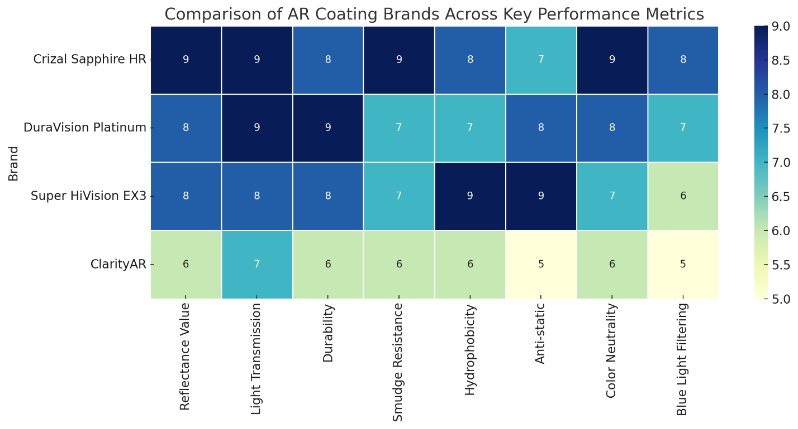
When all these factors are considered together, it becomes evident that metrics of performance go far beyond reflectance alone. An excellent AR coating is defined by its ability to perform well across multiple domains—optical clarity, physical durability, aesthetic appeal, and ease of maintenance.
For dispensing opticians, understanding and explaining these metrics in everyday language can make the difference between a basic lens sale and a premium product that truly meets a patient’s needs. When patients grasp the tangible benefits behind each feature—fewer smudges, clearer vision at night, less time cleaning their glasses—they are more likely to appreciate the value of an advanced AR coating and make an informed investment.

V Differentiating Premium from Basic Coatings
Just like not all opticians are created equal, not all coatings are created equal. While all claim to reduce reflections, their performance varies widely.
Premium coatings:
- Offer a wider bandwidth of anti-reflective effect.
- Incorporate superior scratch-resistant materials.
- Provide better smudge and water resistance.
- Maintain appearance over time with fewer discoloration or edge-peeling issues.
In contrast, “economy” coatings may show early signs of degradation, require frequent cleaning, and produce noticeable color fringes in reflection. For the patient, this translates to frustration and shorter lens lifespan.
One of the key differences between a premium and a basic coating lies in the level of investment and precision involved in their manufacture. As mentioned earlier, premium coatings are often applied using advanced ion-assisted deposition (IAD) or magnetron sputtering methods, which allow for greater control over layer composition and adhesion. These processes result in denser, more consistent coatings that are less likely to degrade with time.
Economy coatings, on the other hand, may use simpler electron beam evaporation methods without ion enhancement. While still effective in reducing reflections, these coatings are often thinner and more prone to wear and tear. Over time, they may begin to peel at the edges, develop micro-cracks, or lose their hydrophobic and oleophobic properties. (See picture below.)
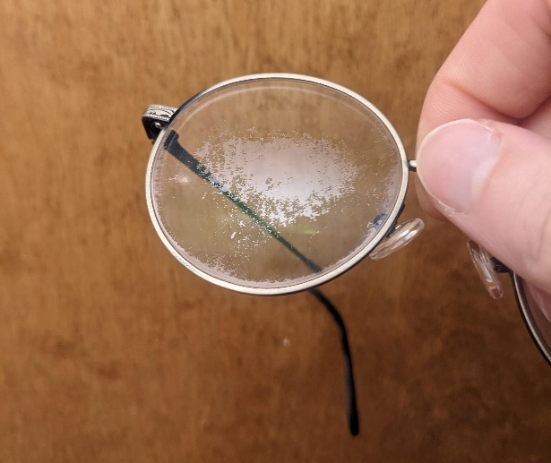

Another important distinction is in the number of layers and their specific functions. Premium AR coatings often include additional layers that serve secondary purposes—such as anti-static performance, UV protection on both surfaces, or blue light filtering—whereas basic coatings may only include the core anti-reflective stack and a minimal hard coat. These added features contribute to a more comfortable visual experience and reduced eye strain, especially for patients with demanding visual environments.
Cleaning and maintenance is another area where differences become evident. Premium AR coatings are engineered to repel oils, dust, and moisture more effectively, which translates to less frequent cleaning and fewer chances of accidental lens damage during cleaning. Patients who wear their glasses all day, or work in environments with frequent temperature changes or high humidity, are likely to notice the benefit of superior coatings.
Aesthetic longevity is also a factor. High-end coatings maintain their clarity and hue better over time. Patients often report that basic coatings start to appear hazy or develop an iridescent sheen after several months, especially if exposed to skin oils, makeup, or environmental pollutants. This discoloration not only affects vision but can make the lenses look aged and poorly maintained—even when the prescription is still valid.
Finally, patient satisfaction and repeat business are closely linked to the quality of AR coatings. A patient who invests in premium coatings and enjoys effortless clarity and low-maintenance lenses is more likely to return to the same optician and refer others. By contrast, dissatisfaction with a “budget” coating can reflect poorly on the practice and lead to lens returns, warranty claims, or lost trust.
For the dispensing optician, understanding and articulating these differences is crucial. Patients should be informed not only about the upfront cost but about the long-term value of premium coatings—better performance, fewer issues, and a longer usable life. When framed this way, many patients see the wisdom in choosing quality from the start.

VI Brand Comparisons and Clinical Experience
Leading AR coating brands include:
- Crizal (Essilor): Known for its UV protection, smudge resistance, and durability. Crizal Sapphire HR and Prevencia incorporate blue light filtering and high transmission rates. Crizal coatings are also praised for their multi-angular durability—offering resistance from both front and rear surface wear.
- DuraVision (Zeiss): Emphasizes toughness and clarity. DuraVision Platinum is highly scratch resistant, while BlueProtect targets screen users with enhanced blue light filtering. Zeiss coatings are also known for their unique hardness due to a densely packed molecular structure achieved through magnetron sputtering.
- Super HiVision EX3 (Hoya): Features anti-static properties and strong hydrophobic performance. This coating offers a slick lens surface that makes cleaning effortless and significantly reduces dust buildup. It’s particularly beneficial for patients in dry or windy environments.
- ClarityAR (Younger Optics): A cost-effective alternative with respectable performance. While not as robust in features as high-end options, ClarityAR offers consistent reflectance control and reasonable smudge resistance, making it suitable for value-focused patients. (Another example: the Essilor Lab I used for many years offered a budget option for AR. They called it Sharpview.)
While branding plays a large role in perception, clinical experience and independent lab testing often tell a more nuanced story. Coatings that perform similarly on paper may have different lifespans, cleaning characteristics, or tolerance to environmental changes. For instance, coatings with similar scratch resistance ratings might differ in how they hold up after six months of use in a high-humidity environment.
Comparative data from independent labs typically includes tests like the Bayer Abrasion Test, smudge resistance, hydrophobicity angle, reflectance percentage, and ease-of-cleaning index. Opticians should consult with their labs to understand what test results are available and how those translate to real-world performance. Some labs even offer side-by-side comparisons under microscope or polarized lighting, which can be shown to patients as a visual demonstration.
Clinical experience—often shared anecdotally between professionals—remains one of the most valuable tools in determining which coating is best for a given practice. For example, some opticians report better long-term satisfaction from patients fitted with Super HiVision EX3 due to its superior water repellence, while others may swear by the anti-smudge effectiveness of Crizal Sapphire HR in high-touch work environments.
Beyond performance, warranties and service support can also differentiate one brand from another. Some premium coatings come with extended warranties against defects, peeling, and discoloration, while others offer satisfaction guarantees or free remakes under certain conditions. These policies are especially important when positioning premium coatings to hesitant patients.
Finally, branding can influence patient perception. A patient may be more inclined to trust a recognized name like Crizal or Zeiss, especially if they've had positive experiences with those brands in other contexts, such as camera lenses or sunglasses. Leveraging brand trust can help reinforce the value proposition during the consultation process.
Ultimately, the optician’s role is to balance brand reputation, clinical data, lab partnerships, and patient feedback. A comprehensive understanding of each coating’s strengths—and potential drawbacks—helps ensure that each recommendation is well suited to the individual’s needs and expectations.
VII The Psychological and Aesthetic Factors
With 40 years of experience, I can tell you one thing for certain: Patients may not understand metrics, but they do understand experience. Lenses that look clean, resist glare in photos, and feel effortless to maintain create higher satisfaction. Color hue—typically green, blue, or violet—is another consideration. While subtle, patients may have preferences based on skin tone or fashion. Coatings with a green or neutral hue tend to be perceived as more professional and natural, while blue or violet hues may appeal to patients looking for a modern or high-tech aesthetic.
Psychologically, patients feel more confident when their glasses enhance rather than distract from their appearance. Reflections can obscure the eyes in photographs or face-to-face interactions, creating a barrier in communication. AR coatings minimize these distractions, allowing others to see the wearer’s eyes more clearly and promoting better eye contact, which is often associated with trustworthiness and engagement.
The impact of AR coatings on night vision and driving also plays a crucial psychological role. Patients who drive at night often experience starbursts and glare from oncoming headlights. High-quality AR coatings significantly reduce these issues, leading to improved safety and reduced stress. For individuals who are already nervous about night driving, this reassurance can make a profound difference in their independence and peace of mind. In fact, lens manufacturer, Shamir, has developed something they call their Shamir Driver Intelligence™ lenses, which they are calling “Sun” (specifically designed for day driving) and "Moon" lenses, which are designed to improve night driving vision by addressing glare, reducing visual noise, and enhancing contrast sensitivity, leading to clearer and safer driving experiences.
Similarly, those who work long hours in front of screens often experience digital eye strain, characterized by tired, dry, or burning eyes. AR coatings that offer blue light filtering help alleviate this discomfort. Patients who experience a noticeable improvement in comfort after switching to a premium AR coating often report increased productivity and reduced fatigue.
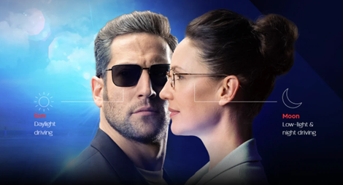

AR coatings also affect patient satisfaction through ease of maintenance. Patients who find their lenses constantly smudged or dirty are more likely to become frustrated and dissatisfied. A premium coating that stays clean longer and wipes easily not only saves time but also enhances the patient’s perception of lens quality. When a lens looks and feels pristine throughout the day, the patient feels they’ve made a wise investment.
The aesthetics of lens clarity extend into social and professional environments. In the workplace, for example, glasses that are free of glare and easy to maintain contribute to a polished, professional appearance. In social settings, individuals are more likely to receive compliments or feel confident taking photos without the distraction of lens reflections.
Ultimately, the value of AR coatings cannot be measured solely by optical performance. The emotional and psychological benefits—such as confidence, visual comfort, and reduced frustration—are just as critical to patient satisfaction. When patients feel good about how their glasses perform and how they look in them, they are more likely to be loyal to their optician, return for future purchases, and recommend the practice to others.

VIII Overcoming Cost Objections
One of the biggest barriers to premium AR coatings is cost. Patients often see coatings as an upsell rather than a necessity. Dispensing opticians must shift this perception through clear, personalized, and value-driven communication. Understanding how to explain the cost-to-benefit ratio is key to helping patients make informed decisions.

Strategies include:
- Explaining cost per day: A premium AR coating that lasts two years may only cost 15–20 cents per day. Framing the cost in terms of daily use—much like a cup of coffee or streaming subscription—can make the price more digestible. Patients often find value in a small daily investment that enhances their vision and quality of life.
- Demonstrating side-by-side comparisons: Use visual aids to show the difference in glare, cleanliness, and appearance between coated and uncoated lenses. Patients are far more likely to appreciate the value when they can see it with their own eyes. Some optical practices use coated/uncoated lens demo kits or simulation apps to make this point clear.
- Sharing personal anecdotes or patient testimonials: Real-world stories of how AR coatings improved someone’s work performance, driving comfort, or everyday convenience can be powerful. Testimonials build credibility and help patients relate to others who have faced similar concerns.
- Emphasizing reduced cleaning and replacement frequency: Premium coatings are easier to clean and stay clean longer. They also resist scratches, smudges, and environmental damage, which means fewer repairs and replacements. Highlight how this saves time and money over the lens lifespan.
- Positioning AR coatings as essential—not optional: Instead of presenting AR as an upgrade, integrate it into the core value of the prescription. Say, “We recommend this coating because it will protect your investment and ensure you see your best,” rather than “Would you like to add this option?” The language used during the recommendation can dramatically influence perception.
- Discussing visual comfort and eye health: Patients experiencing digital eye strain, night driving challenges, or frequent lens cleaning issues may be more willing to invest in a solution that alleviates these daily frustrations. Tie the coating to tangible health and lifestyle improvements.
- Providing multiple options: Present AR coatings as a tiered offering—basic, standard, and premium. Let patients choose but be prepared to explain what they gain at each level. This empowers the patient while still allowing you to guide them toward the best value.
- Bundling with other features: Position AR coatings as part of a bundled lens package that includes UV protection, blue light filtering, or photochromic features. Patients may find the bundled offer more attractive and cost-effective than purchasing options individually.
- Using satisfaction guarantees or warranties: Offering a no-questions-asked guarantee or warranty for peeling or damage can reduce patient hesitation. They’ll be more willing to invest if they know their purchase is protected.
Ultimately, overcoming cost objections requires a confident, informative, and empathetic approach. Patients don’t want to feel pressured. They want to feel like they’re making a wise, informed choice. When opticians frame AR coatings in terms of value, performance, and long-term benefit, they help patients make decisions that improve their lives while building lasting trust.

IX Tailoring Recommendations
Every patient is different. The best AR coating for a busy mother may not be ideal for a long-haul trucker or a software developer. Tailoring recommendations requires asking the right questions and actively listening to the patient’s daily visual experiences. The more specific the optician's recommendation, the more likely the patient is to feel seen, understood, and confident in their purchase.
Some key factors to consider include:
- Occupation: Patients working in offices or spending significant time in front of digital screens benefit from AR coatings with blue light filtering properties. Healthcare workers or first responders may need scratch-resistant and smudge-resistant coatings that can hold up through frequent cleaning and disinfection. Truck drivers or night shift workers benefit from coatings that reduce glare and improve clarity in low-light settings.
- Lifestyle: Individuals with active lifestyles or frequent exposure to the elements require coatings that resist moisture, dirt, and scratches. Hydrophobic and oleophobic coatings will serve hikers, athletes, and outdoor workers well. Parents of young children might value lenses that are easy to clean and maintain.
- Age and Visual Needs: As patients age, contrast sensitivity often decreases. Premium AR coatings can enhance contrast and reduce glare, making them especially beneficial for older adults. Those with cataracts or early signs of visual impairment may notice greater improvements with higher-quality coatings.
- Environment: Patients in dusty, humid, or high-altitude climates will appreciate coatings that resist static and are environmentally durable. Coastal residents benefit from salt-resistant options, while those in northern climates might prefer coatings that resist fog and handle temperature changes well.
- Budget: It’s important to respect financial boundaries while still educating patients about value. Offer a range of options—basic, mid-range, and premium—while clearly explaining what each level includes. For example, a mid-tier AR coating might offer good glare control but lack hydrophobic and oleophobic layers. Highlight the cost savings and performance benefits over time with each tier.
- Patient Expectations: Ask questions such as, “How often do you clean your glasses?” or “What bothers you most about your current lenses?” Their answers will reveal priorities. A patient who values ease of use and time savings will likely see the worth in a smudge-resistant, easy-clean AR coating.
Providing tailored recommendations isn’t just about matching features to lifestyle It’s also about language and delivery. Using clear, relatable examples can make technical features feel relevant. For instance, you might say, “This coating will help you avoid those annoying headlight glares when driving home at night,” instead of, “It reduces reflectance.”
Documenting these conversations also enhances continuity of care. When a patient returns, you can reference their previous preferences and reinforce the feeling of personalized service. Over time, this builds loyalty and encourages referrals.
Ultimately, customized recommendations help transform AR coatings from optional add-ons into essential, patient-specific solutions. When patients feel a product was selected just for them, they’re more likely to be satisfied, wear their lenses consistently, and return to your practice for future eyewear needs.

X The Future of AR Coatings
Emerging trends in AR coating technology are reshaping the future of vision care. As patient needs evolve and technology advances, the demand for coatings that do more than reduce glare continues to grow. Several exciting developments are already influencing the next generation of lens coatings, with many more on the horizon.
- Self-healing coatings: One of the most groundbreaking areas of development is the emergence of self-healing AR coatings. These materials are designed to respond to minor surface abrasions by restructuring themselves under the influence of light, heat, or mechanical pressure. While still in the early stages of commercial viability, these coatings have the potential to significantly reduce the need for frequent replacements due to scratches, which remains a common frustration among eyeglass wearers.
- Adaptive coatings: Research is underway to create coatings that dynamically adjust to environmental lighting conditions. These adaptive coatings could change their reflective properties depending on brightness, improving visual comfort throughout the day. Such technology would be particularly useful for individuals who move frequently between indoor and outdoor settings or who work under fluctuating lighting conditions.
- Sustainable materials: Environmental consciousness is beginning to play a bigger role in consumer optics. Some manufacturers are experimenting with biodegradable or recyclable materials in AR coatings. Others are focusing on reducing chemical waste and energy use during the manufacturing process. As sustainability becomes a selling point for many patients, eco-friendly AR coatings could soon become a competitive differentiator.
- Smart coatings: The integration of technology into everyday eyewear is no longer limited to smart glasses. Future AR coatings may incorporate features that support digital overlays, gesture control, or data collection. Coatings that can reduce interference from ambient light while enhancing the contrast of digital displays could dramatically improve the experience of using augmented reality or heads-up display technologies.
- Coatings tailored by AI and personalization: Artificial intelligence is also entering the space, with some labs working on algorithms that can recommend AR coatings based on a patient’s lifestyle, occupation, climate, and visual habits. Eventually, personalized coatings could be manufactured on-demand, tailored to match the individual’s exact needs, improving not only performance but also satisfaction and compliance.
- Blue light and circadian rhythm support: Future AR coatings may also be developed to help regulate circadian rhythms by modulating exposure to different wavelengths of light at various times of day. Such coatings could benefit patients who suffer from insomnia, shift workers, or frequent travelers. By helping manage exposure to stimulating blue light, coatings might play a role in sleep health and cognitive wellness.
- More aesthetic flexibility: As consumers become more style-conscious, coatings are likely to be offered in more customizable cosmetic hues. In the future, patients may be able to choose a reflective hue that complements their frames, skin tone, or fashion sense—without compromising optical performance. Innovations like color-shifting coatings that change subtly under different lighting conditions could appeal to younger and more tech-savvy demographics.
Staying informed about these trends is essential for optical professionals. Patients are increasingly inquisitive and often come armed with their own research. The ability to speak knowledgeably about upcoming innovations positions the optician as a forward-thinking expert, enhancing trust and credibility. Partnering with innovative labs, attending trade shows, and subscribing to industry publications are great ways to stay ahead.
As the line between medical device, fashion accessory, and digital interface continues to blur, AR coatings will play a pivotal role in how patients experience vision correction. The dispensing optician of tomorrow must be just as comfortable discussing nanotechnology and digital interfaces as they are discussing frame fit and bifocal heights.
The future of AR coatings is not just about clarity. It’s about creating a seamless, comfortable, and personalized visual experience. As coatings evolve, they will continue to impact not only how we see the world, but how we interact with it.

Conclusion
Understanding why one AR coating is better than another requires knowledge of optics, materials science, and human behavior. From manufacturing precision to user experience, every layer contributes to how a lens performs in the real world. Dispensing opticians equipped with this knowledge can better match patients with the right product, elevate their practice, and enhance visual outcomes.
Ultimately, the best AR coating is the one that meets the patient’s specific needs reliably and beautifully. By recommending superior options based on performance and lifestyle, opticians help patients see better and feel more confident - a value that extends far beyond the price tag.
As the optical industry continues to evolve, staying current with AR coating technologies will be essential for maintaining a competitive edge. With patients becoming more informed and health-conscious, opticians must be ready to answer technical questions, offer lifestyle-specific advice, and differentiate between marketing claims and actual performance. This level of professionalism strengthens patient trust and encourages long-term loyalty.
Dispensing AR coatings should not be treated as an afterthought or an optional upgrade, but rather as a critical part of delivering exceptional visual care. When opticians confidently explain the tangible and intangible benefits. Whether it's reduced glare during a late-night drive, smudge-free clarity during a busy workday, or enhanced appearance in a photo, they connect with patients in meaningful ways.
Additionally, understanding and recommending AR coatings is not only good for patients but also good for business. Practices that consistently deliver high-quality visual solutions and personalized care enjoy better patient satisfaction, more referrals, and higher rates of repeat business. A well-informed optician becomes not just a dispenser of glasses, but a trusted advisor in their patient’s daily quality of life.
In the end, mastering AR coatings empowers opticians to deliver on the promise of modern optics: clearer, more comfortable, and more stylish vision for everyone.
Good luck on the Final Assessment.

Final Assessment

- What is the primary function of anti-reflective (AR) coatings?
A. Increase the refractive index of lenses
B. Reduce surface reflections to improve clarity
C. Tint lenses for sun protection
D. Harden the lens material
- Destructive interference is used in AR coatings to:
A. Increase lens color
B. Cancel specific wavelengths of reflected light
C. Absorb UV rays
D. Bond coatings chemically to lenses
- A key benefit of modern AR coatings is:
A. Complete UV elimination
B. Visual distortion enhancement
C. Improved night vision and reduced glare
D. Elimination of the need for lens cleaning
- Which material is commonly used in the outermost layers of AR coatings for light transmission?
A. Magnesium Fluoride (MgF₂)
B. Iron Oxide
C. Polycarbonate
D. Borosilicate Glass
- Which method of AR coating application offers the densest and most durable layers?
  - Spray Coating
B. Electron Beam Evaporation
C. Magnetron Sputtering
D. Heat Compression

- Ion-assisted deposition differs from other methods because it:
  - Produces thicker lens materials
  - Uses mechanical pressure to apply coatings
  - Enhances adhesion and durability with ion beams
  - Eliminates the need for vacuum chambers
- One reason premium AR coatings last longer is because:
A. They are thicker
B. They are applied by hand
C. They use higher-quality base lens materials
D. They incorporate additional functional layers
- A hydrophobic layer on a lens helps by:
A. Improving optical magnification
B. Repelling water droplets
C. Adding UV protection
D. Enhancing prescription accuracy
- The Bayer Abrasion Test is used to measure:
A. Color contrast in AR coatings
B. Anti-static efficiency
C. Scratch resistance of a coating
D. Thickness of lenses
- Smudge resistance is enhanced by which coating layer?
A. Hard coat
B. UV blocker
C. Oleophobic layer
D. Blue light filter
- Patients who drive at night benefit most from AR coatings because:
  - Coatings reduce chromatic aberration
B. Lenses become polarized
C. Coatings reduce glare and halo effects
D. Lenses glow in the dark

- A high contact angle in water droplet tests indicates:
A. Poor hydrophobicity
B. Better water repellency
C. Excessive coating thickness
D. Strong UV absorption
- One characteristic of basic AR coatings is:
A. Highly durable multilayers
B. Strong anti-static properties
C. Limited smudge and scratch resistance
D. Customizable cosmetic hue
- Which coating brand is known for strong water-repellent and anti-static properties?
A. Crizal
B. Super HiVision EX3
C. DuraVision BlueProtect
D. ClarityAR
- A key difference in appearance between AR coatings is:
A. Coating density
B. Reflective hue color
C. Prescription strength
D. Lens curvature
- Blue light filtering AR coatings are especially recommended for:
A. Athletes
B. Nighttime-only lens wearers
C. Digital screen users
D. Children under age 5
- Premium AR coatings typically include which feature?
A. Pre-tinted lenses
B. Built-in prism correction
C. UV protection on front and back surfaces
D. Microchip-based adjustment
- Which group benefits most from anti-static coating properties?
A. Patients who live near oceans
B. Electronics users or those in dusty environments
C. Teenagers in sports
D. Seniors with cataracts
- When recommending coatings, it's helpful to:
A. Use technical jargon to show expertise
B. Offer a single universal coating for everyone
C. Relate benefits to the patient’s lifestyle
D. Avoid demonstrations or visuals
- Which of the following most influences patient trust in premium AR coatings?
A. Celebrity endorsements
B. Brand familiarity and optician confidence
C. Color variety
D. Frame material
- Which factor may lead to early peeling in budget coatings?
A. Over-application of coating
B. Use of ion-assisted deposition
C. Lack of oleophobic layer
D. Frequent UV exposure
- One way to help patients accept higher AR coating prices is to:
A. Downplay the cost
B. Emphasize daily value and long-term benefits
C. Offer only one price point
D. Skip discussing features
- Environmental durability of a coating refers to its:
A. Resistance to high prescriptions
B. Compatibility with tinting
C. Performance in varying climates and conditions
D. Cost-efficiency over time
- Future AR coatings may include:
A. Lens curvature enhancers
B. Personalized AI-generated designs
C. Magnetic lens clips
D. Static gradient control
- A self-healing AR coating would primarily help reduce:
A. UV reflection
B. Color distortion
C. Visible scratches and surface wear
D. Prescription changes

