 SPARTAN SCROLL 
February 2026

SCHOOL BOARD NEWS

Please go to scobeyschools.com and click on the Board tab to view all Board Reports.
February 2026 Breakfast/Lunch Menu
February 2 - 5
Mon: Breakfast- Oatmeal, yogurt, and fruit
Lunch- Tater tot hotdish, cheesy breadsticks, corn, and fruit
Tues: Breakfast – Breakfast sandwich on a pancake and fruit
Lunch – Grilled chicken sandwich, potato wedges, baked beans, and fruit
Wed: Breakfast- Maple bars, yogurt, cheese, and fruit
Lunch- Homemade soup day! Sausage tortellini soup, garlic bread, carrots, and fruit
Thurs: Breakfast – Waffles/Waffle sticks, sausage, and fruit
Lunch – Fish sticks, mac n’cheese, broccoli, and fruit

February 9 - 12
Mon: Breakfast- Cinnamon rolls, yogurt, and fruit
Lunch- Pizza pie day! Pepperoni pizza, caesar salad, and fruit
Tues: Breakfast – Breakfast burritos and fruit
Lunch – Chicken chili, cinnamon rolls, corn, and fruit
Wed: Breakfast- Granola bars, cereal, cheese sticks, and fruit
Lunch- mini corn dogs, pretzels, green beans, and fruit
Thurs: Breakfast – Mini pancakes, sausage, and fruit
Lunch – Pitas ham or turkey, chips, carrots, and fruit

February 16 - 19
Mon: Breakfast- Pancakes/sausage wrap on a stick, and fruit
Lunch- Hot hamburger, mash potatoes, gravy, carrots, and fruit
Tues: Breakfast – Blueberry bake and fruit
Lunch – Chicken fajitas, chips, salsa, refried beans, and fruit
Wed: Breakfast- Bagels, hard boiled eggs, and fruit
Lunch- Riblet sandwiches, fries, green peas, and fruit
Thurs: Breakfast – French toast sticks, sausage. And fruit
Lunch – Ham or turkey sub sandwiches, chips, broccoli, and fruit

February 23 - 26
Mon: Breakfast- Banana bread day! Scrambled eggs and fruit
Lunch- Ravioli, garlic bread, broccoli, and fruit
Tues: Breakfast – Croissant ham breakfast sandwiches and fruit
Lunch – Tortilla chip day! Chicken nachos, rice, black beans, and fruit
Wed: Breakfast- Cereal, yogurt, pop tarts, and fruit
Lunch- BBQ pulled pork sandwiches, chips, carrots, and fruit
Thurs: Breakfast – Surprise Day!
Lunch – Pizza sticks, salad, and fruit

COUNSELING CENTER NEWS
By R Rask

Here are the scholarships that are due in February. This is the last slow month! Scholarships start to really come due in March! I will be emailing your seniors as I get scholarships through email so that they can have a digital copy! As always please reach out if you have any questions or concerns!

ELKS Scholarship-Legacy Award Due 02/02/26
Foundation for Rural Service Due 02/14/26
Society of Automotive Engineers Due 02/28/26

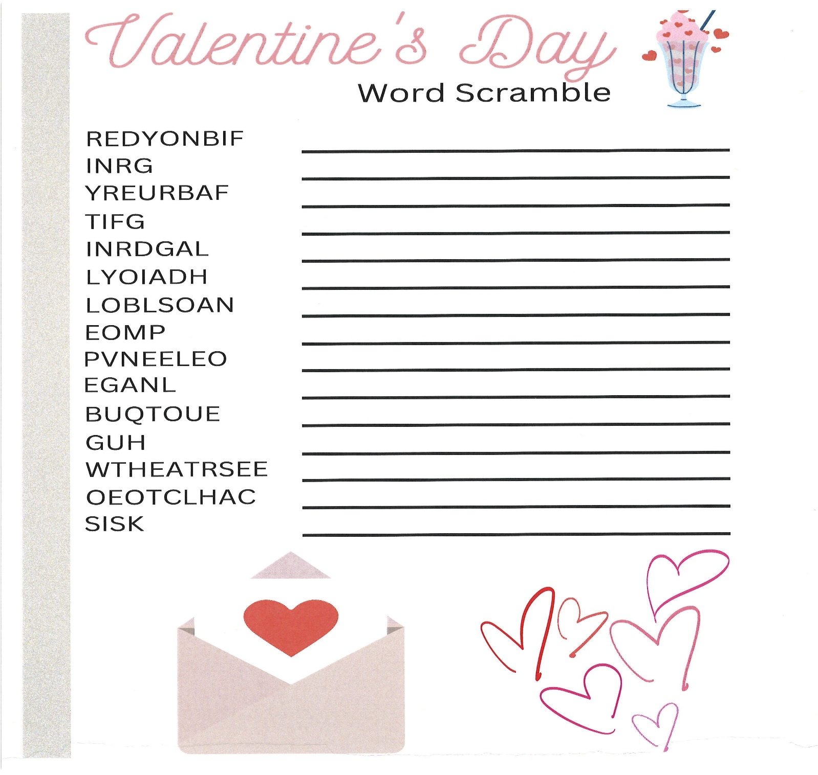

 | February 2026
Sun | Mon | Tue | Wed | Thu | Fri | Sat
1 | 2  C BBGB WOLF POINT  6:00/7:30 | 3 | 4 | 5  C BB at Nashua 5:30/7:00 | 6 | 7  Elem BB in Scobey  JV/V BB LUSTRE  2:30/4:00/5:30/7:00
8 | 9  FFA: District Leadership Development Events in Sidney  C/JV GB/BB at Poplar  4:00/5:30/7:00/8:00 | 10 | 11  SPELLING BEE 2:00  Big Gym | 12  Jet Setters  Sweetheart Dance in Commons 6:30-8:00 | 13  JVG/V BB North Country at Hinsdale 3:00/4:30/6:00 | 14  Valentine’s Day  JV/V BB CIRCLE  2:30/4:00/5:30/7:00
15 | 16 | 17 | 18  District 3C BBB/GBB Tourney  At Glasgow | 19 | 20 | 21
22 | 23  FFA: District Floral and Sales in Lambert | 24 | 25 | 26 | 27 | 28

