VETTECATION

SUBMARINE
TOUR

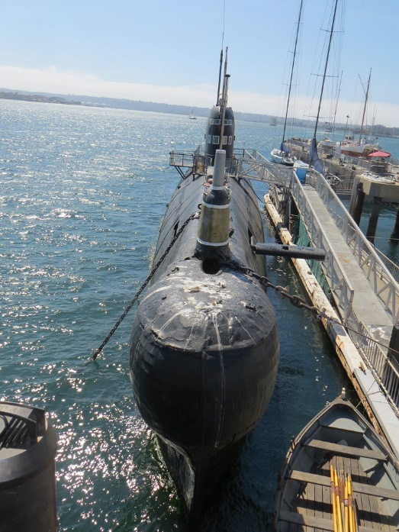
San Diego, CA
Hosted by Larry & Tim Martin
Tuesday, Mar 28, 2023
Tour @ 3:00pm

HOTEL GROUP RESERVATION: Holiday Inn Express
GROUP RESERVATIONS DEADLINE: Mar 10th
GROUP BOOKING NAME: Color Country
GROUP ID: EG4

[NOTE: There are 10 rooms held in the group reservation. 5 King bedrooms and 5 Double Queen. Cost is $205 +tax per night with a $20 per night parking fee.]

Larry Martin & his brother Tim along with Doug Rosa deserve special thanks for coordinating this ‘Vettecation. Tim Martin served as Engineer Officer on USS PERMIT and was kind enough to submit the request for our group tour. It takes a lot of references, clout and checks to make a tour like this happen. So, thank you Martin brothers! And Doug deserves a special thanks for setting up a group rate at the Holiday Inn Express in San Diego for us. This run is a once in a lifetime experience. Let’s go!

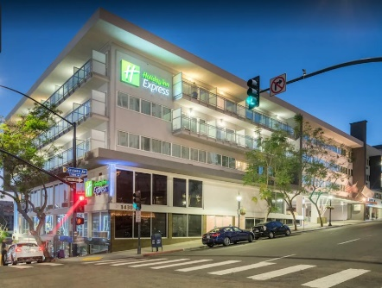
Meet: Monday, Mar 27th @ 8:15am @ BIG SHOTS GOLF located @ 1108 W Black Mountain Dr, St. George, UT 84790 (East side of Sun River exit 2).

Departure: 8:30am
We will leave via I-15 stopping at Mile 66 just north of Las Vegas then take the bypass around Vegas rather straight thru on I15, stop in Baker and Victorville and then on to San Diego.
Sign-Up
Form
Destination: Holiday Inn Express @ 1430 7th Ave, San Diego, CA 92101

