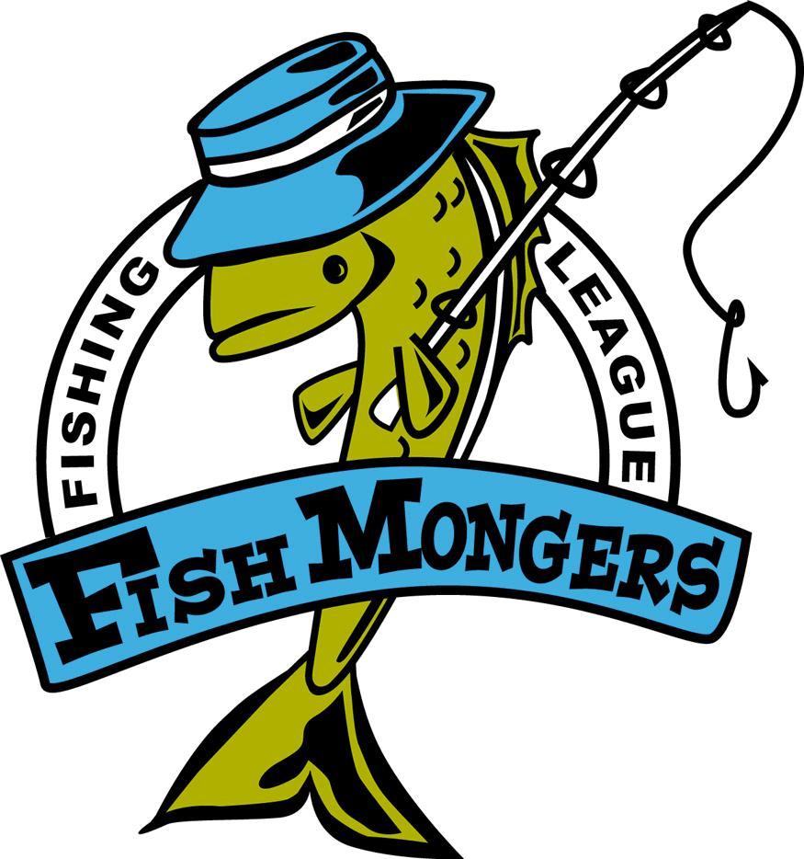
Final 9/7/2006 Gull
Team | Skunk | Walleye  20.25 Matt | Northern  35.5 Rud Sylvan | Black Bass  18.25 Brad? | Rock Bass  10.5 Kurt | Weekly Points | Total Points
Robertson/ Sundquist |  | 15.25 | 23 | 16.75 14.5 |  | 10 | 46
Johnson/ Lueck |  | 15 15 |  | 14 | 11 | 7 | 35
Bryan Raguse/ Andy Kratochvil |  | 15.25 14.5 |  | 15.75 13.125 |  | 8 | 32
Peterson/  Rud |  |  |  | 14 14 |  | 4 | 28
Anderholm/  Nelson |  |  | 24 | 14 |  | 4 | 20
Todd Greatens/  Scott Stahl | NS |  |  |  |  | 0 | 16
Weinkauf/ Nelson |  |  |  |  |  | 4 | 14
Qualey/  Jacobsen |  |  |  |  |  | 2 | 10
Ford/ |  |  |  |  |  | 0 | 2
Big fish were Wally Matt 20.25
Northern Rud 35.5
Bass Qualey 18.25
Rocky Shane 11

See you next year – let’s hope for a rainy summer so we get to fish more – this drought sucked.

