Mars UP Church

Apostles’ Creed
I believe in God the Father Almighty, Maker of heaven and earth; and in Jesus Christ His only Son our Lord; who was conceived by the Holy Ghost, born of the Virgin Mary, suffered under Pontius Pilate, was crucified, dead and buried; He descended into hell; the third day He rose again from the dead; He ascended into heaven, and sitteth on the right hand of God the Father Almighty; from thence He shall come to judge the quick and the dead. I believe in the Holy Ghost, the holy catholic church; the communion of saints; the forgiveness of sins; the resurrection of the body; and the life everlasting. Amen.

Gloria Patri
Glory be to the Father, and to the Son, and to the Holy Ghost. As it was in the beginning, is now and ever shall be,
world without end.
Amen. Amen.

Come Holy Spirit, Come
Before the Service – Speak to God!
During the Service – Let God speak to you!
After the Service – Speak to each other!

(*Please stand, if able)
Welcome and Mars Messages

Prelude

*The Call to Worship
Leader: Sing praise to our Easter God
People: Who changed sadness into joy;
Leader: Who took the tears of night
People: And dried them in the morning light;
Leader: Who rolled away the stone of despair
People: And placed hope forever in the air;
Leader: Who visits us beside our seashore
People: Teaching us always to love and adore.

*Hymn 370
“Rejoice, the Lord is King”

Call to Confession

Prayer of Confession
We use a lot of words, Gracious God, but do little to turn them into deeds. Instead of being of one heart and soul, we choose sides and form groups of folks just like us. Blessed with great grace, we have trouble sharing it with those who need it the most. Forgive us, God of love. Forgive us, as we step out of our shadows into your light. Restore us, as we reveal our brokenness. Hear us, as we proclaim Jesus Christ as our Lord and our God.
Silent Prayers
Assurance of Pardon
L: This is the good news we have declare: God leads us out of the shadows to walk in the light of Christ.
P: This is the word we have heard: our faithful God forgives our sins and raises us to new life. Thanks be to God. Amen.
Gloria Patri

Children’s Chat

Scripture Acts 2:42-47
1 Peter 2:19-25
The
Lord’s Prayer

Our Father,
who art in heaven,

hallowed be Thy
name,

Thy kingdom come,
Thy will be done,
on earth
as it is in heaven.

Give us this day
our daily bread;

and forgive us
our debts,
as we forgive
our debtors;

and lead us not
into temptation,
but deliver us
from evil.

For Thine
is the kingdom,
and the power,
and the glory,
forever. Amen.

The Doxology

Praise God
from whom
all blessings flow;
praise Him
all creatures
here below;
praise Him above,
ye heavenly host;
praise Father, Son,
and Holy Ghost.
Amen.

Special Music Elizabeth Hixon
“Thank God I Do”
Morning Message Rev. Brian Hauser

*Hymn 571
“Trust and Obey”

Prayer of Dedication

Prayers of the People and Lord’s Prayer

*Hymn 572
“Blessed Assurance”

*Benediction

*Postlude
Church Staff
Rev. Brian Hauser
Pastor
pastor@mars-up.org
724-689-3412

Mrs. Shelly Bocheff
Administrative Assistant
marsup@mars-up.org

AV TEAM
Alma Staskiewicz, Lisa Barbour, Marie Matthews, Bill Guesman, John Ivory, Mike Bocheff, Herb Wellman

Mars United Presbyterian Church

232 Crowe Ave
PO Box 805
Mars, Pennsylvania 16046
724-625-1365
www.mars-up.org
marsup@mars-up.org

Church Office Hours:
Mon -Thurs from 9 a.m. -2:30 p.m.

MUP Session

Class of 2025 Class of 2024 Class of 2023
John Ivory Alma Staskiewicz Lisa Barbour
Susan Cox Louise Fox Mary Ann Croop
Jay Wilson Marie Matthews Don Lewis
Herb Wellman

Clerk of Session: Herb Wellman
Morning Worship:
10:00 am

5th Sunday of Easter

Prayer of Preparation
Lord, we come to you today with so many things on our hearts.

You call us to be in relationship of trust and love with you and you offer healing to us for those portions of our lives that are broken and injured.

Help us to be open to your mercy and healing love. For we ask this in Jesus’ Name.
AMEN.

MUP Deacons

Class of 2025 Class of 2024 Class of 2023
Jill Cooper Steve Martin Sharon Gibb
Robyn Beckwith Marge Nicklas Carol Kopar
Missy Wells Pat Auld Alice Leonberg

Moderator: Steve Martin

MUP Music Committee
Keith Nichols – Chair
Sally Olsen – Clerk
Alma Staskiewicz
John Ivory
Linda Lees
Karl Kennedy

Mars United Presbyterian Church
Welcome!

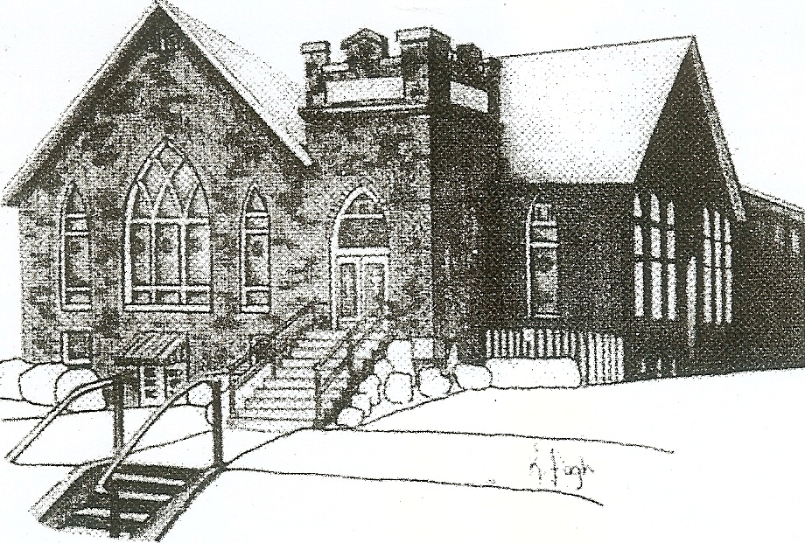
We are your hometown church: Faithful to Tradition, Loving in Fellowship, & Reaching for Tomorrow!

May 7, 2023

We welcome you and we are glad you’ve chosen to Worship with us today!

CALENDAR: May 7th – May 14th

Church Office Hours: Monday -Thursday from 9 a.m. – 2:30 p.m.

Today, May 7th, 2023
VOLUNTEERS☺

LAST SUNDAY’S In-House ATTENDANCE: 57

LAST SUNDAY’S OFFERING:
Operating Funds: $4585.00
Kindness: $85.00
Total: $4670.00

Tarry N Talk Hosts
Stewardship Committee

9:00 am Sunday School Hour
10:00 a.m. THE MORNING WORSHIP SERVICE
11:15 am Deacon Meeting
Monday, May 8, 2023
Tuesday, May 9, 2023
9:00 am A team
7:00 pm AA
7:00 pm Stewardship Committee Meeting
Wednesday, May 10, 2023
9:00 am Material Girls
5:30 pm MSPS Art Show
Thursday, May 11, 2023
5:30 pm MSPS Art Show
Friday, May 12, 2023
Saturday, May 13, 2023
Sunday, May 14, 2023 Mothers Day
9:00 am Sunday School Hour
10:00 am THE MORNING WORSHIP SERVICE
Welcome to all who are Worshiping with us today!

Guests
We sincerely hope our service is a blessing to you. We ask that our guests please take a few minutes to complete one of the Connect Cards found in the pew holder.

Should you have questions regarding any aspect of our church, including membership, please contact Pastor Brian or the church office during the week at 724-625-1365. Thank you for being with us today.

PRAYER – JOYS & CONCERNS
Lou Beckwith Paige Lauten
Paige Barbour (daughter of Andrew and Steph Barbour) Sandy Wahl
Reid Christopher Hall (June Stirling’s nephew) Sue Morris
Lindy McCartney (Lisa Barbour’s Sister)

ANNOUNCEMENTS
Bulletins are printed Thursday mornings; let us know if you have an announcement…

CALLING ALL GRADUATES If you or someone in our church that you know is graduating from high school, college or another post-high school program, please let us know in the church office. We would like to celebrate these graduates. More details to follow.
SAVE THE DATE- New To You Sale – June 3rd We will be accepting donations after April 29th. More info to follow
Items not accepted: Televisions, Couches, Mattresses, Large Appliances, Computers, Clothing, Exercise Equipment and please no Junk!!
SAVE THE DATE – Vacation Bible School- July 9th thru July 13th
SAVE THE DATE Mars UP church annual picnic will be held Sunday, September 10th at Adams Township Park. More Details to Follow

MUP NEWSLETTER Hard copies of the May Newsletter are available in the Tarry N Talk. If you would like added to the email listing, please contact the office.

THANK YOU On April 30TH we held a Spaghetti Dinner Fundraiser for the Adams Township Jim Ellis Fund. We wish to express our thank you to all the people responsible for making this fund raiser so successful. A special thank you goes out to the local businesses for their financial support—Strutz International, Golden Equipment and Pfeifer Hardware.

