4/21/2018 The Warning to All Peoples

Our Creator Elohim said that He placed the lights in the heavens for signs (distinguishing marks, warnings), and seasons (the calculation of appointed times), and to give light on the earth.

Genesis 1:14 And Elohim said, Let there be lights in the firmament of the heaven to divide the day from the night; and let them be for signs, and for seasons, and for days, and years:
15 And let them be for lights in the firmament of the heaven to give light upon the earth: and it was so.

Our Heavenly Father also said that His people were not to be frightened by the signs that He would place in the heavens. That doesn't mean that His signs that He has placed in the heavens aren't valid, it means that He will protect His people from harm when the event that the signs gave warning of comes to pass.

Jeremiah 10:1 Hear ye the word which YaHuWaH speaketh unto you, O house of Israel:
2 Thus saith YaHuWaH , Learn not the way of the heathen, and be not dismayed at the signs of heaven; for the heathen are dismayed at them.

The Orion Sign

The Babylonian Talmud contains a warning in Tractate Berachoth 58B as follows : "Samuel also said: I am as familiar with the paths of heaven as with the streets of Nehardea, with the exception of the comet, about which I am ignorant. There is a tradition that it never passes through the constellation of Orion, for if it did, the world would be destroyed."

The above is a Jewish tradition, for some reason. But why? Why would someone, specifically a Hebrew, mention that a comet passing through the constellation Orion would be a sign of the coming destruction of the world? Did someone hear from heaven? Did and angel speak to them, or give them the thought?

For some reason the information concerning a comet passing through Orion was considered important enough to have it passed down from generation to generation.

The article of 3/26/2018 mentioned comet Hale-Bopp that passed through the constellation Perseus (symbolic of Messiah) and completed the placing of an "X" on the severed head of the evil spirit on 4/10-11/1997. Comet Hyakutake had begun the marking procedure a year to the day earlier on 4/11/1996.
Both comets, Hyakutake and Hale-Bopp, were unusually bright and easily visible to the human eye. It's relatively rare that comets are visible without the aid of binoculars or a powerful telescope.

The graphic below notes the "X", the Hebrew Tav symbolically placed on the severed head of the evil spirit by the two bright comets exactly one year apart on 4/11/1996 and 4/10-11/1997.

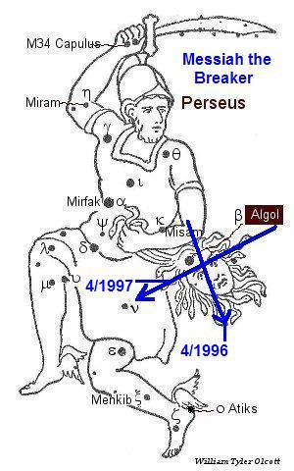

The Orion Sign was Completed in 1997

We might consider the constellation Perseus to be symbolic of David carrying the severed head of Goliath. The ancient Paleo Hebrew "Tav" placed on the evil spirit's forehead by the two comets crossing Perseus in 1996 and 1997 symbolically marked the place where David's slingstone had sunk into Goliath's forehead.

After completing the "X" on the evil spirit's forehead, comet Hale-Bopp continued across the heavens to pass through the constellation Orion on the 30th anniversary of the Israeli Six Days War, 6/5/1997 to 6/11/1997 as indicated in the graphics below.
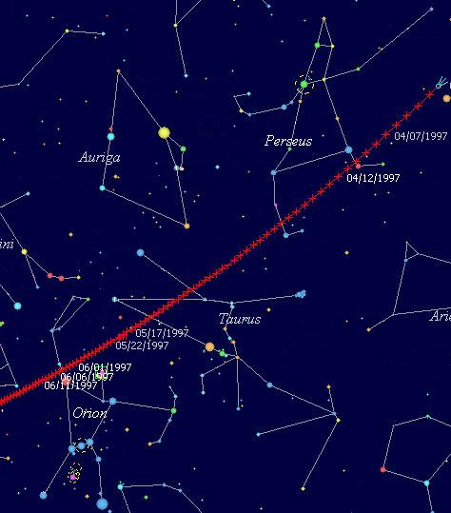

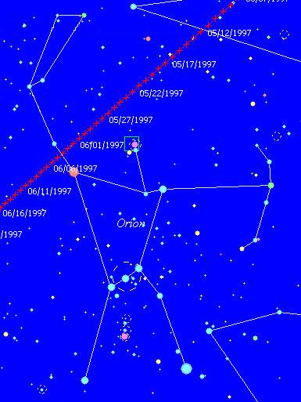

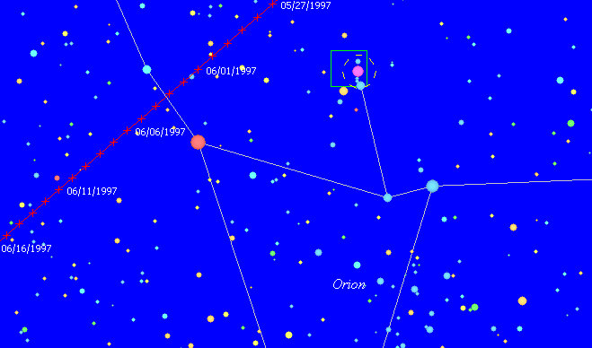

Above: The path of comet Hale-Bopp passing through the constellation Orion on the 30th anniversary of the Israeli Six Days War in 1997.

The 30 Year Age Requirement

We note that a Hebrew Priest would enter his ministry at about the age of 30 years.

Luke 3:21 Now when all the people were baptized, it came to pass, that YaHuShua also being baptized, and praying, the heaven was opened,
22 And the Holy Ghost descended in a bodily shape like a dove upon him, and a voice came from heaven, which said, Thou art My beloved Son; in thee I am well pleased.
23 And YaHuShua himself began to be about thirty years of age, being (as was supposed) the son of Joseph, which was the son of Heli,

It is noted that the years 1996 and 1997 would have been just about exactly 2,000 years from the conceptions and births of John the Baptizer and YaHuShua the Messiah.

John's birth would have been about 6 months before the birth of YaHuShua according to the gospel account. That means a 3rd, 1,000 year "day" from their births would have begun around 1996 -1997.

John would have entered his baptismal ministry first at the age of about 30 years in order to prepare the way for YaHuShua's arrival and ministry at about the age of 30 years, 6 months later.
The passing of the two comets through Perseus in 1996 - 1997 form a sign that the son of David is arriving on the scene as a Shepherd to annihilate the modern day Nephilim.

The comet of 1997 then went on from "symbolically smacking Goliath on his head" to pass through Orion on the 30th anniversary of the Six Days War.

These are warnings to all the peoples of the earth that Israel is coming of age, and that the world will be destroyed.

Summary

These signs from our heavenly Father are precise and accurate, and they speak the truth.

We need not fear, as our Father, YaHuWaH Elohim, has given instruction to His children that we need not fear any of the signs in the heavens.

Scriptures confirm that the world will indeed be innundated with fire and destroyed at some point, but we need not worry if we shelter under His wings. The example was set in a fiery furnace in ancient Babylon over 2,500 years ago. We can indeed walk the nuclear fireball alive if our Father wills.

Those who reject Him should have cause to be concerned, but the entire message above is probably of no concern for the unbeliever, just like it was in the days of Noah.

