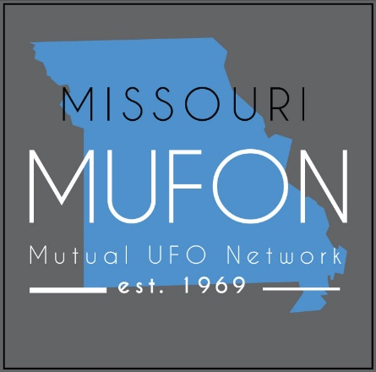

Missouri MUFON (Mutual UFO Network)
PO Box 1166
Independence, MO 64051
www.missourimufon.org
816-365-9492
Debbie Ziegelmeyer, State Director Margie Kay, Assistant State Director

PRESS RELEASE
Missouri MUFON to be represented at two festivals this weekend.

State Director Debbie Ziegelmeyer and Assistant State Director Margie Kay will speak at the Buck Nelson Festival on Sunday, April 7 staring at 1:30 pm at the Mountain View Family Youth Center, 306 Bay Street, Mountain View. Margie Kay will present the Buck Nelson, UFO Traveler from Mountain View, Missouri., and Debbie Ziegelmeyer will present “The SE Missouri UFO Flaps.”
Debbie, Margie, and Chief Investigator, Mel Van Vickle will speak at the Piedmont UFO Festival on April 6 at the Wayne County Community Building (AARP) from 12:00 pm. to 4:00 pm. Margie Kay’s presentation is “Buck Nelson, UFO Traveler from Mountain View, Missouri.” Debbie Ziegelmeyer’s presentation is “Visitors or Colonists, in our Oceans and Seas.” Mel’s talk is “The St. Clair Lights: A Tribute to Harley D. Rutledge, Ph.D. and Project Identification.” After the talks, the team will introduce MUFON and give information about how to file a UFO report with MUFON.
The three will be on hand to answer questions and take reports. Margie and Debbie will have their books “The Alien Colonization of Earth’s Waterways,” The 50th Anniversary of the SE MO Ozarks UFO Flaps,” and more available for sale. Margie is also working on a documentary film and is looking for people to interview.
For more information visit “Buck Nelson Festival/Eclipse 2024” Facebook page and www.piedmontmo.com/piedmontufofest.

Contact:
Margie Kay 816-365-9492 (call or text)

