***Pleasant Township Board of Trustees Meeting***

**Date _September 10, 2024______________ Next Resolution No._ 66--9-10-2024_ _**

* **Call to Order -- The meeting tonight will also be on WebEx.**
* **Please stand for a moment of silence. --Pledge of Allegiance--Roll Call**
* **Visitors –**
* ***Hanna Poling*** with the Southwest Messenger via WebEx.
* **Minutes to approve**- No minutes
* **Financial Reports** –
  + Resolution 66 to approve a Then & Now for Phoenix Safety Outfitters for $67,200 for gear from Grant funding.
  + Resolution 67 to approve a Then & Now for Bio-Care for $20,080 for physicals from Grant funding.
  + Motion to pay expenditures.
* **Franklin County Sheriff’s Dept-Community Liaison, Deputy Adkins, 1120- Cell: 614-809-5843**

none

* **Road Department****- Robert**
* Equipment maint.
* Ditch mowing.
* Training NPDES. 9/18
* Safety Training. 9/19
* Pouring headstone footer
  + Reminder of Fall clean update Friday, October 4th, 7:30 am to 5:00 pm and Saturday, October 5th, 7:30 am to 4:00 pm.
  + Wednesday, 9/4/24 at 9:32 pm, Nancy received the following email from Mr. Owen in reference to a list of complaints he gave us a few weeks ago from Oakhurst:

“One bush was trimmed do you understand the difference between single and plural? I have a great friend who works at channel 6! Have you ever seen 6 on your side?” ***–Robert is working on the complaint list as time permits.***

* *Any updates on Gay Rd. about repairs due to heavy rains washing the roadway and gravel away. (meeting on 8-8-23 we said we’d keep it on the agenda till resolved in some way.)*
* **Fire Dept. – Lt. Johnson in for Chief Whiting**
* Apparatus
* M-231 at Brawn.
* Personnel
* Extending Kamryn Carrol's probationary period until completion of paramedic school.
* Part-time additions
* Resolution _68_ to hire Javan Svarda as parttime firefighter/EMT.
* Equipment
* Fire Gear has come in and distributed.
* Training
* Training fire scheduled for Saturday, September 14
* Station
* Station washing Machine broke and is being replaced. Capital City came out to repair it, the repair would cost almost as much as a new one so the just purchased a new one and Capital City did not charge for the service call. Thank you to Capital City for that.
* **New Business –**
  + Ed gave a report from a meeting he attended at SWACO about the trash hauling contract. The current contract with Local Waste ends December 31, 2025. They are working on new contracts to be ready by June 2025 to go out to bid. It will be a 5 year contract. All trash haulers are having trouble getting and keeping employees.
* 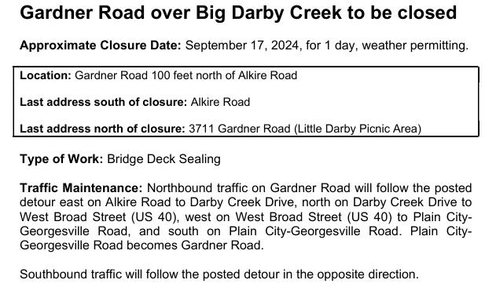**Announcements-**
* **Clerk Updates- Paula**
* Miscellaneous correspondence
* Need a RESOLUTION_69_ ACCEPTING THE AMOUNTS AND RATES AS DETERMINED BY THE BUDGET COMMISSION AND AUTHORIZING THE NECESSARY TAX LEVIES AND CERTIFYING THEM TO THE COUNTY AUDITOR
* Resolution _70_ to accept the OTARMA renewal.
* **Speaker Sheets-** (come to the podium to be heard on WebEx)
* **Adjourn**