Mars UP Church

Apostles’ Creed
I believe in God the Father Almighty, Maker of heaven and earth; and in Jesus Christ His only Son our Lord; who was conceived by the Holy Ghost, born of the Virgin Mary, suffered under Pontius Pilate, was crucified, dead and buried; He descended into hell; the third day He rose again from the dead; He ascended into heaven, and sitteth on the right hand of God the Father Almighty; from thence He shall come to judge the quick and the dead. I believe in the Holy Ghost, the holy catholic church; the communion of saints; the forgiveness of sins; the resurrection of the body; and the life everlasting. Amen.

Gloria Patri
Glory be to the Father, and to the Son, and to the Holy Ghost. As it was in the beginning, is now and ever shall be,
world without end.
Amen. Amen.

Come Holy Spirit, Come
Before the Service – Speak to God!
During the Service – Let God speak to you!
After the Service – Speak to each other!

(*Please stand, if able)
Welcome and Mars Messages

Prelude
“Thank God I do”

Call to Worship
Leader: Our help is in the name of the Lord our God,
People: The Maker of heaven and earth,

Leader: Who comes to our aid in times of need,

People: Who gives us the courage to do what we know is
right,

Leader: Who invites us to turn away from the influences of
the world around us and confess Him alone as
Savior and Lord.

People: This is our God! Let’s worship together.

Opening Prayer

*Song
“Goodness of God”

Scripture Exodus 1:8-2:10

Children’s Chat
The
Lord’s Prayer

Our Father,
who art in heaven,

hallowed be Thy
name,

Thy kingdom come,
Thy will be done,
on earth
as it is in heaven.

Give us this day
our daily bread;

and forgive us
our debts,
as we forgive
our debtors;

and lead us not
into temptation,
but deliver us
from evil.

For Thine
is the kingdom,
and the power,
and the glory,
forever. Amen.

The Doxology

Praise God
from whom
all blessings flow;
praise Him
all creatures
here below;
praise Him above,
ye heavenly host;
praise Father, Son,
and Holy Ghost.
Amen.

Morning Message Rev. Brian Hauser
“Do God’s Job First”

*Hymn 678
“We Are an Offering”

Prayers of the People and Lord’s Prayer

Affirmation of Faith Apostles Creed

*Hymn 571
“Trust and Obey”

*Benediction

*Postlude

Flowers today are presented to the Glory of God and in honor of our daughters, Abigail and Adison on their birthdays by Mom and Dad

The rosebud on the altar is in celebration of the birth of Audrey Jane Walters. She was born on August 22, 2023 to Matt and Lindsay (Barbour) Walters. Proud Grandparents are Jack and Lisa Barbour.

Church Staff
Rev. Brian Hauser
Pastor
pastor@mars-up.org
724-689-3412

Mrs. Shelly Bocheff
Administrative Assistant
marsup@mars-up.org

AV TEAM
Alma Staskiewicz, Lisa Barbour, Marie Matthews, Bill Guesman, John Ivory, Mike Bocheff, Herb Wellman

Mars United Presbyterian Church

232 Crowe Ave
PO Box 805
Mars, Pennsylvania 16046
724-625-1365
www.mars-up.org
marsup@mars-up.org

Church Office Hours:
Mon -Thurs from 9 a.m. -2:30 p.m.

On Saturday, September 23rd at 7:00 pm. The Cranberry Men’s Chorus will present a concert of accapella music from the 1950’s – 80’s at the North Catholic High School on Route 228. They will also be joined by the Fabulous Gemtones band. If you’d like to attend, you can get tickets from Paul Aiello. His email address is chapaiello@aol.com. Tickets are $20 for adults and $15 for students age 18 and under. Its going to be a wonderful evening of oldies music that you’ll definitely recognize.

Morning Worship:
10:00 am

14th Sunday after Pentecost

Prayer of Preparation
Lord, we come to you today with so many things on our hearts.

You call us to be in relationship of trust and love with you and you offer healing to us for those portions of our lives that are broken and injured.

Help us to be open to your mercy and healing love. For we ask this in Jesus’ Name.
AMEN.

Mars United Presbyterian Church
Welcome!

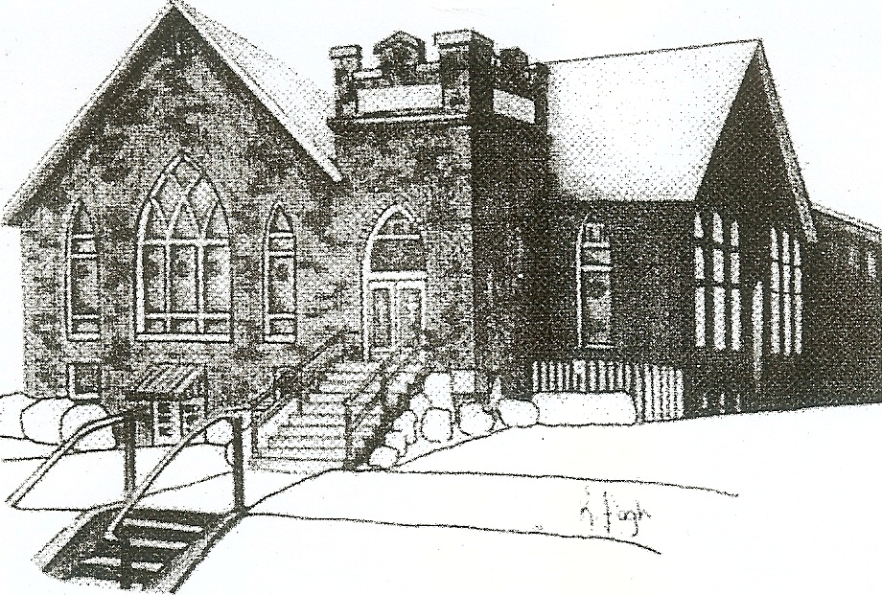
We are your hometown church: Faithful to Tradition, Loving in Fellowship, & Reaching for Tomorrow!

September 3, 2023

We welcome you and we are glad you’ve chosen to Worship with us today!

CALENDAR: September 3rd – September 10th

Church Office Hours: Monday -Thursday from 9 a.m. – 2:30 p.m.

Today, September 3, 2023 Communion
VOLUNTEERS☺

LAST SUNDAY’S In-House ATTENDANCE: 58

LAST SUNDAY’S OFFERING:
Operating Funds: $2990.00
Kindness: $10.00
Mission: $10.00
Total: $3010.00

Tarry N Talk Hosts
Stewardship Committee
10:00 a.m. THE MORNING WORSHIP SERVICE
Monday, September 4, 2023
LABOR DAY – OFFICE CLOSED
Tuesday, September 5, 2023
9:00 am Ateam
7:00 pm AA Meeting
Wednesday, September 6, 2023
9:00 am Material Girls
9:00 AM MOPS
Thursday, September 7, 2023
Friday, September 8 , 2023
Saturday, September 9, 2023
Sunday, September 10, 2023
10:00 am THE MORNING WORSHIP SERVICE @
Adams Township Park – CHURCH PICNIC

Welcome to all who are Worshiping with us today!

Guests
We sincerely hope our service is a blessing to you. We ask that our guests please take a few minutes to complete one of the Connect Cards found in the pew holder.

Should you have questions regarding any aspect of our church, including membership, please contact Pastor Brian or the church office during the week at 724-625-1365. Thank you for being with us today.

PRAYER – JOYS & CONCERNS
Lou Beckwith Paige Lauten
Paige Barbour (daughter of Andrew and Steph Barbour) Sandy Wahl
Reid Christopher Hall (June Stirling’s nephew)
Lindy McCartney (Lisa Barbour’s Sister)

ANNOUNCEMENTS
Bulletins are printed Thursday mornings; let us know if you have an announcement…
MOTHERS OF PRESCHOOLERS (MOP) group starting SEPTEMBER 6th at Mars UP Church. To register or questions contact church office or Ashley Hauser at 814-270-9101. More details to follow!!
ANNUAL CHURCH PICNIC Mars UP church annual picnic will be held Sunday, September 10th at Adams Township Park. We will also be celebrating Rally Day this Sunday. Hamburgers and Hot Dogs will be provided. Everyone is asked to bring a covered dish. Questions?? Please contact the office. **A special note** On September 10th will be the start of our Capital Campaign/Pledge Sunday for the new parking lot. Pledges can be made using the pledge cards provided or mark your donation “Parking Lot” and put in the offering plate.

MONDAYS WOMEN’S BIBLE STUDY The Women’s Monday Bible Study will be starting on September 11th at 1:30 pm. The Bible Study is held in the Board Room. Starting in October the bible study will meet the FIRST Monday of the month. If you have any further questions, please contact the office or Nancy Huggins.
VOLUNTEERS NEEDED Beginning on Sunday Sept. 17th nursery care (kids through kindergarten) will be available for the entire Church hour if parents so desire. Children may also come down to the nursery after the Children’s Chat or remain in Church if parents prefer. The nursery will be staffed by an adult and a teenage helper. Rev. Brian will be putting out a sign-up genius for adult volunteers to sign up. Please support this effort and volunteer!

GRIEFSHARE FALL MEETINGS The Fall/Winter Session of Griefshare will start again. Meetings will be held on Monday evening in the Board Room of the Church. The fall session will start on September 18th at 6:30 For more information, please contact Denise @ ddemarco5@yahoo.com

QUIET HOUR DEVOTIONALS The Fall edition of the Quiet Hour is available in Tarry N Talk for your daily devotion. Please feel free to take one.
YOUTH GROUP will begin on Sunday, October 8th at Mars UP Church. Youth Group will meet every other Sunday from 1:00pm to 2:30pm. Mars UP Church will be working together with St. John Lutheran Church to bring Youth Group to all youth in the community. For further info, please contact Pastor Brian or the office.

