SPARTAN SCROLL
November 2025

Please go to scobeyschools.com and click on the Board tab to view all Board Reports.

November 2025 Breakfast/Lunch Menu

Nov 3 - 6
Mon: Breakfast- Bagels with cream cheese, hard boiled eggs, and fruit
Lunch- Sandwich day (ham, turkey, or tuna) chips, and carrots
Tues: Breakfast – Orange dreamsicle parfait and fruit
Lunch – Chili, cinnamon rolls, corn, and fruit
Wed: Breakfast- Chocolate cake donuts, yogurt, and fruit
Lunch- Breaded chicken sandwich, fries, green beans, and fruit
Thurs: Breakfast – Pancakes, sausage, and fruit
Lunch – Nacho day, white rice, refried beans, and fruit

Nov 10 - 13
Mon: Breakfast- Breakfast pizza and fruit
Lunch- Chili dogs, fries, corn, and fruit
Tues: Breakfast – Cheese omelet, toast, bacon, and fruit
Lunch – Traveling tacos, black beans, blueberry muffins, and fruit
Wed: Breakfast- Mini blueberry pancakes, sausage, and fruit
Lunch- French dip sandwiches, chips, green beans, and fruit
Thurs: Breakfast – Cereal, poptarts, fruit
Lunch – Chicken fettuccini, garlic bread, broccoli, and fruit

Nov 17 - 21
Mon: Breakfast- Pancake breakfast sandwich and fruit
Lunch- Cheeseburger, fries, green beans, and fruit
Tues: Breakfast – Strawberry french toast bake and fruit
Lunch – Beef burritos, rice, refried beans, and fruit
Wed: Breakfast- Pancake/sausage wrap and fruit
Lunch- Chicken nuggets, mac n cheese, broccoli, and fruit
Thurs: Breakfast – French toast, sausage, and fruit
Lunch – Italian sausage tortellini soup, cheesy breadsticks, corn, and fruit
Fri: Breakfast – Waffle sticks, scrambled eggs with cheese and bacon, and fruit
Lunch – Pitas, chips, carrots, and fruit

Nov 24 - 27
Mon: Breakfast- Mini maple pancakes, sausage patty, and fruit
Lunch- Pepperoni pizza, salad, ranch, and fruit
Tues: Breakfast – Parfait day, cheese sticks, and fruit
Lunch – Popcorn chicken bowls, corn, and fruit
Wed: Breakfast- NO SCHOOL/THANKSGIVING BREAK
Lunch- NO SCHOOL/THANKSGIVING BREAK
Thurs: Breakfast – NO SCHOOL/THANKSGIVING BREAK
Lunch – NO SCHOOL/THANKSGIVING BREAK

CLASS OF 2027
By K. Leibrand

The Junior Class is selling Advent Calendars for $5.00 each. Open a window for a tasty treat each day from December 1st to 24th. See any junior, Mrs. Euken or Mrs. Leibrand in the Library

OFFICE NOTES

Quarter 1 grades have been posted in Infinite Campus. If you have not yet established Parent Portal Access, please contact Mrs. States at judystates@scobeyschools.com.

Report cards were sent home with Grades K-6 students. Printed report cards for Grades 7-12 students are available upon request. Please contact Mrs. States at judystates@scobeyschools.com.

Parent-Teacher Conferences are scheduled for Tuesday, November 4th from 1:30 p.m. until 7:30 p.m. Requested report cards may be picked up at that time as well. Requests must be received by 4:00 p.m. Tuesday.

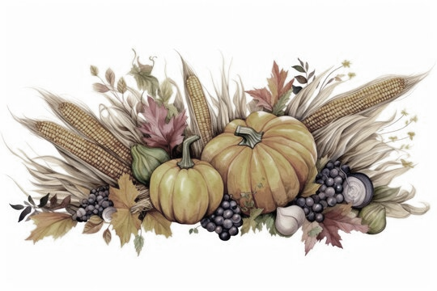

 | November 2025
Sun | Mon | Tue | Wed | Thu | Fri | Sat
1
FB CHOTEAU

JH B/G BB SCOBEY 9am

District VB Tourney at Saco
2 | 3 | 4  SCHOOL OUT AT 1:30  Parent Teacher Conference 1:30 – 7:30 | 5 | 6  DIVISIONAL VB TOURNEY AT  SIDNEY | 7  JH B/G BB at Sidney 9am | 8  FB Qtr Finals
9 | 10 | 11  VETERANS DAY | 12  VB State C Tourney at MSU – Bozeman  FFA: Montana AG Expo in Bozeman | 13 | 14  JH B/G BB at Malta 9am | 15  FB Semi FInals
16 | 17 | 18 | 19 | 20  HS B/G BB 1st Day of Practice | 21  FRIDAY SCHOOL DAY  8:00-4:05 | 22  State C FB CHAMPIONSHIP  JH B/G BB at Harlem 9am
23  Symphonette Concert | 24 | 25 | 26  THANKSGIVING BREAK –  NO SCHOOL | 27  THANKSGIVING DAY | 28 | 29
30 | 12/15: Elementary Christmas Concert  12/16 JH/HS Christmas Concert  12/19: FRIDAY SCHOOL DAY 8:00 – 4:05  12/22 – 1/1: Christmas Break  1/2: SCHOOL RESUMES  JV/V B/G BB WOLF POINT at Scobey 4:30/4:30/6:00/7:30

