TIRZEPATIDE INJECTION SITES

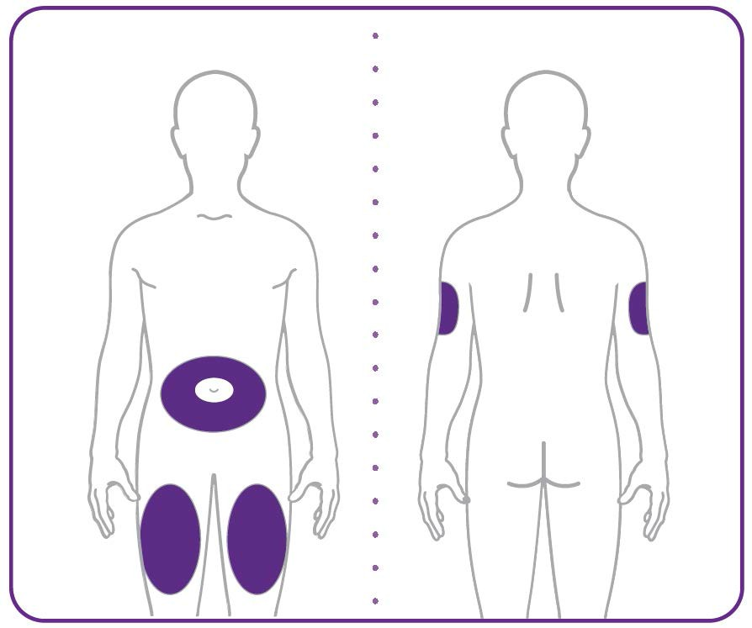

- Your healthcare provider can help you choose the injection site that is best for you.
- You or another person can inject the medicine into your stomach or thigh.
- Another person should give you the injection in the back of the upper arm.

ZEPBOUND DOSING GUIDE 30mg/ml | (100 Units = 1ml = 1cc)

MG | CC | UNITS | MG |  | CC | UNITS
15 | 0.5 | 50 | 4.2 |  | 0.14 | 14
14.7 | 0.49 | 49 | 3.9 |  | 0.13 | 13
14.4 | 0.48 | 48 | 3.6 |  | 0.12 | 12
14.1 | 0.47 | 47 | 3.3 |  | 0.11 | 11
13.8 | 0.46 | 46 | 3.0 |  | 0.10 | 10
13.5 | 0.45 | 45 | 2.7 |  | 0.9 | 9
13.2 | 0.44 | 44 | 2.4 |  | 0.8 | 8
12.9 | 0.43 | 43 | 2.1 |  | 0.7 | 7
12.6 | 0.42 | 42 | 1.8 |  | 0.6 | 6
12.3 | 0.41 | 41 | 1.5 |  | 0.5 | 5
12.0 | 0.40 | 40 | 1.2 |  | 0.4 | 4
11.7 | 0.39 | 39 | 0.9 |  | 0.3 | 3
11.4 | 0.38 | 38 | 0.6 |  | 0.2 | 2
11.1 | 0.37 | 37 | 0.3 |  | 0.1 | 1
10.8 | 0.36 | 36
10.5 | 0.35 | 35
10.2 | 0.34 | 34
9.9 | 0.33 | 33
9.6 | 0.32 | 32
9.3 | 0.31 | 31
9.0 | 0.30 | 30
8.7 | 0.29 | 29
8.4 | 0.28 | 28
8.1 | 0.27 | 27
7.8 | 0.26 | 26
7.5 | 0.25 | 25
7.2 | 0.24 | 24
6.9 | 0.23 | 23
6.6 | 0.22 | 22
6.3 | 0.21 | 21
6.0 | 0.20 | 20
5.7 | 0.19 | 19
5.4 | 0.18 | 18
5.1 | 0.17 | 17
4.8 | 0.16 | 16
4.5 | 0.15 | 15

