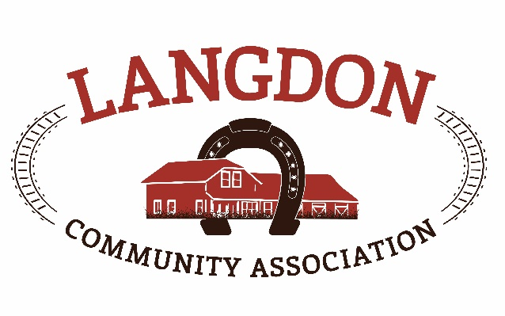
Langdon Community Association
Box 134
Langdon, AB T0J 1X0
www.goodlucktown.ca

LCA AGM – March 14, 2021
Location: On line Zoom call

In Attendance:
Chrissy Craig – Chair
Jessica Smythe – Vice Chair
Tom Craig – Capital Projects
Nicole Porquet-Seitz – Director
Crystal Upstone – Events
Brian Ferguson - Treasurer
Corrie Carrobourg – Director
Nicki Black – Secretary
Heather Miller – Fiedlhouse
Brand-Lee Mouck – Community Programs
Scott Pike – Parks Lead
Dave Miller
Tony Baker
Georga Fisk
Brian Hogg
Becky Ring

Meeting called to order at 1907

- Approval of Agenda:
  - Motion to approve the agenda: Jessica and 2nd Corrie
- Approval of Minutes:
  - Motion to approve the minutes from March 8, 2020: Nicole and 2nd Corrie

- Chair report: 2020 was a difficult year for all organizations. LCA dipped in to emergency
Funds to pay bills and keep the Fieldhouse open for essential use. Many great community events where the community came together for support (Easter egg hunt, window paintings, parking lot coffee meets, etc). The outdoor rink was used more than any other year, and the creation of the little rink created much needed skating space. Thank you to the Zamboni crews for maintaining the rinks.
More highlights: Langdon Jr/high fully approved for design and build funding, completion of the quad ball diamonds, adopt a planter expanded, Dolly Parton Imagination Library grew (1022 books distributed), Casino days brought in $40k, Survival Raffle, $20K Healthy Communities Grant to work with Community Collaborative to promote health and community development.

- Project Report: Multi Court development will be behind the south diamond in Langdon Park.
Will include tennis, basketball, pickleball and a rebound wall for soccer, etc. Winning bid has been awarded and the landscaping will be a secondary bid at a later date.
Christmas lights were installed on and around the Fieldhouse, shelving units were put in the Fieldhouse garage and the hockey rink boards were replaced in the outdoor rink.
The Quad diamonds construction has been completed other than a few deficiencies that will be dealt with in the spring.
There was a preliminary design for a gathering space (to allow for Covid restrictions), put together for a grant application. If the grant is received, there will be further discussion around the design, etc.
There was a $100k design approval from Rocky View County for the Indoor Rec center which will be on the site near the highschool and quad diamonds.

- Treasurer Report: See budget attachment for full details. Main highlights are that we received
additional grants through Government Covid relief. All fundraising is significantly less for 2020. Brief review 2021 budget, which will be changing due to operational expenses for the ball diamonds. Will be approved by the board at the next meeting.
Motion to accept the 2020 Treasurers Report – Jessica, 2nd Brandi Lee, passed.

- Grants: RVC Capital assistance grant
Picnic tables, landscape lighting, Garage shelves
Applied for $10244.47 and received $6000

RVC Community Benefits Initiative
Volunteer recruitment, winter planter program
Applied for $5100 and received $3600

Langdon Recreation Grant
Operations for the Fieldhouse (due to Covid), playground maintenance, adopt a
planter program, equipment to flood the rink
Applied for $33442.35 and received full amount

Small / Medium relaunch grant
Approved but unsure of amount to be received

Applied so far in 2021
RVC Capital Assistance Grant
Multi Use court build
Applied for $172K – decision end of May

Community Facility Enhancement Program
Quad baseball diamonds – garage, maintenance equipment, score boards
Applied for $61955 – decision end of March

Canada Healthy Communities Initiative
Langdon Park Revitalization project
Applied for $250K – decision end of April

- Bylaw Approval: Motion to approve bylaws as presented and to include additional board positions –
Heather, 2nd Brian, all approved

- Board Positions: Treasurer – Brian Ferguson, 2nd Corrie, all approved
Program Lead – Brandi Lee Mouck, 2nd Corrie, all approved
Funds Lead – Chrissy Craig, 2nd Heather, all approved
Members at Large – Georga Fisk, Tony Baker, Corrie Carrobourg, Dave Miller and Nicole Porquet-Seitz, 2nd Tom, all approved.

- Next Board Meeting: March 21, 2021 at the Fieldhouse

Adjourned 1946h

