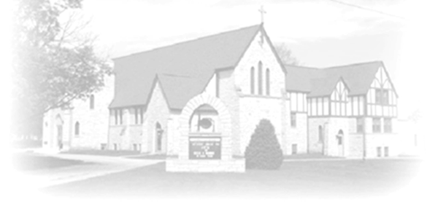
Trumpet Minor
October 25 & 26 2025
Christ Lutheran Church
ANNOUNCEMENTS
FALL OPEN HOUSE: A great time was had by many at Pastor Chrissy’s fall open house. Thank you for coming out and fellowshipping and special thanks to those who provided treats.
TRUNK OF TREAT- OCTOBER 31ST 4pm-6pm Please arrive at the church parking lot with your trunk full of treats for the event. Costumes are encouraged as well!
ALL SAINTS WORSHIP November 1 & 2 –- Honoring the lives we have lost in the past year. To honor your loved ones who passed away outside of the church in the past year, please send their names and dates of birth and death to Jeanie Taggart at christlutheranchurch70@gmail.com
CONFIRMATION CLASS: students in grades 7th & 8th grade and older who would like to learn more about their faith, will gather on the 2nd and 4th Sundays of the month from 8:30-9:45 am. Please sign up online or talk to Pastor Chrissy. Mark your calendar for the Fall Retreat at LOMC November 21-22. More info to come.
ITEMS NEEDED FOR 2026 BIBLE SCHOOL: in the back of the church, we are collecting your plastic milk bottle lids, small plastic pop bottles and assorted plastic bottle lids. Please collect and bring them in!
THE COMMUNITY TABLE: The Community Table is an opportunity for outreach to the local community. This is a twice a month meal on the first and third Tuesday of the month at 11:30, here at Christ to gather for food, fellowship and fun, if you are interested in volunteering please talk with Janet Haas or Debbie Goebel. Join us Tuesday, November 4th and 18th. All are welcome.

A VISIT WITH CORRIE: On Saturday, November 1st at 1 pm at Trinity Lutheran Church 308 E. Brayton Road in Mount Morris. Compelling and inspiring portrayal by Gayle Hass of the Nazi concentration camp survivor and Dutch resistance fighter Corrie ten Boom. Free admission, reception after performance. Donations will be accepted by the national and global women’s ministries of the NISynod WELCA.
BIBLE STUDY: join us on Wednesday mornings at 9am Beginning September 24th, we will meet in the narthex weekly to study the scripture readings for the upcoming Sunday. Come for a chance to explore the Word together and pray over those on our prayer list. We will also be studying the Small Church Advantage we will talk about chapter ten on November 5th. Copies of the book are available. This will meet every Wednesday unless otherwise noted.
OPERATION CHRISTMAS CHILD BOX DROP OFF: will take place here Monday November 17-24 Times are M, W, F, Sat 9 am to noon and T, Th, Sunday 3-6. Volunteers are needed! Please see Nancy Rice to sign up.
OPERATION CHRISTMAS CHILD SHOE BOX: start collecting items as we will be having a packing party this year for the shoe boxes. You can still pack your own if you want! Items needed: personal care items (toothbrush, wash cloth, comb or brush, nail clippers, water bottles, flashlights, hair accessories), School Supplies (pencils, pencil sharpeners, erasers, crayons, colored pencils, markers, notebooks, calculators, scissors, rulers, glue sticks, drawstring bags), toys/ puzzles activities (small backpack or purse, doll, balls with pump, puzzles, coloring books, chalk board and chalk, jump rope, stickers, slinky, yo-yo, small toys), remember items will be packed in shoe boxes.
Next Week Readings:
Jeremiah 31:31-34 I will write my law in their hearts, says the Lord Psalm 46 The Lord of hosts is with us; the God of Jacob is our stronghold. (Ps. 46:7)
Romans 3:19-28 Justified by God’s grace as a gift John 8:31-36 Jesus says, Continue in my word and you will know the truth

