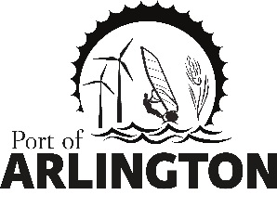

Special Commission Meeting

Tuesday April 6, 2021

4:00 pm

Meeting Location:
Port Office
Arlington, Oregon

- Call meeting to order

- Port Island Restroom Project
  - Notice of Intent to Award to M&M Excavating, LLC

- Executive Session ORS 192.660(2)(a) and 192.660(7) To consider the employment of an officer, employee, staff member.

Upcoming Meetings:
Regular Commission Meeting on Tuesday, April 13, 2021 - Port of Arlington, Arlington, Or.
This meeting location is accessible to persons with disabilities. A request for an interpreter for the hearing impaired or for other accommodations for persons with disabilities should be made at least 48 hours before the meeting by contacting Kelly.margheim@portofarlington.com / 541-705-2004
Posted: Tuesday, March 30, 2021: Bank of Eastern Oregon - Condon & Arlington; U.S. Post Office - Condon & Arlington; Condon Times-Journal; Arlington City Hall;
Port Office and Website.

