Mars UP Church
Come Holy Spirit, Come
Before the Service – Speak to God!
During the Service – Let God speak to you!
After the Service – Speak to each other!

(*Please stand, if able)
Lighting of Candles
Presentation of the Colors
Pledge of Allegiance
Welcome and Mars Messages

Prelude

Apostles’ Creed
I believe in God the Father Almighty, Maker of heaven and earth; and in Jesus Christ His only Son our Lord; who was conceived by the Holy Ghost, born of the Virgin Mary, suffered under Pontius Pilate, was crucified, dead and buried; He descended into hell; the third day He rose again from the dead; He ascended into heaven, and sitteth on the right hand of God the Father Almighty; from thence He shall come to judge the quick and the dead. I believe in the Holy Ghost, the holy catholic church; the communion of saints; the forgiveness of sins; the resurrection of the body; and the life everlasting. Amen.

Gloria Patri
Glory be to the Father, and to the Son, and to the Holy Ghost. As it was in the beginning, is now and ever shall be,
world without end.
Amen. Amen.

The
Lord’s Prayer

Our Father,
who art in heaven,

hallowed be Thy
name,

Thy kingdom come,
Thy will be done,
on earth
as it is in heaven.

Give us this day
our daily bread;

and forgive us
our debts,
as we forgive
our debtors;

and lead us not
into temptation,
but deliver us
from evil.

For Thine
is the kingdom,
and the power,
and the glory,
forever. Amen.

The Doxology

Praise God
from whom
all blessings flow;
praise Him
all creatures
here below;
praise Him above,
ye heavenly host;
praise Father, Son,
and Holy Ghost.
Amen.

*The Call to Worship
Leader: Praise the LORD! Sing to the LORD a new song,
his praise in the assembly of the faithful.

People: Let the people be glad in our Maker; let the
children of Zion rejoice in their King.

Leader: Let the praise his name with dancing, making
melody to him with tambourine and lyre.

People: For the LORD takes pleasure in his people; he
adorns the humble with victory.

Leader: Let the faithful exult in glory; let them sing for
joy.

People: Praise the LORD!

Pastoral Invocation

*Hymn 43
“All Hail the Power of Jesus’ Name”

Call to Confession
*Prayer of Confession
Beloved God, who was known to our mothers and fathers, and even to our spiritual forebears, have mercy on us. We do not always love as you would have us love. We do not always do as you would have us do. In our stubbornness, we turn from you when we should turn toward you. Hold us, dear One –comfort us when we mourn the passing of friends and family, and help us to know that they are rejoicing in your presence. We praise you for the grace you shower on us, constantly forgiving our errors, especially the ones that we don’t share with any but you. Hear now the silent fears and worries of our hearts.

*Assurance of Pardon
*Gloria Patri

*Passing of the Peace
Leader: May the grace of our Lord Jesus Christ, the love of God, and the fellowship of the Holy Spirit be with you all!
People: And also with you.

Children’s Chat

Scripture Luke 6:20-31
Morning Message Rev. Brian Hauser
“The Good, The Bad & The Difficult”
Hymn 808
“Eternal Father, Strong to Save”

Honoring our Veterans and Saints

Prayers of the People and the Lord’s Prayer

Offertory
Offering

Doxology

*Hymn On Screens
“Song of Hope”
Retiring of the Colors

*Benediction

Church Staff
Rev. Brian Hauser
Pastor
pastor@mars-up.org
724-689-3412

Mrs. Shelly Bocheff
Administrative Assistant
marsup@mars-up.org

AV TEAM
Alma Staskiewicz, Lisa Barbour, Marie Matthews, Bill Guesman, John Ivory, Keith Nichols, Mike Bocheff, Herb Wellman

Mars United Presbyterian Church

232 Crowe Ave
PO Box 805
Mars, Pennsylvania 16046
724-625-1365
www.mars-up.org
marsup@mars-up.org

Church Office Hours:
Mon -Thurs from 9 a.m. -2:30 p.m.
*Postlude

Mac Purvis would like to express his appreciation for all the thoughts, prayers and cards that came his way after his stroke. He is recovering and the doctors are optimistic for full recovery.

MUP Music Committee
Morning Worship:
10:00 am

22nd Sunday after Pentecost

Prayer of Preparation
Lord, we come to you today with so many things on our hearts.

You call us to be in relationship of trust and love with you and you offer healing to us for those portions of our lives that are broken and injured.

Help us to be open to your mercy and healing love. For we ask this in Jesus’ Name.
AMEN.

Keith Nichols – Chair
Sally Olsen – Clerk
Alma Staskiewicz
John Ivory
Linda Lees
Karl Kennedy

**In Memorium**
William Allen Brack
Member
August 24, 1935 – October 26, 2022

Mailing address for Doris
Doris Brack
556 Harbourview Drive
Haines City, FL 33844

Mars United Presbyterian Church
Welcome!

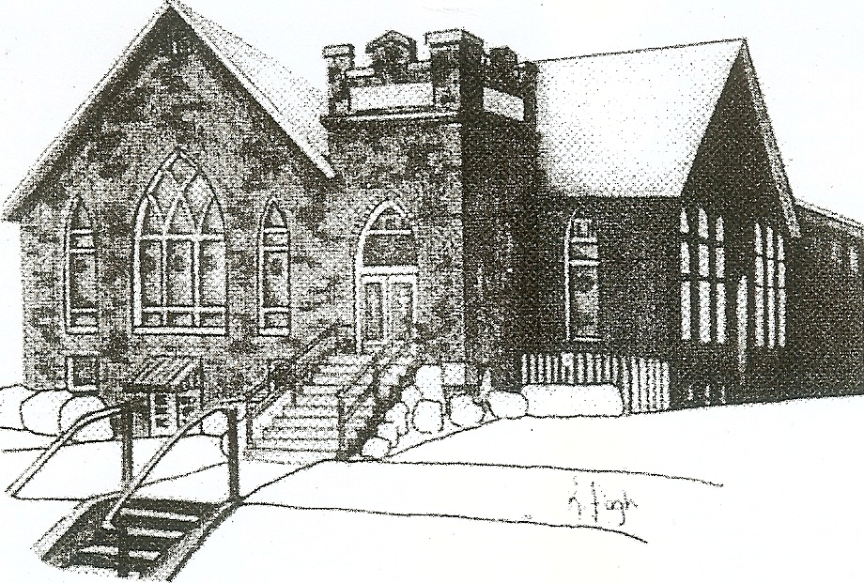
We are your hometown church: Faithful to Tradition, Loving in Fellowship, & Reaching for Tomorrow!

November 6, 2022
Scout/Veteran Sunday
All Saints Sunday

We welcome you and we are glad you’ve chosen to Worship with us today!

CALENDAR: November 6th – November 13th

Church Office Hours: Monday -Thursday from 9 a.m. – 2:30 p.m.

Today, November 6, 2022
VOLUNTEERS☺

LAST SUNDAY’S In-House ATTENDANCE: 48

LAST SUNDAY’S OFFERING:
Operating Funds: $2990.00
Kindness: $30.00
Total: $3020.00

Tarry N Talk Hosts
Buildings & Grounds

9:00 am Sunday School Hour
10:00 a.m. THE MORNING WORSHIP SERVICE
11:15 am Deacon Meeting
1:00 pm Youth Group
Monday, November 7, 2022
1:30 pm Women’s Bible Study
6:00 pm Cub Scouts 413
6:30 p.m. Griefshare
7:30 pm BS Leader Meeting
Tuesday, November 8, 2022
9:00 am A team
7:00 pm AA
Wednesday, November 9, 2022
9:00 am Material Girls
12:00 pm Rotary meets in Fellowship Hall
7:00 pm Cub Scouts
Thursday, November 10, 2022
Friday, November 11, 2022
Saturday, November 12, 2022
7:00 am Rotary Breakfast
Sunday, November 13, 2022
9:00 a.m. Worship at St. John Lutheran Church
1:00 pm Youth Group
Welcome to all who are Worshiping with us today!

Guests
We sincerely hope our service is a blessing to you. We ask that our guests please take a few minutes to complete one of the Connect Cards found in the pew holder.

Should you have questions regarding any aspect of our church, including membership, please contact Pastor Brian or the church office during the week at 724-625-1365. Thank you for being with us today.

PRAYER – JOYS & CONCERNS
Lou Beckwith
Paige Barbour (daughter of Andrew and Steph Barbour)
Reid Christopher Hall (June Stirling’s nephew)
Lindy McCartney (Lisa Barbour’s Sister)

ANNOUNCEMENTS
Bulletins are printed Thursday mornings; let us know if you have an announcement…

ROTARY PANCAKE BREAKFAST Come Support the Pancake Breakfast on November 12, 2022 7am until 11am All you can Eat Pancakes and Sausage. Event held at MUP Fellowship Hall. Tickets available at the door. Watch for more details!

SUNDAY, NOVEMBER 13th Worship Service will be at St. John Lutheran Church. The Youth Group will be leading worship and Rev. Brian is asking us to worship at St. John Church. Service starts at 9:00 am. There will not be any worship services or Sunday School at Mars United. St. John Lutheran church is located at 420 Beaver Street, Mars. If you have any questions, please contact the office.
TURKEY BASH The Turkey Bash is Back! On Thursday, November 17th at 12:30 pm the Deacons will be serving the Seniors and Community for a Thanksgiving Meal. Please RSVP by November 10th if planning on attending.
HOMELESS YOUTH EVENT On November 18th – November 19th , area youth will be joining together to worship God, play games, enjoy snacks and food, and most importantly make a difference in the community by aiding our Veterans! Every youth between 5th and 12th grade are welcome to attend. This event will be held at St. Johns and will be chaperone. Please contact the office or Pastor Brian to find out more info.
OFFICER NOMINATIONS If you are interested in serving as an Elder or Deacon, please contact the office or someone on the nominating committee (Robyn Beckwith, Jill Cooper, Ruth Wilson or MaryAnn Croop).

NOVEMBER 20TH We will be privileged to hear the musical voices of Light of the City singers from Pine Valley Bible Camp during worship. After Worship we will be decorating the church for the Holiday season. Please Come and help beautiful the church for Christmas. Don’t miss this Sunday!!

HARD TACK CANDY It’s that time of year again!!!!! We will be taking orders for hard tack, the cost is $5.00 per 1 lb bag and comes in assorted or single flavors. Order forms are located in the Tarry N Talk area for your convenience.

