09/09/2016 Fifty Prophetic Years from 6/7/1967

September 17, 2016, will mark 50 prophetic years (360 day years) from 6/7/1967 when Israel took Jerusalem from Jordanian control in the Israeli Six Days War.

On September 23, 2015, exactly 49 prophetic years from 6/7/1967, Pope Francis was the first ever Pope to visit a standing President of the United States in the White House. September 23, 2015, was also the most holy day in the Hebrew year, the Day of Atonement when the High Priest would enter the most holy place in the Tabernacle and offer the blood of atonement to YaHuWaH Elohim for the sins of the people of Israel.

Only those familiar with this most holy procedure given to Israel by YaHuWaH Elohim would recognize the possible veiled blasphemy perpetrated by Pope Francis and President Obama.

Pope Francis, being the "High Priest" of Christianity, appeared privately before President Obama in the White House on the same and only day of the year that the High Priest of Israel would have been allowed to appear privately before YaHuWaH Elohim in the holy of holies. Be aware that President Obama was symbolically equated with YaHuWaH Elohim on 9/23/2015. I hope that the event timing was unintentional for everyone involved, and not an intentional blasphemous act. If it was intentional, we're all in a very bad way.

The Scapegoat and the Scarlet Thread

On the Day of Atonement two goats were chosen by the Hebrew Priesthood. One would be slain and the other, the scapegoat, would bear the sins of the nation of Israel and be sent alive into the wilderness, never to return. A scarlet thread was attached to the scapegoat. Each year that scarlet thread would supernaturally turn white as the High Priest emerged from the Holy of Holies, having just appeared before YaHuWaH Elohim with the blood of Atonement. For the last 40 years before the destruction of the Temple by the Romans in 70 AD, the scarlet thread no longer turned from red to white on the Day of Atonement. This is a matter recorded in Jewish history.

The crucifixion of YAHUSHUA Messiah occurred at Passover in 30 AD. His blood sacrifice was the final offering for the sins of Israel that was acceptable by YaHuWaH Elohim. The goat blood offering and scapegoat ceremony continued to be observed by the Temple Priesthood for the next 40 years, but was rejected by our Elohim.

The Timeline

Next weekend on 9/17/2016, exactly 50 prophetic years will have passed from the acquiring of Jerusalem by Israel in the Six Days War on 6/7/1967.

Here's a graphic indicating the timeline:

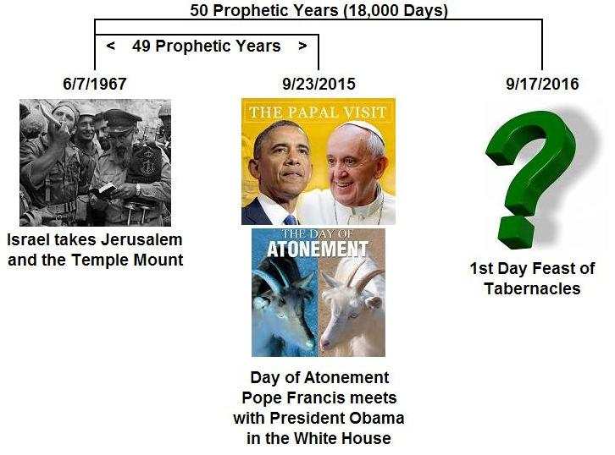

Here's another graphic indicating the final 50th prophetic year from 6/7/1967 and a curious rare twin comet close encounter that occurred exactly half way through the prophetic year:

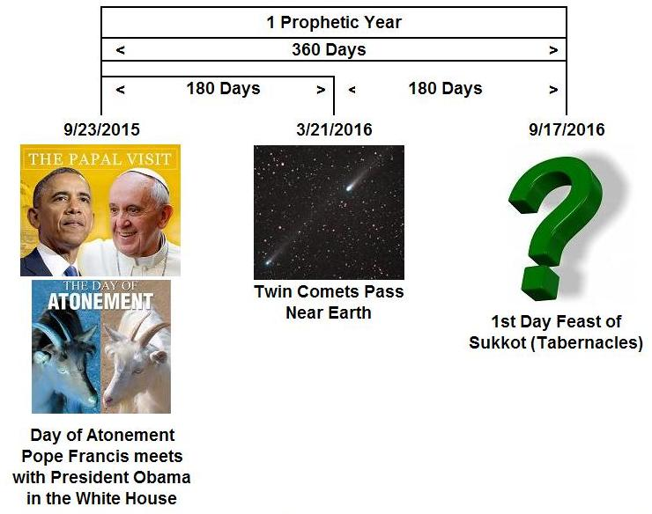

The twin comets that passed near the earth were comet 252P/LINEAR and comet 2016 BA14. Comet 2016 BA14 was the closest comet to approach the earth since Lexell's comet in 1770 over 200 years ago. The paths of these twin comets were ordained by YaHuWaH Elohim at the creation of heaven and earth. They precisely divided the 50th prophetic year from 6/7/1967 in half.

