

SUMMER – 2021 SEASON
14th July 2021
Liberation Club Handy Cap Cup

21 players turned up for the first competition of this type in the Island with lower ranked players starting with positive points giving them more of a chance of a win and putting more pressure on those players at the top when starting a match already behind.

All matches played in Round 1 were close with a winning margin of 13 – 9 being the biggest win. Two shocks in this round as Daniel beat Geoffroy 13 – 11 with Daniel’s plus 5 helping him on the way. James also won against Premier League opposition with a 13 – 10 win over Brian.

Paul beat Ross to 9 and a good win for Tim over Kevin.

In Round 2 Alex took advantage of his plus 2 to beat Laurent 13 – 12 and Kim was unfortunate giving points away at the end to lose just 12-11 to Andrew Limbrick.

Daniel made it two in a row beating Tim as did Paul over Brandon and Callum over James.

Jean beat Brian 13 – 6 for a big win and two 13 – 4 wins as Toby beat Neil and Andrew Bellamy-Burt beat Ross.

Round 3 saw Alex make it three in a row beating Toby and Andrew Limbrick just beating Daniel 13-12. Tim also won 13-12 over Kim who lost her second match in a row by just 1 point.

Geoffroy won a big match against Laurent 13 – 10 two make it two in a row as did Jean who just beat Mo 13 – 11. Brian just got his first win 11 – 10 over Matt Hutchings.

Round 4 saw Andrew Limbrick come back from 11-2 down to win 13 – 11 against Toby to make it 4 straight wins and Callum also made it four from four beating Alex.

Paul Bell beat Andrew Bellamy-Burt to move both players to three wins as did Geoffroy over Tim.

Daniel took his second Premier League scalp beating Neil to 5 and Branden beat Laurent 13 – 11. Brian won another match by just one point over Kevin.

Lorna got a good win over Mo and Kim beat Matt Hutchings.

In the final round Andrew just beat Callum 12 – 11 to make it 5 wins from 5 but only +9. With Callum qualifying in third place.

Daniel had a big win over Paul which meant he finished second in the rankings with 4 wins.

Geoffroy beat Jean to make it four straight wins which saw him qualify in fourth place by 1 BHN over Andrew Bellamy-Burt who was the only player on four wins not to go through.

Another shock though as Kim beat Neil 13 – 9 for one of the results of the day. Lorna also taking a Premier League player out beating Brian.

FINAL RANKINGS

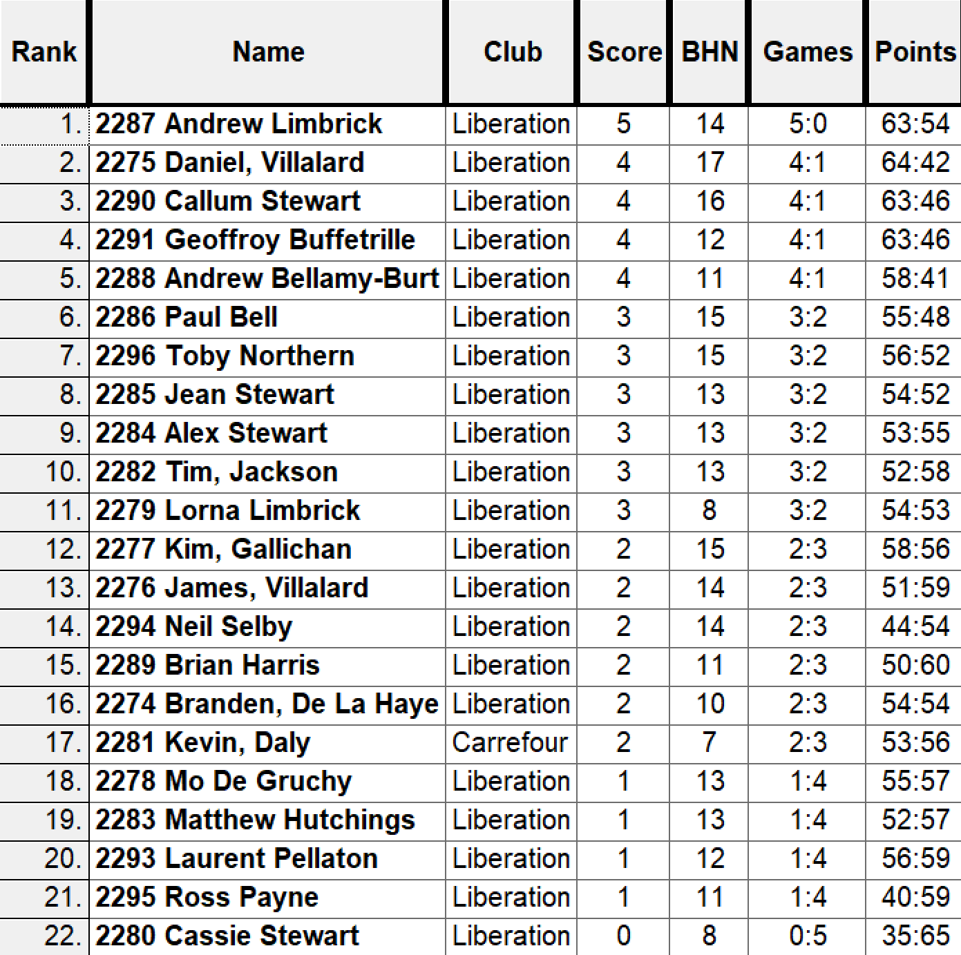

So the Semi Finals were played as follows:

Ranked 1st Andrew Limbrick v Geoffroy Buffetrille Ranked 4th

Ranked 2nd Daniel Villalard v Callum Stewart Ranked 3rd

Well the top ranked curse struck again as Andrew just couldn’t get going against Geoffroy with a few ends giving points away from holding positions to give Geoffroy the advantage who won 13 – 5.

Well Daniel was on great form after winning four out of five in the swiss rankings and only losing 13 – 12 to Andrew Limbrick in Round 3 so was going to be tough for the more experience player Callum. Daniel played exceptionally well and boosted by +5 points went on to take the win 13 – 4 and book a final spot against Geoffroy whom he beat in Round 1.

Third Place went to Andrew Limbrick winning 13 – 8 over Callum for yet another top finish in competitions.

Well despite starting the final 5 – 0 down Geoffroy hit the ground running moving to 8 – 5 up before Daniel got his first points on the next two ends to get to 7 – 8, but that was to be all as Geoffroy skill showed through as he went on to win 13 – 7.

Champion

Geoffroy Buffetrille

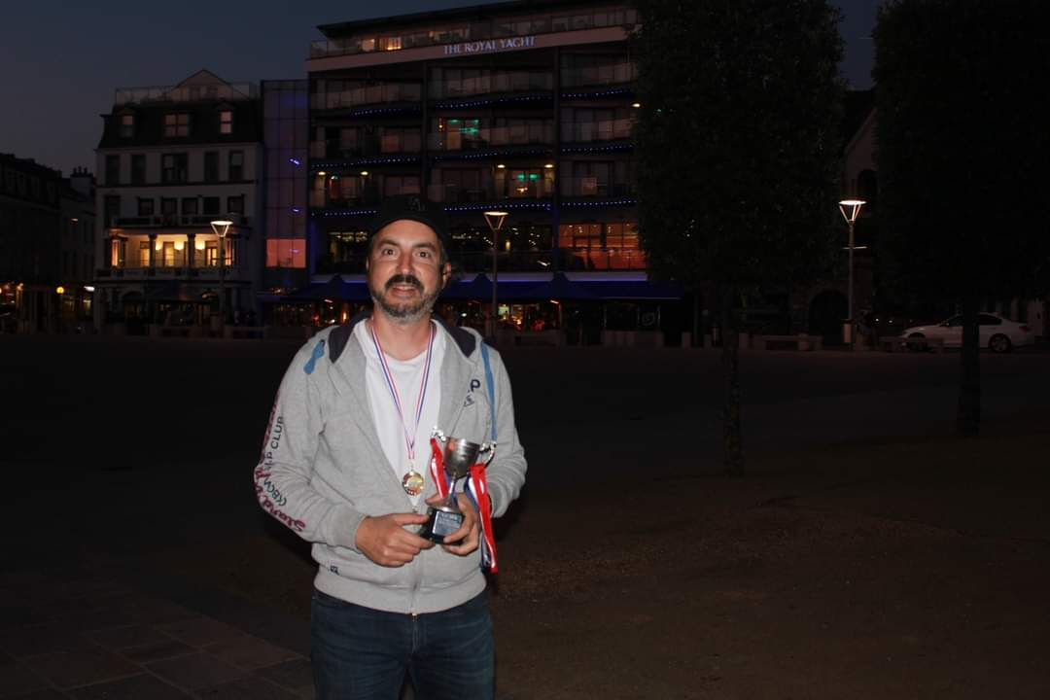

Runner Up

Daniel Villalard

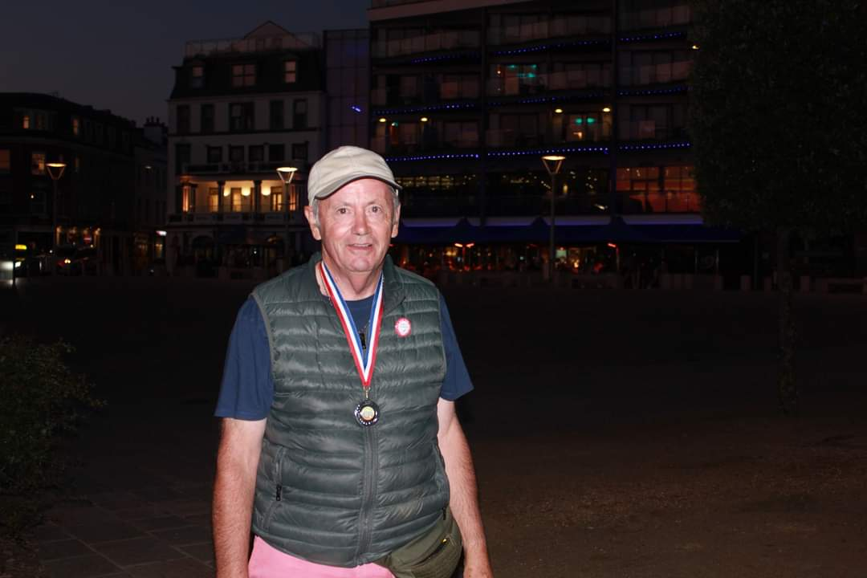

NEXT WEEK - Doubles League

Club email address -

Club Website -

Kind Regards

Toby Northern

Chairman

Liberation Petanque Club

