Create Auto Purchase Order / Reorder Report / Inventory Transfer

The Point Of Sale Management System Advanced Auto Purchase Order Creation feature will give you great control and flexibility with your inventory control whether you are a single location or a chain with multiple locations. Creating purchase orders can be automated based on Sales History over a number of months, Items Sold over a date range, or manually or automatically calculated Reorder Levels. Displayed on the right side of this screen is all the information you need as each item is selected to make an informed intelligent decision on the reorder status of that item.

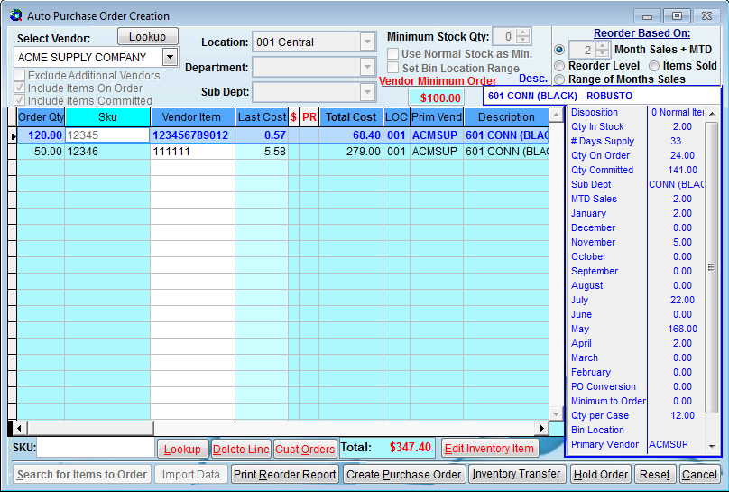

To create an Auto Purchase Order, Reorder Report or Inventory Transfer:
Set the desired criteria along the top of the Auto Purchase Order Creation screen. Then click on the "Search for Items to Order" button on the bottom left of this screen. The program will scan for items to reorder based on the criteria you selected. When the search is completed, the suggested items to reorder will be displayed in the grid below. As you scroll up and down and select items in the grid, the description, quantity in stock, sales history and other information is displayed on the right side of the screen. By viewing this information, you can make an informed intelligent decision if you want to leave the suggested reorder quantity, override the quantity, or delete the item from the screen completely. After you have reviewed the items to order, you can click the Print Reorder Report button to print a hard copy report for review, or click the Create Purchase Order button to generate a Purchase Order for the items selected.

If you have multiple locations you can also click the Inventory Transfer button to transfer inventory between locations. You will then be prompted with the location to transfer from and the location to transfer to. The Inventory Transfer is then electronically transferred to the appropriate locations to remove inventory from stock when shipped and add inventory to stock when received. All of this information is saved in the Purchase History files globally and by item.

The Hold Order button will allow you to hold this order as is and then finish the order the next time you select the Auto Purchase Order Creation option from the menu. Clicking on the dark blue headers on the grid will sort the items by that heading. You can also add additional items to the order by entering the item number in the Add Items box or by clicking on the Lookup button.

There is a column labeled with a dollar sign "$". This indicates items that have a better cost form a different vendor.

$ indicates an additional vendor has a better cost
* indicates s better cost is on a vendor promo
P indicates the primary vendor for this item has a better cost

Double click in this column to view the appropriate better cost. This will allow you to determine which vendor to order an item form with the best cost.

Vendor
Select the Vendor to create a purchase order for or select All Vendors
Include Items On Order When checked, items on already on order will be considered in stock so as not to reorder items already on order.

Include Items Committed When checked, items committed on customer orders, layaways, etc., will be considered sold so they will be reordered.

Location
If this is the Central Location of a Multi-Site company, select the location you are placing the order for.

Department
Select a specific Department to limit your auto selection criteria or leave blank to select all.

Style
Select a specific Style to limit your auto selection criteria or leave blank to select all.

Set Bin Location Range
This allows auto selection criteria to select just items in a specific Bin Location range.

Minimum Stock Quantity
Entering a quantity here will allow you to override and maintain a minimum quantity in stock even if sales history doesn't justify that quantity.

Vendor Minimum Order
This is the minimum order amount set in Vendor Maintenance for this vendor. A minimum order amount may be a vendor requirement or a minimum order amount to obtain free shipping.

Reorder Based On:
Number of Months Sales + MTD
The quantity to reorder for each item is based on the sales for the number of days for the number of months selected and the number of days for this Month To Date. The system will calculate the quantity needed per day and the suggested quantity to order based on the lead time in the vendor record, the quantity in stock, on order and committed.

Reorder Level
The quantity to reorder is based on the quantity in stock, on order and committed, and the manually or automatically calculated Reorder Level and Normal Stock Quantity in the item record. You can select to order items with quantities less than the reorder level, or equal to or less than the reorder level. The suggested quantity to order will be the normal stock quantity less the quantity in stock.

Items Sold
The quantity to reorder is based on the quantity of items sold for the date range selected. The quantity in stock does not effect the suggested order quantity. This is useful if you have not yet done a physical inventory but you want to maintain the quantity in stock based on the item quantity you have sold.

Add Items:
Manually add items to the Purchase Order by entering the item number here.

Lookup button
Click the Lookup button to browse for items to add to the Purchase Order.

Delete Line button
Click on this button to delete the selected item in the grid from the Purchase Order.

Edit Item button
Click on this button to edit the selected item in the inventory maintenance screen.

Search for Items to Order
Click on this button to scan for items to reorder based on the criteria you selected at the top of the screen. When the search is completed, the suggested items to reorder will be displayed in the grid.

Print Reorder Report
Click this button to print a hard copy reorder report for review.

Create Purchase Order
Click this button to generate a Purchase Order for the items selected on the screen.

Inventory Transfer
Click this button if you have multiple locations and you want to transfer inventory. You will be prompted to select the location to transfer from and transfer to. The quantities on the screen should be positive quantities. The system will automatically adjust the quantities to negative for the location you are transferring items from. Inventory Transfer Purchase Orders will be sent to the appropriate locations for pulling and receiving of inventory.

Hold Order
Click this button to hold this order as is and exit the program. The next time you select the Auto Purchase Order Creation option from the menu at this workstation, the held order will be re-displayed on the screen to continue editing or finish the order.

Reset
Click this button to clear the existing screen and reset the options to start a new order.

Cancel
Click this button to clear the existing screen and exit the program

