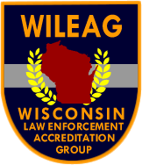
WISCONSIN LAW ENFORCEMENT ACCREDITATION GROUP
Challenging Wisconsin’s Law Enforcement Agencies to Pursue Excellence

Mark Ferguson, President
Chief of Police
Glendale Police Department
5909 N. Milwaukee River Pky.
Glendale, Wisconsin 53209
Tel: (414) 228-1753
E-mail: m.ferguson@glendalewi.gov

November 9, 2020

Use of Force Policy Certification

On June 16, 2020 President Trump issued an Executive Order on Safe Policing for Safe Communities. Part of the Executive Order instructs that the US Attorney General will allocate Department of Justice discretionary grant funding only to those State and local law enforcement agencies that have sought or are in the process of seeking appropriate credentials from a reputable independent credentialing body certified by the Attorney General. The Attorney General’s standards for certification shall require independent credentialing bodies to, at a minimum, confirm that:

- The State or local law enforcement agency’s use-of-force policies adhere to all applicable Federal, State, and local laws; and

- The State or local law enforcement agency’s use-of-force policies prohibit the use of chokeholds except in those situations where deadly force is allowed by law.

To receive discretionary DOJ grant funding your use of force policy must comply with the Attorney General’s requirements and be certified by an independent credentialing body. Agencies will be required to receive certification by January 31st to be eligible for federal funds in that year’s funding cycle. Certification is valid for three years.

The Wisconsin Law Enforcement Accreditation Group (WILEAG) has been approved by the Attorney General’s Office as the primary independent credentialing body for Wisconsin. We will certify a requesting agency if their use of force policy complies with the two mandatory requirements.

Information and forms for policy certification can be found on the WILEAG website at www.wileag.info.

The Wisconsin Law Enforcement Accreditation Group promotes excellence and professionalism within law enforcement through voluntary compliance with recognized best practices.

Please feel free to contact me should you have any questions regarding Use of Force policy certification or the WILEAG accreditation process.

Sincerely,
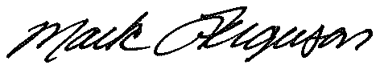

Mark Ferguson, President
Wisconsin Law Enforcement Accreditation Group
Chief of Police, Glendale Police Department
m.ferguson@glendalewi.gov

