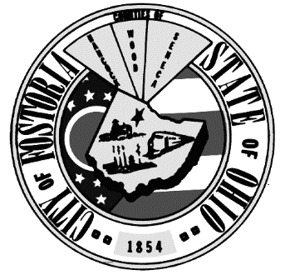
CITY of FOSTORIA
213 SOUTH MAIN STREET
Co-Chairs: Amy Mendoza
Mike Shaffer

FOSTORIA, OHIO 44830

PUBLIC AFFAIRS COMMITTEE

MEETING MINUTES

July 5, 2022

Meeting Called to Order by Councilperson Mendoza at 5:30 pm.

Attendees: Councilperson Amy Mendoza

Councilperson Mike Shaffer

Meeting Minutes of Previous Meeting:

May 31, 2022 meeting minutes were previously reviewed and uploaded to the City’s website.

Old Business:
Closed out all previously pending “Action Items.”

New Business:
Discussed Council website uniformity.
Public Affairs Committee will utilize the same template as other council committees henceforth and have requested a “Committee Objectives” form from the Finance Committee to add to the City’s website.

Discussed communications – Auditor Tab, City FB page, Council FB page, and video streaming.
Councilperson Ed Logsdon will be meeting with a representative from Sound Solutions to provide more information which he will then distribute to Mayor Keckler and Council for further considerations.

Briefly discussed fireworks ordinance.
Law and Ordinance Committee will be discussing this at their next meeting.

Public Comments:
Bill Sayre spoke about a FB poll of sorts he created and the outcome of votes concerning the following issues: decriminalization of cannabis, freedom of speech/public input on government ran pages, and food security/freedom to farm.

Communications:
Brian Shaver – communicated concerns about the Public Affairs Committee following proper protocol.

Adjournment:
With no other business to come before the Public Affairs Committee, the meeting was adjourned at 5:50 pm. The next regular Public Affairs Committee meeting is August 2, 2022 at 5:30pm in City Council Chambers.

Signed: Attest:

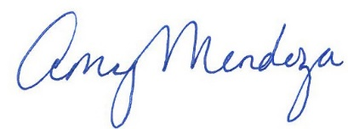

____________________________________ __________________________________
Councilperson Amy Mendoza, Co- Chair Councilperson Mike Shaffer, Co-Chair

Date: 7-7-2022

