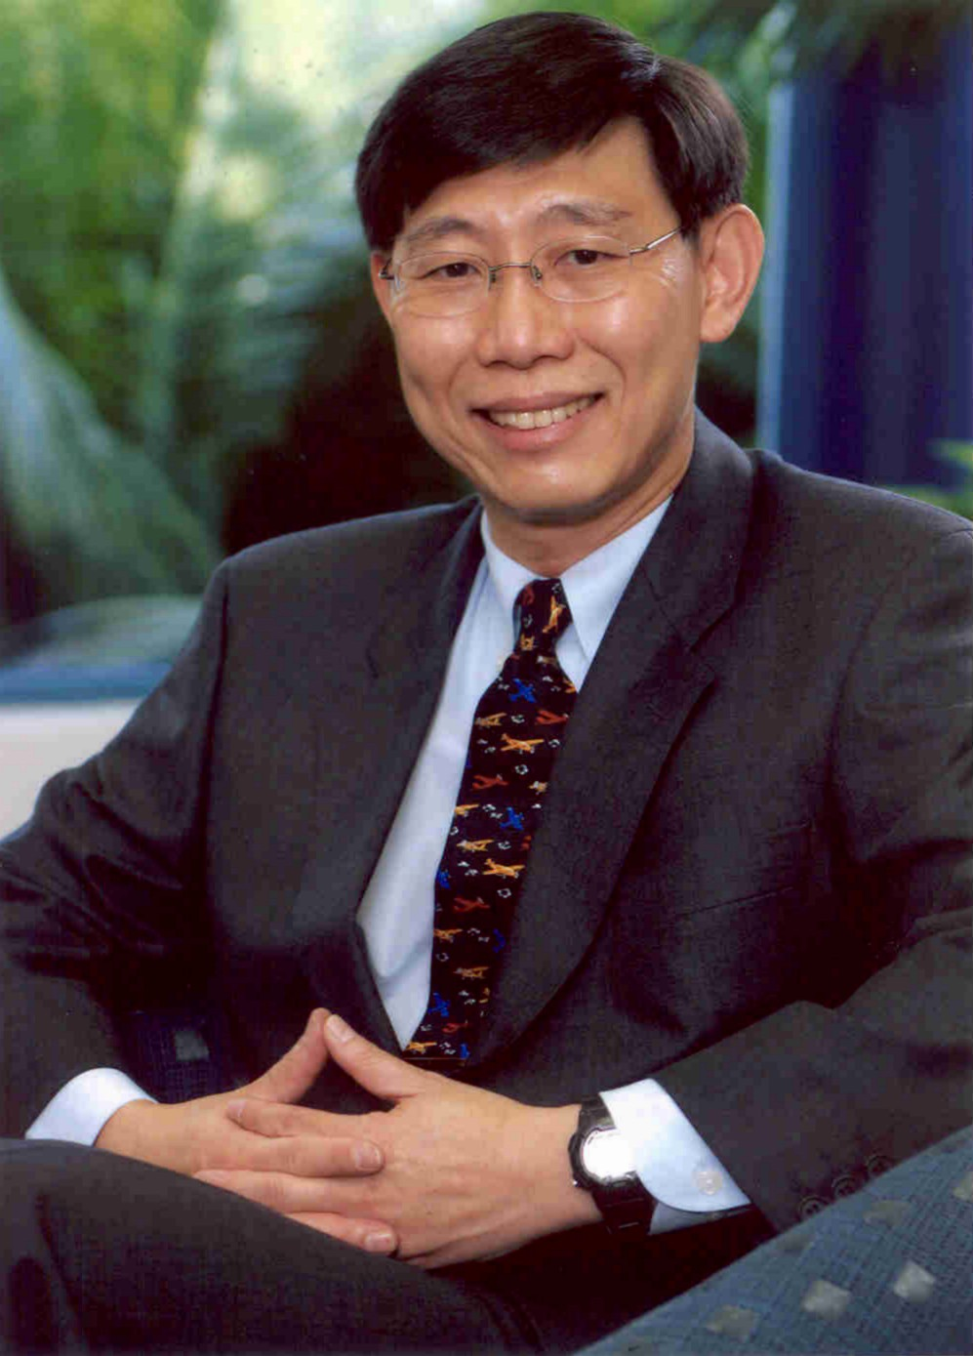

Ho-Beng is has a PhD in Organizational Behavior from the University of British Columbia in Canada; was a NUS Overseas Merit Scholar; and holds a Bachelor or Business Administration with Honours from the National University of Singapore where he won the Monetary Authority of Singapore book prize for being the best student in his honours class. He is also a certified mediator (Lawyers Engaged in Alternative Dispute Resolution, Australia) and an adjunct coach at the Center or Creative Leadership.

Ho-Beng is a full time faculty with the Department of Management and Organisation at the National University of Singapore, and served on the mediation and dispute resolution committees of Securities Investor Association of Singapore, and the Singapore Chinese Chamber of Commerce and Industry. He was on the research group at Singapore Mediation Centre, and on the management committee of the Centre for Corporate Social Responsibility.

He teaches undergraduates, university scholars, post-graduates, executives, and unionists in organizational behavior, management, leadership, change management, creative problem solving, human resource management, negotiations, mediation, and conflict resolution. He was awarded the Outstanding Educator Award in 2001 and 2002 and has made the list of the top 6 percent of educators at NUS in 2003. He is the program director for several key custom corporate executive programs at the NUS Business School.

Ho-Beng has taught in executive program for Siam City Cement, P.T Astra International, P.T. Telkom, P.T. Sinarmas, Toshiba, Panasonic, Fujitsu, Citibank Indonesia, Mizuho Bank, Sampath Bank, Asahi Glass Company, Daimler Chrysler, Nestle, Robinsons Group (Singapore), National Healthcare Group, Sanofi Aventis, Asia Development Bank, Alcatel, Telenor Group, Digi (Malaysia)

Prior to his academic career, he worked in both the financial and manufacturing sectors. His work experience includes managing corporate accounts, turnaround management, managing in merger transitions, and problem loans management.

Ho-Beng brings to the classroom a combination of theory and practice.

