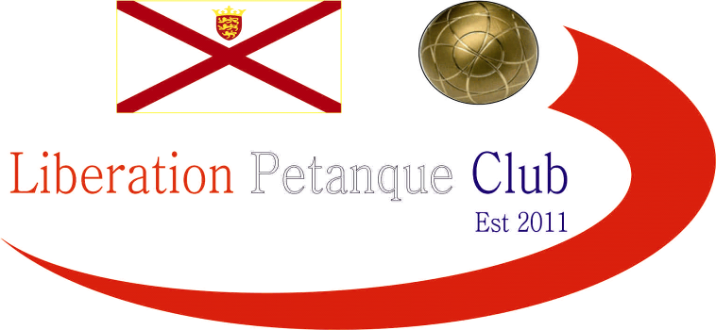

2022
International Singles Open

Twenty-four players took part in our first International Singles Open in our weekend of competitions.

Round one saw Matt Pinel take on top Scottish player Robert Stronach and a close match it was but going in Matt’s way just 13 – 11. Laurent Pellaton beat Michael Watt and Andrew Bellamy beat Alec Davie

Neil Selby beat the other top Scottish player Derek Adam 13 – 7 to complete Jersey whitewash over the Scottish visitors. Eliot Mortimore beat Andrew Limbrick 12 – 10 in one of two matches not to get to thirteen, the other was Lorna Limbrick losing 9 – 8 to John Wilson.

Wins for Toby Northern over Chris Bigmore and Ross Payne over Jay Geldert.

Round two saw a big match between two of the best local players with Matt Pinel playing Laurent Pellaton. It was a close match with Matt just taking it 13 – 11, but Laurent would get a chance later to reverse that score.

Local Scottish player Alex Stewart played one of the top visiting Scottish players in Robert Stronach and this went down to the wire with Alex winning 13 – 12. Andrew Limbrick beat another top Scottish player Derek Adam 13 – 7 but John Wilson made up for it beating Toby Northern.

Englishman Eliot Mortimore beat top Jersey player Neil Selby 13 – 3 and Clifton Consalves beat Jean Stewart.

The Welsh contingent did not do as well in this round as Jim Page and Jay Geldert both lost.

Round three saw Derek Adam and Robert Stronach play each other, with the latter winning comfortably 13 – 5. John Wilson continued his good form winning against Clifton Consalves.

Neil Selby won by one point over Andrew Limbrick 12 – 11 and Michael Watt just beat Ann-Marie Stanley 13 – 12. Win also for Toby Northern over Ross Payne and Andrew Bellamy over Keith Pinel.

Jay Geldert beat fellow Welsh player Jim Page for bragging rights and Cassie Stewart-Le Gallais beat Paula Fauvel 13 – 1.

Round four saw some big matches at the top end of the rankings with Matt Pinel just beating John Wilson 13 – 10, Andrew Bellamy beat Neil Selby 13 – 9 and Laurent Pellaton beat Toby Northern 13 – 10.

Jean Stewart beat Husband Alex and Lorna Limbrick won 12 – 7 over Alec Davie. Ross Payne suffered a heavy defeat against Robert Stronach. Derek beat Jay and Jim beat Ann-Marie.

In the final Round to determine the top sixteen for the Main and the remaining eight players for the plate. Matt Pinel topped the rankings with a win over Andrew Bellamy who finished second in the rankings.

Laurent Pellaton finished third with a win over Jean who also qualified in nineth place. Keith Pinel beat Clifton Consalves to make it four wins finishing fourth with Clifton in sixth.

John Wilson lost his second match in a row against Chris Bigmore but still finished fifth top of the players with three wins with Chris also ending with three wins in twelfth the bottom of player with three wins.

Toby Northern beat Lorna Limbrick 13 – 3 to finish seventh with Lorna taking the last Main spot in sixteenth. Robert Stronach made eighth with a win over Eliot Mortimore who took thirteenth.

Neil Selby, Andrew Limbrick, Alex Stewart and Cassie Stewart Le Gallais made up the rest of the players going through to the main competitions.

One top Jersey player to miss out was Ross Payne in seventeenth and Derek Adam also in the bottom eight. They were joined by Michael, Paula, Alec, Jay, Jim and Ann-Marie.

Final Swiss Rankings

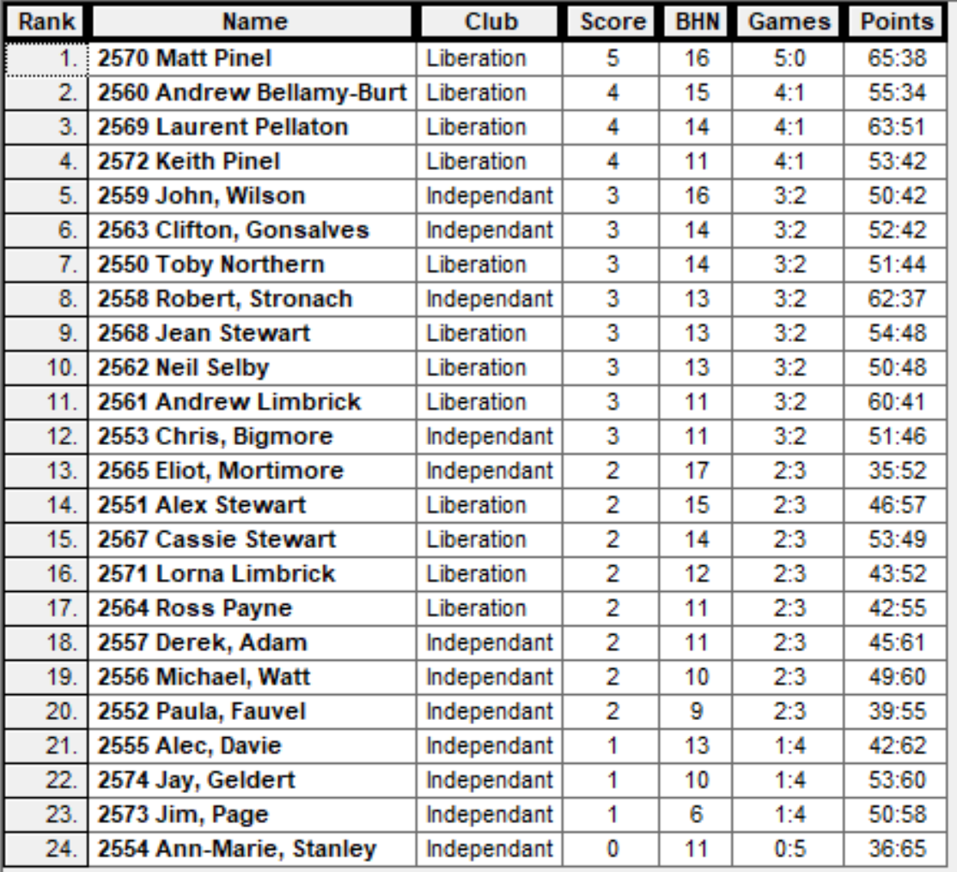

The Plate Competition

Ranked 17th Ross Payne v Ann-Marie Stanley Ranked 24th

Ranked 18th Derek Adam v Jim Page Ranked 23rd

Ranked 19th Michael Watt v Jay Geldert Ranked 22nd

Ranked 20th Paula Fauvel v Alec Davie Ranked 21st

Ross Payne made the Semi-Finals with a close win over Ann-Marie and doubles win for the Scottish over the Welsh as Derek Adam and Michael Watt, both made it through.

Paul Fauvel though spoiled the party as she beat Scotsman Alec Davie.

In the Semi-final Ross struggled against Paula and only just made the final where he met Michael Watt who gained bragging rights over Derek Adam.

Derek took third place with a win over Paula and Ross recovered some pride after failing to make the Main competition by winning the Plate.

The Main Competition

Last 16

Ranked 1st Matthew Pinel v Lorna Limbrick Ranked 16th

Ranked 2nd Andrew Bellamy v Cassie Stewart-LG Ranked 15th

Ranked 3rd Laurent Pellaton v Alex Stewart Ranked 14th

Ranked 4th Keith Pinel v Eliot Mortimore Ranked 13th

Ranked 5th John Wilson v Chris Bigmore Ranked 12th

Ranked 6th Clifton Consalves v Andrew Limbrick Ranked 11th

Ranked 7th Toby Northern v Neil Selby Ranked 10th

Ranked 8th Robert Stronach v Jean Stewart Ranked 9th

Matt Pinel continued his fine form winning comfortably 13 – 1 over Lorna, Andrew had a much tough match against Cassie coming through 13 – 9. This was also the score as Laurent beat Alex.

Keith beat Eliot and John beat Chris as the top five ranked players all went through. Andrew prevented Clifton though from making it the top six ranked players and Jean provided a shock knocking out Robert 13 – 10.

Neil raced ahead of Toby leading 8 – 0 before Toby got onto the score sheet and Neil was 11 – 5 up until Toby hit top form for a great comeback winning 13 – 11 on the last end.

The Main Competition

Quarter Finals

Ranked 1st Matthew Pinel v Jean Stewart Ranked 9th

Ranked 2nd Andrew Bellamy v Toby Northern Ranked 7th

Ranked 3rd Laurent Pellaton v Andrew Limbrick Ranked 11th

Ranked 4th Keith Pinel v John Wilson Ranked 5th

Matt again made light work of his opponent beating Jean 13 – 3. Andrew could not get a look in though as Toby hit top form winning 13 – 6.

In a nail biting finishes Laurent squeezed through taking the match against Andrew 12 – 11. Despite leading much of the way John could not get over the line as Keith won on the last end taking the match 12 – 11.

The Main Competition

Semi Finals

Ranked 1st Matthew Pinel v Keith Pinel Ranked 4th

Ranked 3rd Laurent Pellaton v Toby Northern Ranked 7th

Keith could not keep up the consistency as Matt ran out the winner making the final.

In the second semi final its was much closer but a very fortunately coche move on the last end gave Laurent the win.

Third Place went to Toby who played very aggressively shooting the majority of his boules to win 13 – 7.

The final was a closer affair until Matt took a 12 – 8 lead but then Laurent got two points back on the next end. Laurent then pointed a great first boule which Matt missed with his fire but recovered well to out point Laurent boule. Laurent though placed a great shot pushing out Matt’s boule leaving him holding two. Unfortunately, Matt last boule was poor leaving an easy place for Laurent to get the three points and snatch a 13 – 12 win to become the first International Open Singles Champion.

2022 – Winner – Laurent Pellaton

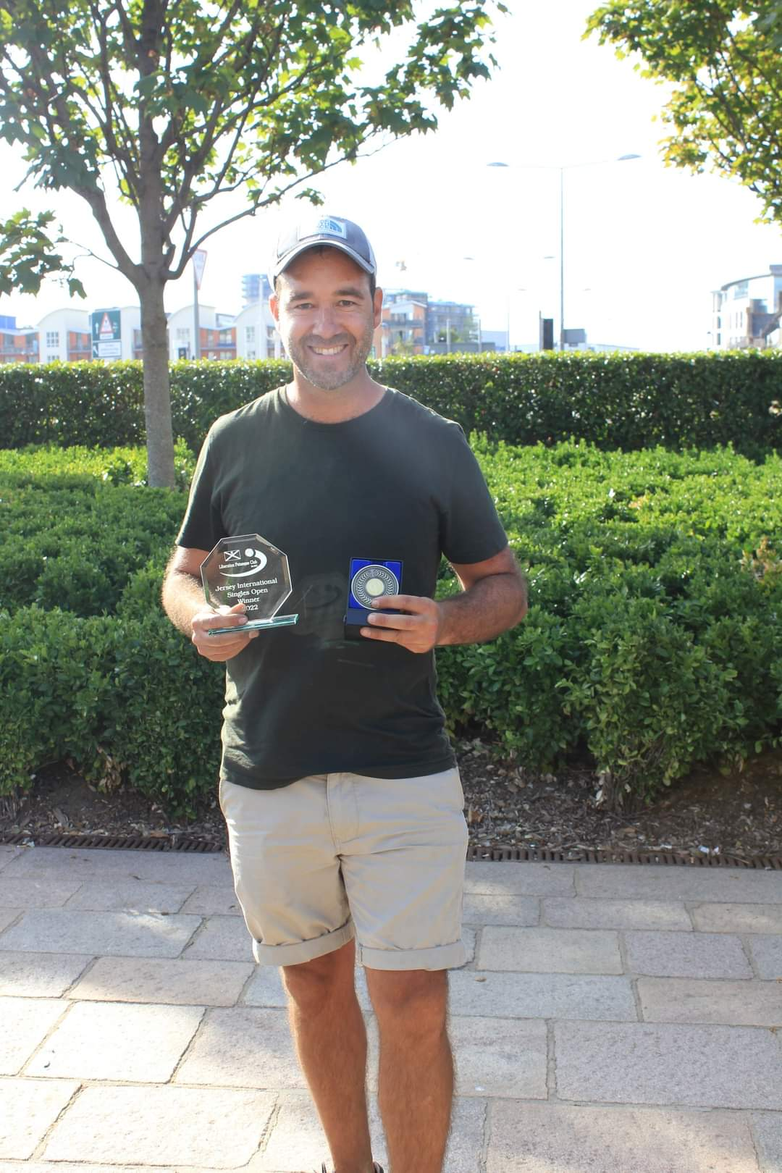

Thanks to all those who helped, especially Dawn Buckley on the day to make it another great competition.

Sponsored by



CoinShares | Digital Asset Investment Strategies for Professionals 🚀

Club email address - liberationpc@gmail.com

Club Website - www.liberationpetanque.co.uk

Kind Regards

Toby Northern

Chairman

Liberation Petanque Club

