Strange Stuff

Prophecies of the Removal of the Wicked

From "The Book of Enoch the Prophet" by R.H. Charles, Chapter 1 Verse 1:
"The words of the blessing of Enoch, wherewith he blessed the elect and righteous, who will be living in the day of tribulation, when all the wicked and godless are to be removed.

The words of YAHUSHUA Messiah:
Matthew 13:49 So shall it be at the end of the world: the angels shall come forth, and sever the wicked from among the just,
50 And shall cast them into the furnace of fire: there shall be wailing and gnashing of teeth.

Many people experience some strange things in their lives and are reluctant to share them with others, perhaps fearing rejection by friends and society. I once went on a Full Gospel Business Men's Advance where some of the men began talking about the visions they had seen. It was then that I found that other Christian people had experienced seeing visions, and that it was more common than I thought.

Spiritual experiences will usually leave us asking questions, like, "what was that thing that I just saw?". The bible records that the prophet Daniel was shown many things and when he inquired what the meaning was he was told that the meaning was shut up until the time of the end.

Strange Stuff

The prophet Ezekiel in chapter 1 was visited by four angelic beings each having four faces, the face of a man, the face of a lion, the face of an ox, and the face of an eagle. That sounds pretty bizarre, but is entirely normal in spiritual visions and visitations. It turns out that the four faces may be symbolic of the four quadrants of the heavens known as the mazzaroth. The One seated on a throne in the sky above the four angelic beings was YaHuWaH Elohim, the Ruler of the universe. Please check out Ezekiel chapter 1 for the wild descriptions of living beings and living wheels.

There's the testimony of Gary Stearman, a member of the family who owned the Stearman Aircraft Corporation established in 1927. Boeing still owns the military portion of the Stearman operations today. Gary tells of flying to a meeting in his private aircraft, and having enough gasoline to fly for 2 hours. He was accompanied by a UFO during his flight and ended up being 3 hours late for his scheduled meeting in a plane that could only have flown for 2 hours. His wristwatch said that 2 hours had transpired during the flight, but 5 hours had actually transpired. Strange stuff.

Author Benjamin Baruch tells of going with some friends to pray at about midnight, the group praying for about 5 minutes, and then immediately it was 7 AM.

These are the kinds of things that occur in the presence of supernatural beings.

A Personal Experience

At the age of six I said to myself "God will be my Father" after being disheartened because my parents had visited with me and then left me again to live with my grandparents while they went to a distant city to work. Now I know that YaHuWaH Elohim heard what I said. He's now my Father and I love Him.

At the age of 12, I went to sleep one evening and during the night found myself standing outside our home by the side of the street. A street light illuminated the area. I was facing east and in the moonlight I saw two triangular objects race across the sky, coming from the north. One of the objects made an abrupt 90 degree turn and landed at my feet, while the other object continued to fly south out of sight.
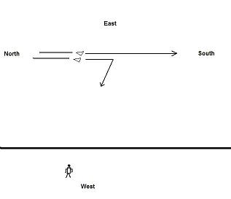

I picked up the triangular object. It was the color of olive drab and shaped like a flattened pyramid.
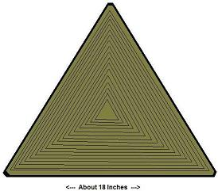
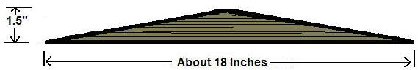
It had grooves like the grooves of a phonograph record on its surface. I ran my hand over the grooves and I could feel them vibrating. There was information encoded in the grooves.

I then took the object and flung it underhand up into the air toward the east from where it had come, and it flew away, it didn't spin, it flew straightly, and made an abrupt 90 degree turn and flew southward at high speed.

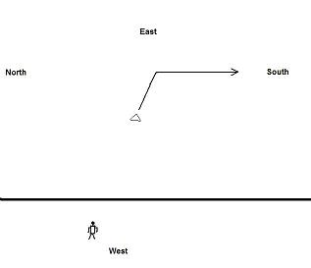

A few seconds later both triangular objects came flying from the south at high speed, passed by in the sky, and continued northward returning toward their point of origin.

Then I was immediately back in my bed. Maybe this was just a dream. If it was, it's the most vivid dream I've ever had.
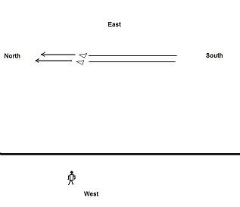

Just recently I've come to understand that in the extreme north is the location of the throne of YaHuWaH Elohim. This is the direction the triangular objects came from. I've also come to understand that at about 12 years of age is the Bar Mitzvah, a ceremony where a boy can read from the Torah for the first time. Twelve years is the age when YAHUSHUA (Jesus) was found by His parents to be in the Temple in Jerusalem beginning to engage with the Torah teachers as an adult. All that I can surmise from this strange event is that the information I received from running my hand across the grooves in the triangular object was something akin to a boy reading from the Torah for his first time. I wasn't particularly religious through my teen years, just attending church from time to time, with no other odd experiences for years before or after this event.

I've wondered about this strange experience once in a while through the years. I had no other strange experiences like this one, until about 20 years later.

At the age of 32 years I became involved with researching UFO's. Strange events then began to happen. It was the most horrendous period of my life. I would not want what I went through at the age of 32 to happen to anyone, so I discourage everyone from investigating UFO's without knowing and practicing the power and authority of YAHUSHUA Messiah. Unfortunately, the extremely terrible time that I went through in 1978 is probably going to be the experience of millions of people on earth soon. I won't go into the details right now, but I can understand why the bible says that "men's hearts will be failing them in fear of what's coming upon the earth". The bible is quite clear that angelic beings will administer the plagues and judgments of Almighty YaHuWaH Elohim.
What most people don't understand is that, because He's the Creator of the universe, YaHuWaH Elohim owns the earth. Man was created by Elohim from the dust of the earth. Therefore YaHuWaH Elohim owns us, and He will do whatever He wants to do with us. He has given us instruction, but few today follow His instruction. Repentance has been commanded. A time of judgment is set. The End.

Strange Cattle Mutilations

There are many instances of strange cattle mutilations occurring currently in the western United States. The situation is described beginning at about 9:50 into this video featuring Gary Stearman as host: https://www.youtube.com/watch?v=cXHdvgpnkDA

Yes, he's the same Gary Stearman mentioned above who flew his airplane for 5 hours on 2 hours worth of gasoline while experiencing a UFO flying nearby. Albert Einstein discovered that if a person could travel fast enough, time for that person would slow down. That means the Messiah could leave the earth and then return to earth thousands of years later and only have aged a few days Himself, if He travelled fast enough while He was away. That's basic Einsteinian relativity. But there's more at play here with these supernatural occurrences than we yet understand.

In the video link above we find that the cattle mutilations now occurring in the western USA are very strange. The cattle have been found to have their eyes, tongues, and sex organs precisely surgically removed.

There is coming a future battle in northern Israel that is described in
Zechariah chapter 14.

Zechariah 14:12 And this shall be the plague wherewith YaHuWaH will smite all the people that have fought against Jerusalem; Their flesh shall consume away while they stand upon their feet, and their eyes shall consume away in their holes, and their tongue shall consume away in their mouth.

What's interesting is that the soldiers who will be destroyed in that battle against Jerusalem will be found to be missing their eyes and tongues, just like the missing eyes and tongues in the recent strange cattle mutilations in our western states. Might these cattle mutilations be a kind of spiritual warning of what's coming to the humans who are YaHuWaH 's enemies and come against HIM in the end times?

