**Atoms and Molecules** Matter, or ***STUFF*** 😉, is composed of **ELEMENTS.** Elements can also be called atoms. They contain **PROTONS**(+), **NEUTRONS**(0) and **ELECTRONS**(-). Protons and neutrons are located in the nucleus of an atom. Electrons revolve around the nucleus in an **ORBITAL (valence)**. Orbitals closest to the nucleus contain electrons with less potential energy. The inner orbital can hold two electrons. Outer shells can contain eight electrons each and are stable only when full (octet rule).   
<https://www.youtube.com/watch?v=6Ecr7m-0E0E>

Atoms bond with other atoms which allows their outer orbitals to “contain” eight electrons.

The **elements(atoms)** are organized into the **Periodic Table** of **108** known elements each with a letter symbol. Interestingly, there are just six common elements; **C, H, N, O, P, and S,** whichmake up most of the atoms found in living organisms.   
Each element has an **ATOMIC NUMBER** found above the symbol which equals the number of protons or electrons of an atom.   
There are always the same number of protons (+) as electrons(-) in an atom. BUT, below each symbol is the **ATOMIC MASS** which equals the number of protons and the number of *neutrons* added together. If the Atomic Number (# protons or # electrons) is not approximately “half” of the Atomic Mass (protons and neutrons), the atom is an **ISOTOPE** of the element. Isotopes may be radioactive and can be used to identify, trace and treat as they “decay”. Decaying is nothing more than the predictable release energy by this unstable atom trying to balance out its proton/ neutron numbers. Check out this link that explores radioisotopes:  
<https://socratic.org/questions/what-are-radioisotopes>

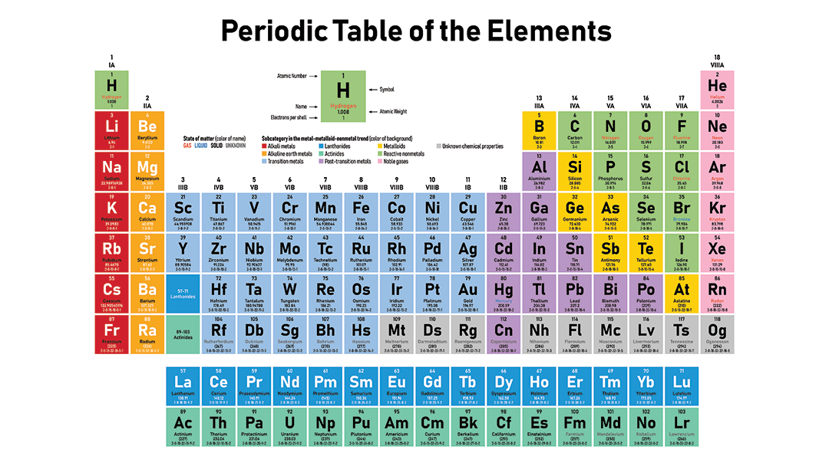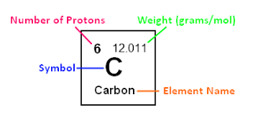

Molecules are atoms that have bonded together. Atoms bond together in an attempt to fulfill the octet rule.   
<https://www.youtube.com/watch?v=4OKy782ePKM>

Bonds may be:  
A. **IONIC:** electrons are *transferred* between atoms, creating   
 + (cations) and – (anions) ions. These ions then are attracted to one another. Opposites attract! Ex.: Na+ plus Cl- = NaCl  
  
   
  
  
  
  
B.**COVALENT**: electrons are *shared* between atoms   
 to fulfill the octet rule.   
  
   
  
There are two types of covalent bonds:

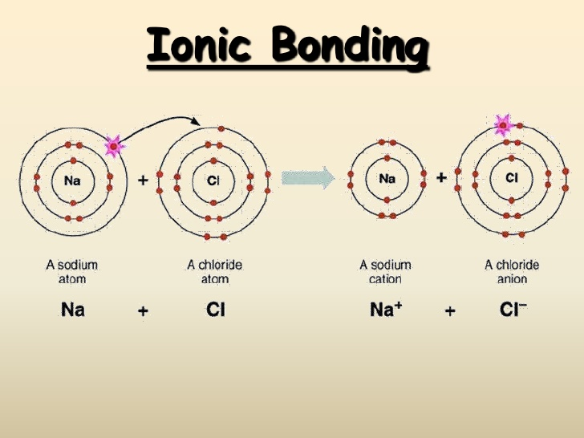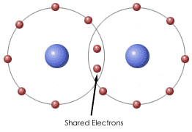

a. **NON- POLAR, COVALENT** bonds exhibit equal sharing. In methane, as an example, the electrons shared between the Carbon and Hydrogen atoms are shared evenly, spending as much time rotating around the Carbon nucleus as the Hydrogen nuclei.

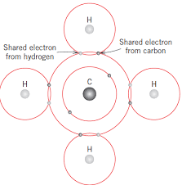

b. **POLAR, COVALENT** bonds exhibit unequal sharing due to

differences in **ELECTRONEGATIVITY** of the bonded atoms.   
Example: water = H2O. Water has two hydrogens and one oxygen. Each hydrogen shares its electron with the oxygen which shares its electrons with the hydrogens. But the electrons are shared unevenly spending more time around the nucleus of the oxygen atom. That’s because oxygen is more electronegative than hydrogen meaning it has a stronger attraction for shared electrons than hydrogen.   
   
When polar covalent bonds occur, it sets up a partial positive and partial negative charge at the two ends of the bond. These aren’t ionic charges but rather partial charges that occur because the shared electrons are unevenly distributed.  When molecules exhibit polar covalent bonds we call them **polar molecules.   
  
Hydrogen Bonds** occur when two **polar molecules are attracted to one another.** This occurs because the partial positive end of one molecule is attracted to the partial negative end of another.[**https://www.youtube.com/watch?v=m-v5G8C70pc**](https://www.youtube.com/watch?v=m-v5G8C70pc) Single Hydrogen bonds are **weak attractions** between polar molecules. BUT, they are VERY powerful when multiplied in number. The two halves of your DNA is held together by bajillions of hydrogen bonds.   
 **Water** is the ultimate polar covalently bonded compound and makes up 70-90% of life. The hydrogen bonds between water molecules provide water with the ability to exhibit may REALLLLY important features such as:  
  
  
what this: <https://www.youtube.com/watch?v=z5Vm56Pu4hU>

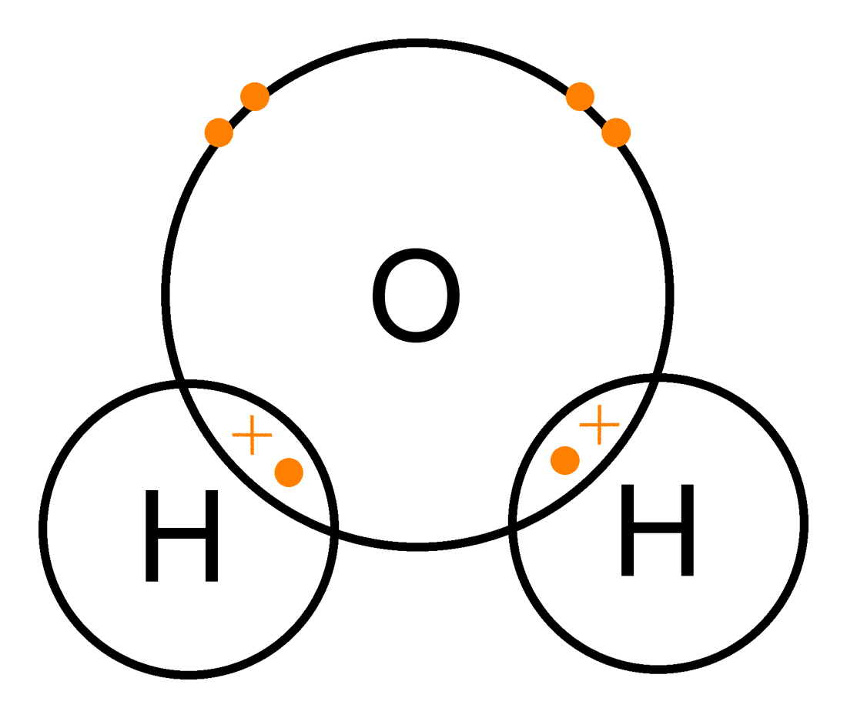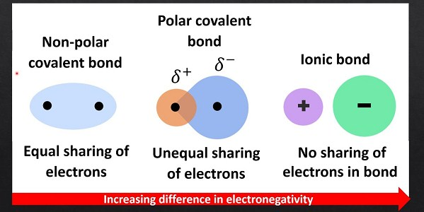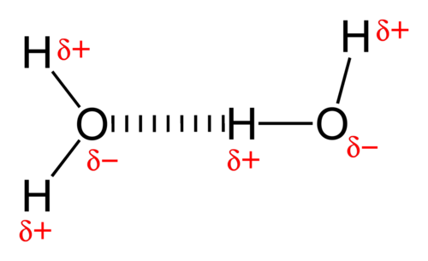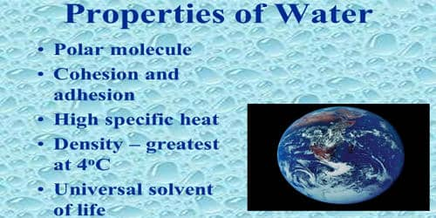

**What about pH?** What does it mean when you hear about the pH of something?  
<https://www.youtube.com/watch?v=KfWvdSyW6Io&t=102s>

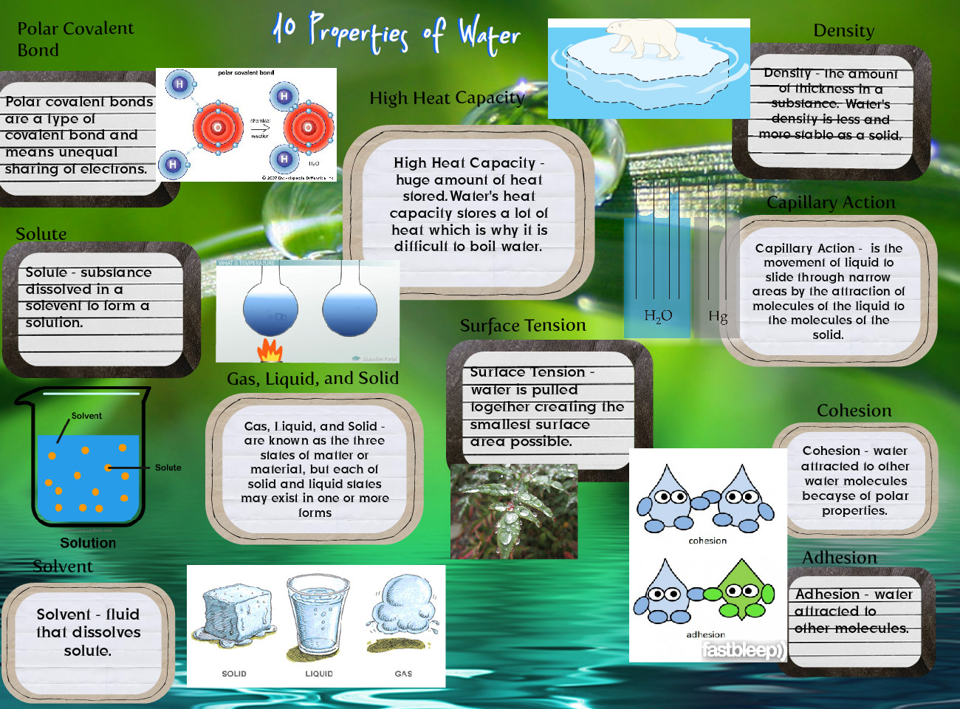

The pH scale measures the concentration of [H+] in a solution. The pH values range on a scale from 0 to 14

0= VERY acidic/A LOT of H+ 14 = VERY basic/little H+.

7 = Neutral

Water has a neutral pH of 7. Acids have a pH < 7. When they dissociate in water, they release H+ ions making a solution MORE acidic by **adding more H** to the solution. Bases have a pH >7. When they dissociate in water, they release OH- making a solution LESS acidic with **less H** because the OH combines with the H to form water = H2O!   
   
So, a solution with a high H concentration is acidic and one with low H concentration (but high OH) is basic.   
   
A pH of 14 is very basic/less acidic. A pH of 2 is VERY acidic, less basic.

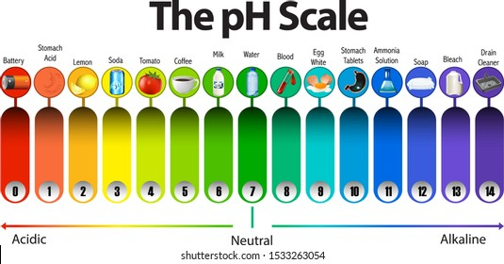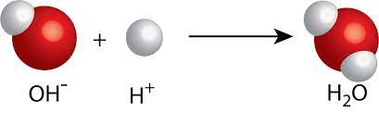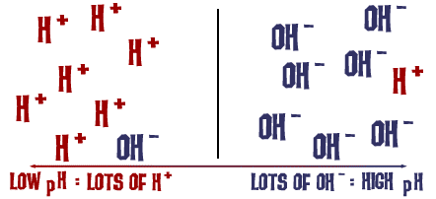

FYI…What is *acid rain*?? <https://www.epa.gov/acidrain/effects-acid-rain>

**So, what is a chemical equation or formula?**

Chemical equations describe an interaction between/among molecules.   
 **Equations are just molecular stories.**Equations must always be balanced. What goes in to an equation (left side) must come out of the equation (right side)!

An example of a common equation is the description of your metabolism.  
The process is called cellular respiration…

we eat, intake oxygen🡪exhale carbon dioxide, make water, get energy   
   
  
 food + oxygen 🡪 carbon dioxide + water + energy

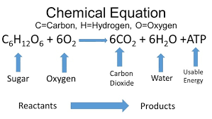

Notice that there are numbers before some of the molecules. These serve to “balance” this equation. For every 6 Carbon atoms that enter the equation, 6 Carbon atoms have to be exit the equation. Same for the Hydrogen. Same for Oxygen. It’s like solving a number puzzle…   
 <https://www.youtube.com/watch?v=MVJRrW1BqOQ>

So, that’s our basic chemistry info. Next time, we’ll explore Organic molecules which are molecules which contain Carbon. YOU are a   
**carbon-based** life form…

The link below…well, I just couldn’t help it…  
 <https://www.youtube.com/watch?v=Sx0xOgFDXFg>