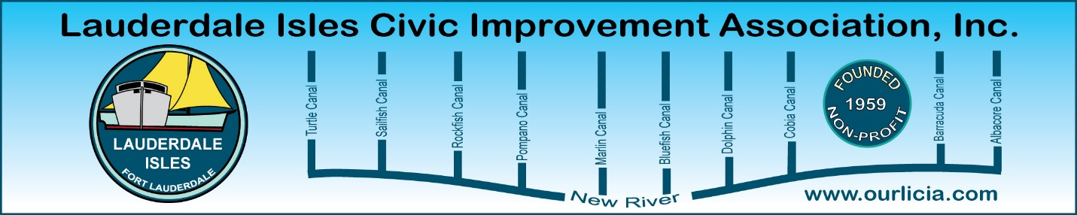
Minutes of the Lauderdale Isles Civic Improvement Association Board Meeting Zoom call June 19, 2025
The meeting was called to order by our President Earl Prizlee at 7:05pm.
Roll call was taken.
Present: Earl Prizlee, Geoff Rames, Karen Rames, Dick Cahoon, Dawn Hannah, Julie Gordon, Glo Knowles, Joann Kratky, Trent Simpson, Eric Silva, Rick Cunningham
Absent: Penny Shea, Aynsley Geramanis, Jackie Zumwalt, Andrew Silverman
FLPD report: Officer Kerri Haggerty, representing the police department, reported a single incident at Riverland Woods Park where a boat and trailer were stolen, with the boat later found abandoned and tied to a random dock. The group discussed the unusual circumstances of the boat's recovery, including the absence of hull numbers and the possibility of insurance fraud.
Code Compliance: Matthew Flesher presented current enforcement statistics, including 14 compliant cases, 19 closed cases, and 48 pending compliance cases. The top five violations were solid waste handling and containment, public nuisance, bulk trash, storage on residential property, and exterior maintenance. Matthew agreed to provide addresses of vacation rental violations upon request. Geoff reported a large Airbnb violation incident on Gulfstream Lane where police were called but no report was initially filed. After following up with a sergeant, Geoff was assured a report would be generated, as it's required for Airbnb-related incidents.
Earl is working with Parks and Recs to develop a fence plan for Lauderdale Isles Landing to address parking issues, particularly where people drive onto grass areas and damage the concrete wall.
Treasurer reports: No Treasurer reports were available. The Board discussed the need to find someone to help Andrew with the treasurer's duties. Dawn offered to help catch up on the Treasurer's work, and Geoff suggested calling Andrew to discuss the situation further.
Secretary reports - Board Meeting Minutes: For the April minutes, Geoff made the motion to approve, Dawn seconded and all approved. For the May General Zoom Meeting minutes , Geoff made the motion to approve, Dick seconded the motion, and we all approved.
Vacation Rentals update: The Board discussed ongoing issues with Airbnb rentals in our neighborhood, particularly regarding noise and party disturbances. We expressed frustration with the police inadequate response to complaints, highlighting communication breakdowns and a lack of proper procedures. Earl proposed a solution involving registration numbers and visible symbols on Airbnb properties to help officers identify and properly document violations.
We agreed that police should document visible violations while code enforcement should handle more comprehensive checks. We decided to approach the new City Manager about these concerns, potentially meeting with her before the next general meeting to present a list of issues and questions. We plan to invite her for a friendly meeting and then present our concerns, including the lack of code enforcement on Monday, Tuesday and Wednesday nights and proper reporting by Police.
The Board discussed strategies for addressing problematic Airbnb rentals, emphasizing the importance of compliance and the three-strike rule while maintaining a focus on legal actions rather than public statements. Geoff shared experiences with code enforcement and police responses to noisy parties, highlighting issues with citation procedures and the need for proper documentation. Earl stressed the importance of consistent enforcement and the need to avoid situations escalating to violence, while Dawn and Geoff agreed on the necessity of following the established citation process. We plan to follow up with the City Manager and continue discussions in an upcoming board meeting. Amy Brown to follow up on the $15,000 fine case for the Nassau Lane Airbnb incident.

Fort Lauderdale Green Your Routine Program: Geoff introduced the Fort Lauderdale Green Your Routine program, which awards points for participating in various civic activities, with each point worth $45. Our Association could earn money for activities like attending meetings, participating in waterway cleanups, and organizing neighborhood events. Trent and others expressed interest in joining, and Geoff agreed to send out information about the program. We agreed to review the program details and potentially appoint a representative to attend the bi-monthly meetings.

Lauderdale Isles Water Management Report: Geoff highlighted Marco Aguilera’s contributions, including his work on developing procedures for sunken boats and mangrove planting projects, which have been well-received by the City Manager. Geoff also shared details about Marco's initiative to secure a grant for a pump-out boat to address the lack of such facilities in the area, with contributions from various organizations to cover the initial costs and operations.
August Newsletter: Geoff discussed the August newsletter, emphasizing the need for articles by July 25th, and Dawn mentioned she had obtained photos of a boat fire in Whale Harbor from Channel 10.

Port A Potty: Earl advised Carl Williams is consulting with the adjacent neighborhood about the need for a Port a Potty in Civic Peoples Park to let us know the feedback from other neighborhoods about keeping or removing the port a potty in this park.
Next General meeting August 21: Earl will invite the City Manager to be our guest speaker at our August General Meeting. Our goal is for AirBNB compliance. Board Members: Prepare a list of concerns and questions regarding code enforcement and vacation rental issues for Earl to present to the City Manager before her attendance at the next general meeting and draft a formal request for code enforcement coverage on Monday, Tuesday, and Wednesday nights.

Motion made by Geoff to adjourn the meeting. Dick seconded and all approved. The meeting ended at 8:25pm.

Submitted by Karen Rames, Secretary

