5/13/2017 The Jerusalem Eclipse and Babylon

The last total solar eclipse to cross Jerusalem occurred on 8/20/993 AD. The next one will occur on 8/8/2241, about 1248 years later. Jerusalem is the only city on the face of the earth that YaHuWaH Elohim has chosen to be His residence. We will explore some events that occur at 500 year intervals from the last Jerusalem solar eclipse of 993 AD.

Below: A graphic indication the events at the time of the 500th year of the last Jerusalem total solar eclipse of 993.

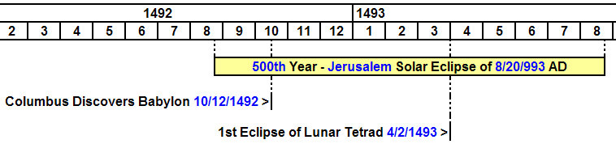

Some major events occurred during the 500th year from the last Jerusalem total solar eclipse.

A lunar tetrad began, an unbroken sequence of four total lunar eclipses in a row, falling on YaHuWaH Elohim's appointed Feast days of Passover and Sukkot. The next unbroken sequence like this one in 1493 - 1494 would begin to occur 456 years later in 1949, just after Israel became a modern sovereign nation.

Below is a look at some of the events that occurred during the 1000th year from the last Jerusalem total solar eclipse of 993 AD.

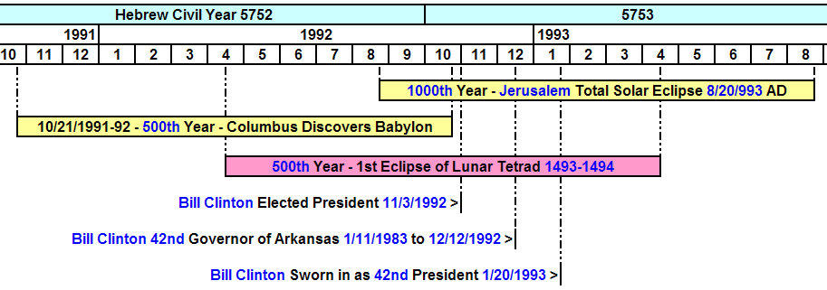
Bill Clinton became President of modern Babylon the great during the 1000th year from the last Jerusalem total solar eclipse of 993 AD.

The 500th anniversary of the discovery of America by Columbus was on 10/21/1992, during the 1000th year from the Jerusalem eclipse. The date, 10/21/1992, is not a mistake. Although Columbus discovered land on the morning of 10/12/1492, there were 10 days removed from the Roman calendar in 1582 that causes the 500th anniversary, exactly 182,621 days after 10/12/1492, to fall on 10/21/1992.

We also note that the 500th anniversary of the lunar tetrad of 1493 - 1494 occurs during to 1000th year of the Jerusalem total solar eclipse. The first eclipse of the lunar tetrad in 1493 fell on 4/2/1493. Again, because of the 1582 calendar shift, the 500th anniversary of the 1st lunar eclipse in the tetrad of 1493 - 1494 is 4/11/1993.

We recall that it was on 4/11/1996, exactly 3 years to the day from the 500th anniversary of the 1st lunar eclipse in the tetrad of 1493-1493 mentioned above, that comet Hyakutake was ordained by our Creator Elohim to cross the forehead of Medusa in the constellation of Perseus. A year later another comet crossed Medusa's forehead, placing an "X", a Paleo Hebrew end mark, on the image.

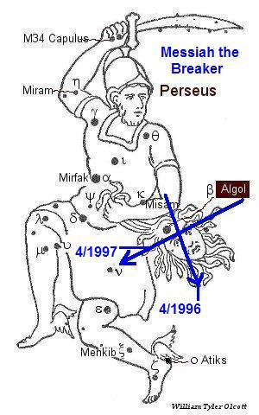
Above: An "X" was placed on Medusa's forehead by our Creator Elohim beginning on 4/11/1996 and ending on 4/11/1997, beginning exactly 3 years to the day after the 500th anniversary of the 1st eclipse of the lunar tetrad of 1493-1494.
The graphic below investigates the timing relationship between the 500th anniversary of the discovery of the land that would become Babylon the great, and the deaths of David Koresh and his congregation in their church building in Waco, Texas, on 4/19/1993.

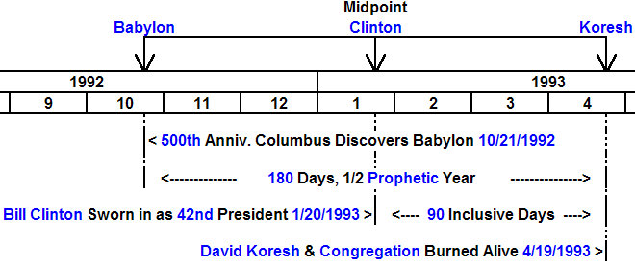

The timeline above reveals that exactly 180 days exist between the 500th anniversary of the discovery of Babylon by Columbus, and the Waco tragedy on 4/19/1993 when at least 74 people, including infants, were burned alive in their church compound by agents of Babylon the great.

David Koresh stated that his heavenly Father told him that he and his people were to be for signs. The graphic above seems to confirm his statement.

Notice that the graphic above reveals a chiasm, an emphasized central event at the midpoint, the day on which Bill Clinton officially became President, 1/20/1993. We have examined President Clinton's conception timing in past articles, and have seen that the 72nd anniversary of his conception will occur on 11/13/2017, a significant date that was also treated in a previous article. The 72nd year has to do with a biblical doubling of the judgments allotted to Babylon by YaHuWaH Elohim.

Below is a graphic that concerns lunar tetrads.

The last lunar tetrad that occurred on the Feast Days of YaHuWaH Elohim was in 2014 - 2015. The next similar event will occur more than 500 years in our future in the years 2564-2565.

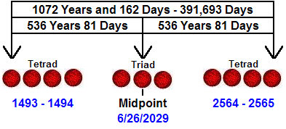

The above graphic reveals the lunar tetrads of 1493-1494 and the next one in our future during 2564-2565.

The country that would become Babylon the great was discovered in 1492. Note in the graphic above that there are 1072 years between the outer eclipses of the tetrads. We can easily think of 1000 years and then 72 years. Remember the 72 years arrived at by doubling the number 36, the number of the Babylonian gods who's individual numbers added up to 666, all arranged on the Babylonian Magic Square "good luck" amulet. In case you don't know, the word "luck" is derived from the word "Lucifer".

Note that the emphasized midpoint of the entire 1072 years and 162 days in the graphic above is 6/26/2029.

Note also that either side of the midpoint is the period of 536 years, which might be broken down into 500 years + 36 years + 81 (9 x 9?) days.

On 6/26/2029 there is a total lunar eclipse that passes directly through the center of the earth's shadow. It's a very precise timing event, and precisely centers in earth's shadow.

Below is a graphic showing the location in the sky where the lunar eclipse will occur at 3:23 UT.

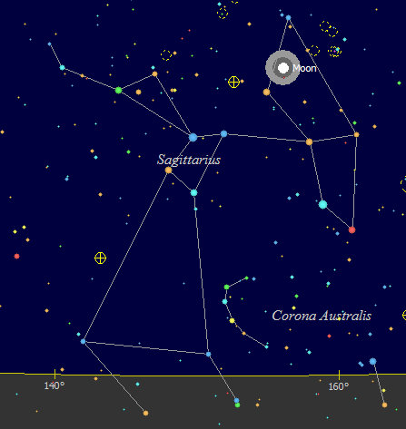

We might wonder what will be happening on the earth at that time in 2029. Whatever is happening, YaHuWaH Elohim and His Son YAHUSHUA will be the only correct answer.

Previous articles are available here: http://www.joybysurprise.com/articles.html

