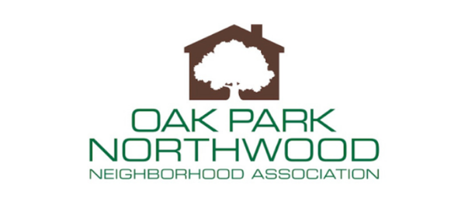
Board Meeting
Tuesday, September 19, 2023 at 6 p.m.

- Welcome
- Approve August 15, 2023 Board Meeting Minutes
- Treasurer’s Report
- President’s Report
  - CCPF Funds approved $1,265
- Halloween Yard Decorating Contest
- Fall Membership Meeting Tuesday, October 17, 2023
  - 7 p.m.
  - St. Andrews’ United Methodist Church on Robinhood in Fellowship Hall
  - Board elections. Send intent to run to Gina Eisenberg at opnna09@gmail.com
- New Business/Announcements
- Adjourn

