**Enclosure 1: Pictures of Texas Township Devastation.**

These pictures are representative of the flooding situation and they show the devastation experience of Texas Township homeowners.

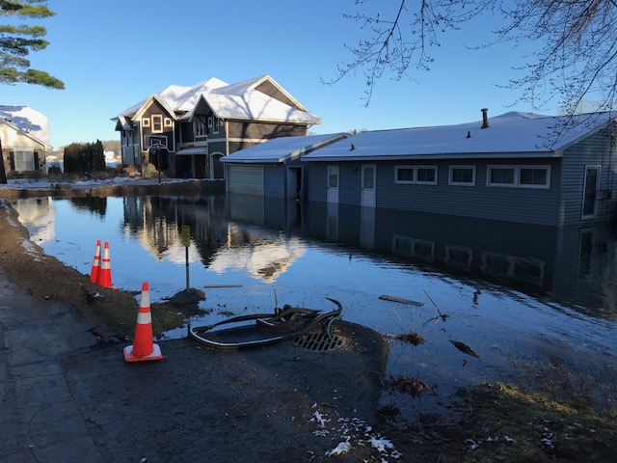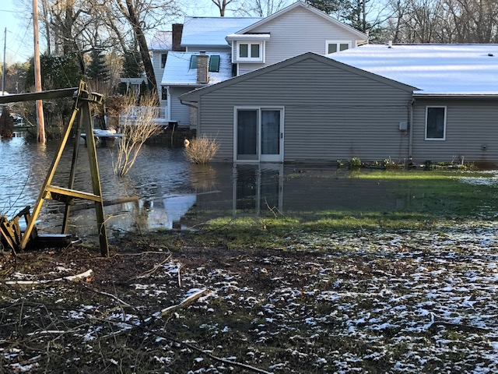

 

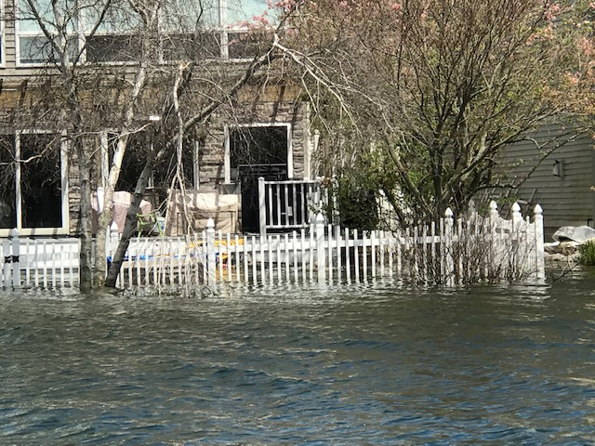

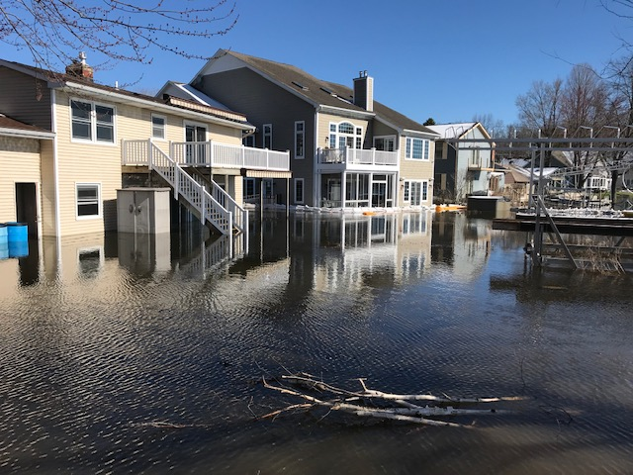

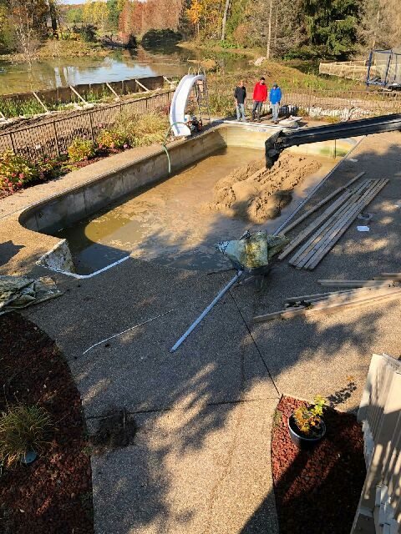

Swimming pool being filled with soil to prevent the collapse of pool walls and base by external ground water pressure.

House being raised in an effort to bring it above the water level and save the structure.

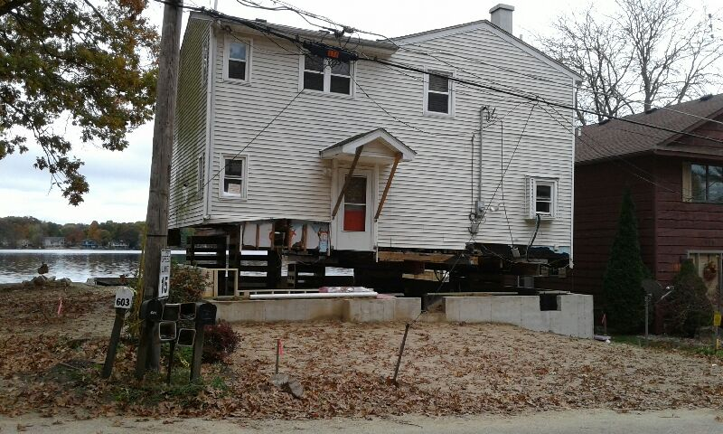

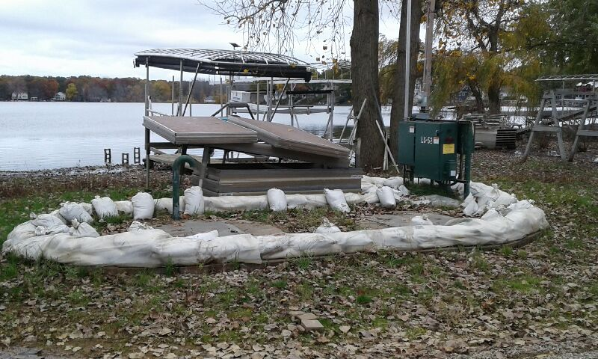 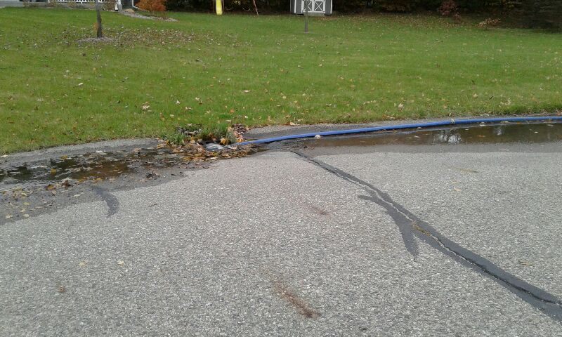

Sand-bagged sanitary sewer pump station. Sump-pump pumping into storm sewer