

Winter 2017-2018 Season

Pre-Season Report

November 2017

Welcome to the Winter League and also welcome new club member Mo De Gruchy, Laurent Pallaton, Luke Canavan and welcome back Dawn Buckley.

Premier League Doubles, can Jake Romeril & Ross Payne win again! They have won three out of the last 4 winter seasons, quite a formidable team.

It will be another tough season though with Matt Pinel teaming up with Toby Northern in the league for the first time. Can they transmit their incredible cup form to the league, their first 3 league fixtures couldn’t be any tougher though.

Geoffroy Buffetrille & James Gennoe
Callum Stewart & Andrew Bellamy-Burt
Ross Payne & Jake Romeril

Can Callum and Andrew rise back to the top having won the title in winter 2015 / 16 Season.

Alan Oliveira & Craig Kelly won the first ever winter Premier League doubles winter title in the 2011 / 12 season and return to the Premier league after being relegated in the winter 2015 / 16 season.

Could Alan & Mike, Colin & Steve, Cassie & Alex, Keith & Sue, Alice & Brigitte do a Leicester City and shock everyone and win the Premier League.

Division 1 could be anyone’s as last year showed with just three points separating first to sixth place. Matt Ryan & David Ibitson should be title favourites but I’m sure Brian & Paul, James & Tom, David & Susan and Neil & Dawn to name a few will push them all the way.

We have expanded to 3 divisions this winter following an influx of players which is great news and after a number of changes, back and forth, are they in or out, the final singles leagues have been confirmed!! (Well at least for now!)

Toby Northern will be looking to retain his winter Premier League Singles title, which he has won a record three times but will have work to do after being relegated in the Summer!

Will Geoffroy Buffetrille continue his fine form and add the winter title to his summer one!

Will Ross Payne stop escaping relegation by the skin of his teeth!

Will newly promoted Neil Selby, make an impact!

Will Andrew Bellamy-Burt be relegated!! Based on his form at the end of the summer season, could be relegation favourite? (Or not?)

We’ll soon find out.

Brian Harris has to try and win Division 1 again after being relegated last winter and James Rondel, Cassie Stewart, Tom McMinigal and John McGaw all in with a shout as are David and Susan.

Division 2 will see several new members take part,

Who will be the new rising star this season?
Will Brigitte Ibitson regain her place in division 1 after being relegated last winter?
Will Brendan Jones cope with the cold weather and win promotion.

Can’t wait to find out.

WEEK 1

Doubles League - Start time 10.00am

WEBSITE www.liberationpetanque.co.uk
EMAIL liberationpc@gmail.com



Kind Regards
Report Editor
Toby Northern
Liberation Petanque Club

SPONSORED BY



Winter 2017-2018 Season

Week 1

4th November 2017

Doubles League

Well the season got off to a slow start with just 4 matches being played and two of those by Alice & Brigitte Ibitson who played one match in advance from week 2 (18th November).
Alice & Brigitte fought back from losing the first game against Keith & Sue Pinel 13 -11 to gain a valuable draw in their scheduled match. They top the league though as they beat one of their week 2 opponents Colin Myers & Steve Simpkin quite easily, well at least that’s what the score line suggests. Colin & Steve already look to have an uphill struggle.
The only other fixture in the Premier league was between two of the big four teams, as Geoffroy Buffetrille & James Gennoe took on Matt Pinel & Toby Northern. It was a tight affair in the first game at 5 -4 to James & Geoffroy, before Matt fired Toby’s boule out, instead of James and four poor placing attempts left an easy 6 for James & Geoffroy, how ran out 13 – 5 winners. Game two started well again for James & Geoffroy who took for on the opening end before finding themselves 4 – 8 down. They again turned it around to lead 10 – 8, but some excellent placing by Matt and Toby through the puddle’s gave them the draw with a 13 – 10 win.
Division 1 saw just one match played between Jean Stewart & Chris Le Gallais v Harrison Marie & Richard Williams. It was a close match with Jean & Chris starting their partnership well with a 13 – 11 win in game one, but ever growing in confidence and skill Harrison & Marie took the second game for the draw.


Did you try our new feature – Super 6, 12 people did which included 1 none member. Look out for week 2 picks on Thursday.
Week 1 winner was Toby Northern.
NEXT WEEK

Singles League

WEBSITE www.liberationpetanque.co.uk
EMAIL liberationpc@gmail.com
Kind Regards
Report Editor
Toby Northern
Liberation Petanque Club

Winter 2017-2018 Season

Week 2

11th November 2017

Singles League

Welcome to the singles league season, hope you all enjoyed playing in the rain. Well for those who weren’t afraid of a bit of rain!

Toby started his defence of his title against the only person to beat him last winter, but was also the only person who he beat in the summer, David Ibitson. This time though a fair draw with both players playing really well.

Ross Payne was hoping to show Matt Buesnel how hard the Premier league is upon Matt’s promotion but it was Ross who found the going tough losing as Matt continues to improve.

Second and forth place from the summer Matt Pinel & Neil Selby played each other after Neil won Division 1 last winter. Nothing could separate the pair as they also drew. Alice Ibitson had a bye.

Division 1

Brian Harris was facing De Ja Vue as he again attempts to get promoted to the Premier League after being relegated last winter.

No matches though were played in the Division.

Division 2

Newcomers Laurent Pellation and Luke Canavan played each other but something tells me Laurent will be the one to watch in this division as he ran out a comfortable winner 13 – 4, 13 – 5.

Matt Hutchings just got over the line with a 13 – 12 win in the second game against Harrison Marie to take the full 3 points.

NEXT WEEK

Doubles League

WEBSITE www.liberationpetanque.co.uk
EMAIL liberationpc@gmail.com

Kind Regards
Report Editor
Toby Northern
Liberation Petanque Club

Winter 2017-2018 Season

Week 3

18th November 2017

Doubles League

A double fixture week saw Andrew and Callum hand out the first certificate of the season as they beat Toby & Matt 13 – 0 in game one and went on to win the match.

Toby & Matt then played current champions Ross & Jake, but despite winning the first game lost the second by a narrow margin for a draw. Ross & Jake lost their first game against James & Geoffroy in a real big weekend of matches in the Premier League.

Elsewhere Colin & Steve managed a draw against ever improving Cassie & Alex, but then lost to Brigitte & Alice.

Division 1 saw Laurent & Matt won their first match not only of the season but playing together against Lauren & Paul, well done a good start. The second match though not so good scoring just 6 points against Matt Ryan & David Ibitson losing 13 – 5, 13 - 1.

Brian & Paul won their second match in a row, before handing the game to Neil & Dawn in the second. Neil & Dawn lost their first match to Jean & Chris 6 – 13, 6 – 13.

9th December will also be a double fixture week as we pile in the matches before Christmas.

NEXT WEEK

Singles League

WEBSITE www.liberationpetanque.co.uk
EMAIL liberationpc@gmail.com

Kind Regards
Report Editor
Toby Northern
Liberation Petanque Club

Winter 2017-2018 Season

Week 4

25th November 2017

Singles League

Christmas Charity Doubles Open
Saturday 2nd December 2017

Top of the table Matt Buesnel was up against Andrew Bellamy-Burt. Not many people taking part in the Super 6 gave Matt a Chance.
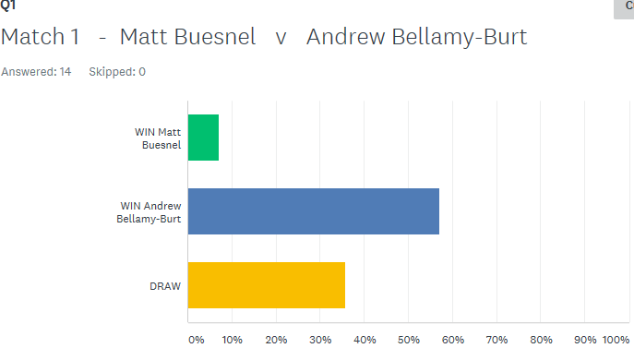

Matt though took the first game 13 – 8. The second game though went to a 12 – 12 shootout with Andrew taking that final point for a draw.

Matt Pinel forgot his boules, borrowed some from Magic Touch two sizes smaller than his normal ones and still beat Callum Stewart 13 – 6, 13 – 11!

Well if you’ve played Super 6 check this out!!!

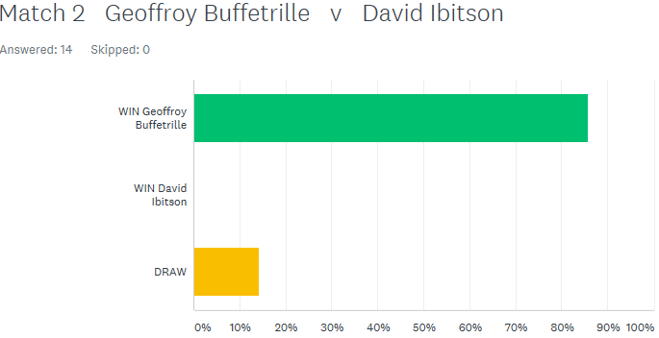

Not one person thought David Ibitson would beat Geoffroy Buffetrille, but that he did and comfortably as well, 13 – 7, 13 – 3! Well Done David who now tops the league on points difference.

Toby came back from 10 – 0 down in the first game to narrowly lose 13 – 10, before another 12 – 12 shootout saw Toby gain the draw, with Neil and Toby drawing their first 2 matches.

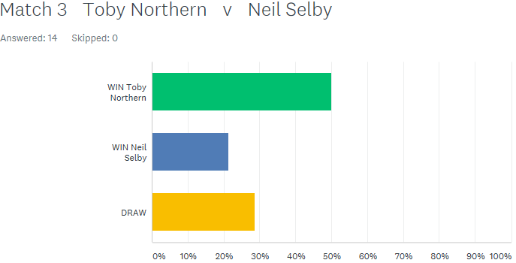

Well one person called this a relegation battle between Alice & Ross (come on! It’s only week 2!). Ross took the first match 13 – 6, but he may have had his own prediction in the Super 6 Tie-Breaker in the back of his mind (Ross picked himself to win the second game 13 – 9, three other people also picked this score), but it was Alice who won 13 – 5.

Cassie Stewart was the closest on the Tie-Breaker guessing 13 – 6 to Alice.

Division 1 saw its first match played with Brian taking all three points against Colin Myers, winning the second game 13 – 12.

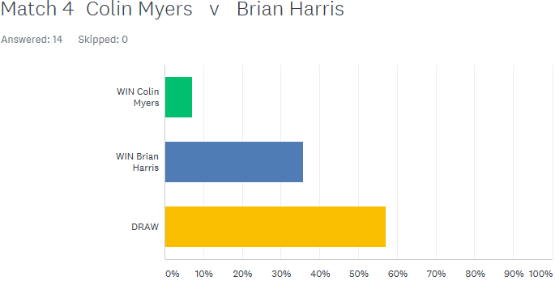

Paul Bell played his first Singles league matches for the club. Despite losing the first game against experience player David Le Gresley 13 – 10, won the second 13 – 2. Paul then just lost to Brian Harris 13 – 11, 13 – 10. Paul Bell will be one to watch this season.

Colin Myers lost his second match of the day to Cassie Stewart and David Le Gresley won his second but only just against Alex Stewart 13 – 11, 13 – 10.

Division 2

Laurent Pellation beat another new comer (although not sure Laurent is that new to the sport), Mo De Gruchy 13 – 1, 13 – 1 to top the table early on. Richard Williams beat Luke Canavan but only just with the second game going to 13 – 10.

Well after being relegated last Winter to division 2 not many people gave Brigitte a chance against Harrison, but 85% of people got the result wrong as Brigitte won 13 – 10, 13 – 8.

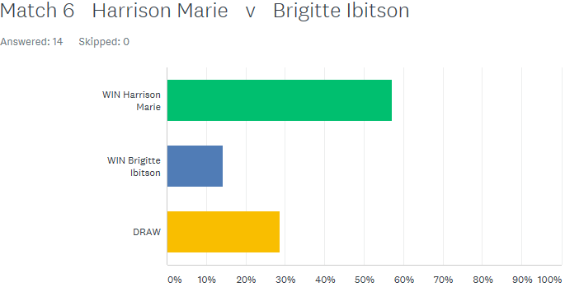

NEXT WEEK

Christmas Charity Doubles Open

WEBSITE www.liberationpetanque.co.uk
EMAIL liberationpc@gmail.com

Kind Regards
Report Editor
Toby Northern
Liberation Petanque Club

Winter 2017-2018 Season

Week 5

9th December 2017

Singles/Doubles League

Well the shocks continue this season as the puddles cause constant problems for many players.

Alex and Cassie Stewart both consistent players caused a big upset beating Matt and Toby 13 – 12, 13 – 4. Matt and Toby though rueing missed chances in the first game despite going 7 – 0 down.

A change in order with Matt placing and Toby firing in the next match saw a big change in fortunes as the pair ran out comfortable winners 13 – 8, 13 – 4.

Ross Payne and Jake Romeril needed a good result against Callum & Andrew and started well winning 13 – 8 but couldn’t make it 3 points losing the second game 13 – 6 handing a big advantage in the title race to Callum & Andrew.

An advance match was played between Ross & Jake against Alan & Craig, this time it was a win for Ross & Jake but Alan and Craig blew a big lead in game one.

So just 3 out of the 10 schedule matches played in the Premier League meaning 14 outstanding matches out of the 25 scheduled ones to date.

Division 1 didn’t play many either with just 3 out of 6 matches played. Neil & Dawn found form against Lauren & Paul to aide their promotion push.

Brian Harris & Paul Le Moine hold on to top spot with a difficult draw against fellow promotion hopefuls Tom & James.

Title favourites David & Matt did win their match against new pair Jean & Chris and will be tough to beat this season.

NEXT WEEK

Singles

WEBSITE www.liberationpetanque.co.uk
EMAIL liberationpc@gmail.com

Kind Regards
Report Editor
Toby Northern
Liberation Petanque Club

Winter 2017-2018 Season

Week 6

16th December 2017

Singles
A double header of fixtures right before Christmas would have a big impact on player’s league positions going into the New Year.
Two players joint top of the Premier League had to play each other first, in Matt Buesnel and Matt Pinel who played together in this year’s Men’s European Triples Championship in France. A big win for Matt B in game one was overturned in game two for a draw.
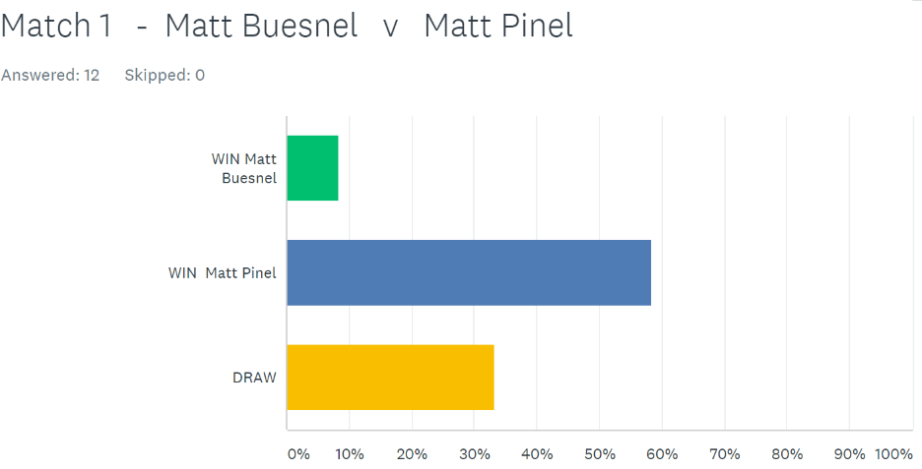
SUPER 6

Neil Selby with two draws before the start of the day took on Callum who finished 3rd last Winter after dropping vital points at the end of the season. Callum had only played 1 match so far losing to Matt Pinel. Callum took the first game in style 13 – 1, and was so close to making it 3 points but lost the 2nd game 13 – 11.
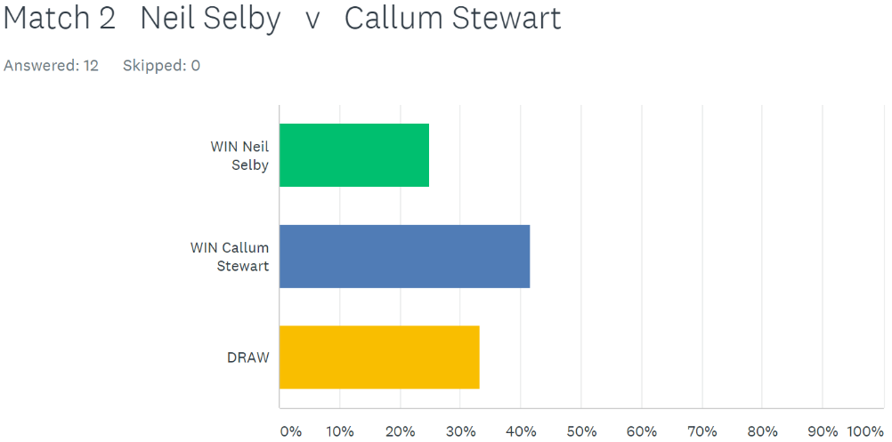
SUPER 6

Geoffroy Buffetrille was last year’s runner up and he played current champion Toby Northern. Geoffroy lost his first match against David Ibitson whilst Toby had drawn both his matches against David and Neil. Geoffroy though was on form today winning very comfortably 13 -3, 13 – 4. Geoffroy went on to also beat Neil Selby to move up to 3rd place.
Elsewhere Ross Payne had just 1 point from two matches, losing to Matt Buesnel and drawing with Alice Ibitson. Well after four matches still has one point after losing to Keith Pinel (including a 13 – 0!!!) and was nearly beaten 13 – 0 again by David Ibitson losing 13–1.
Alice Ibitson handed Matt Pinel a defeat to boost her league chances and hand Matt a huge blow in his title bid.
Matt Buesnel tops the leagues after beating Callum Stewart as he bids for his first ever Premier League title.
Division 1
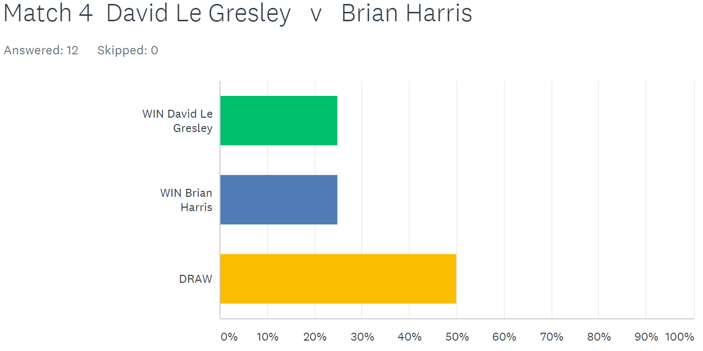
No surprise to everyone that Brian Harris tops Division 1 with 3 wins out of 3 after beating David Le Gresley and leads by 5 points after just four weeks.

Paul Le Moine joins his doubles team mate Brian in the top three with a win over Cassie Stewart and a draw with Colin Myers who stays bottom.
Alex Stewart lost to John McGaw who is on 4 points and in the top 3 along with Paul. John also drew with Paul Bell.
The Stewart’s (Alex and Cassie) did get one point each with a draw against each other.
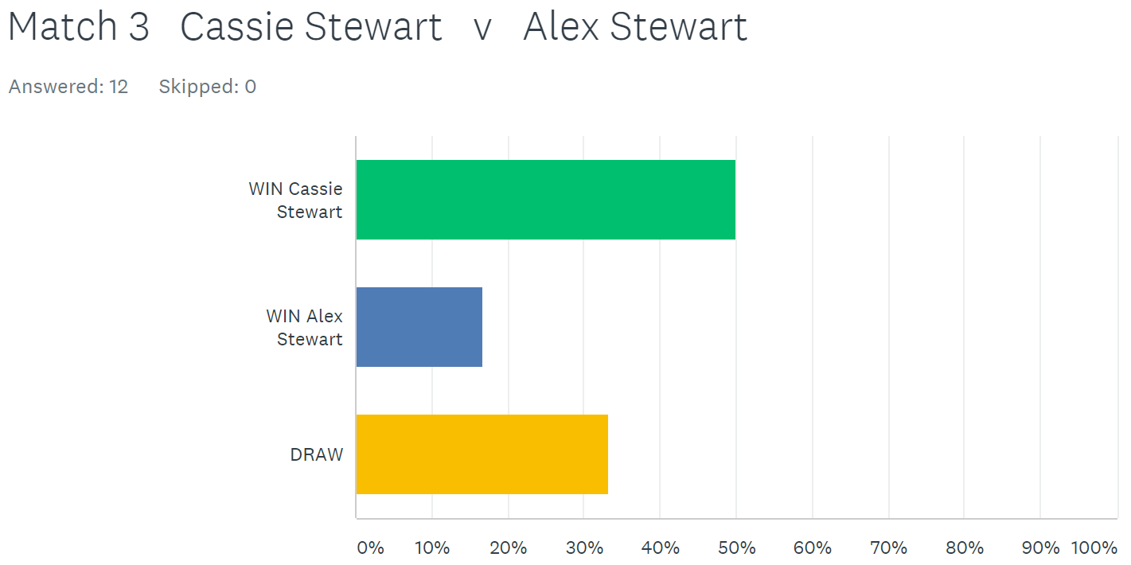

Division 2
Just 3 matches out of 8 in Division 2. Jean Stewart took on Matt Hutchings and was just one point from a win. Jean took the first game 13 – 5, before losing the second 12 – 13 to drop two valueable points. Jean though didn’t have any luck against Brigitte losing 13 – 11, 13 – 3.
Matt Hutchings must have used all his luck against Jean as he was well and truely beaten by Luke Canavan who won his first ever singles match at the club – well done Luke.
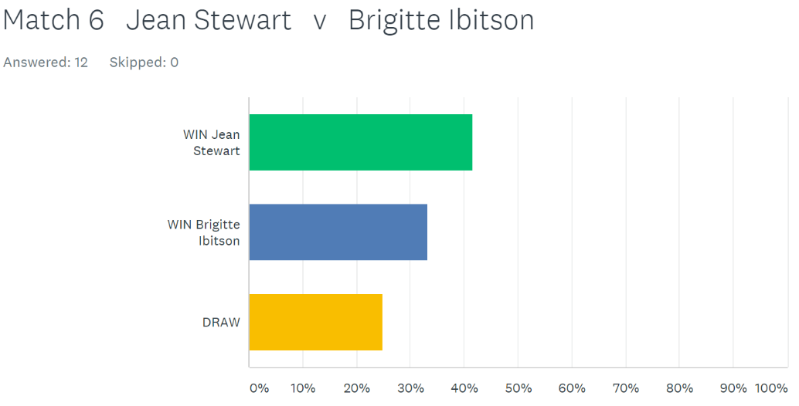

NEXT WEEK

FREE WEEK - Merry Christmas to everyone

WEBSITE www.liberationpetanque.co.uk
EMAIL liberationpc@gmail.com

Kind Regards
Report Editor
Toby Northern
Liberation Petanque Club

Winter 2017-2018 Season

Week 7

23rd December 2017

FREE WEEK

Winter 2017-2018 Season

Week 8

30th December 2017

Doubles League

Well a first for Liberation Petanque Club playing in between Christmas and New Year. Just 5 matches played though, four in the Premier League and one in Division 1.

League leaders and current champions Jake & Ross took on Brigitte & Alice who were just 2 points behind but with 2 matches in hand, so had a good chance to move into contention with a win. The real question though, was Ross going to rediscover some form to help himself and Jake to the win. According to Super 6 responses a win was the likely outcome.

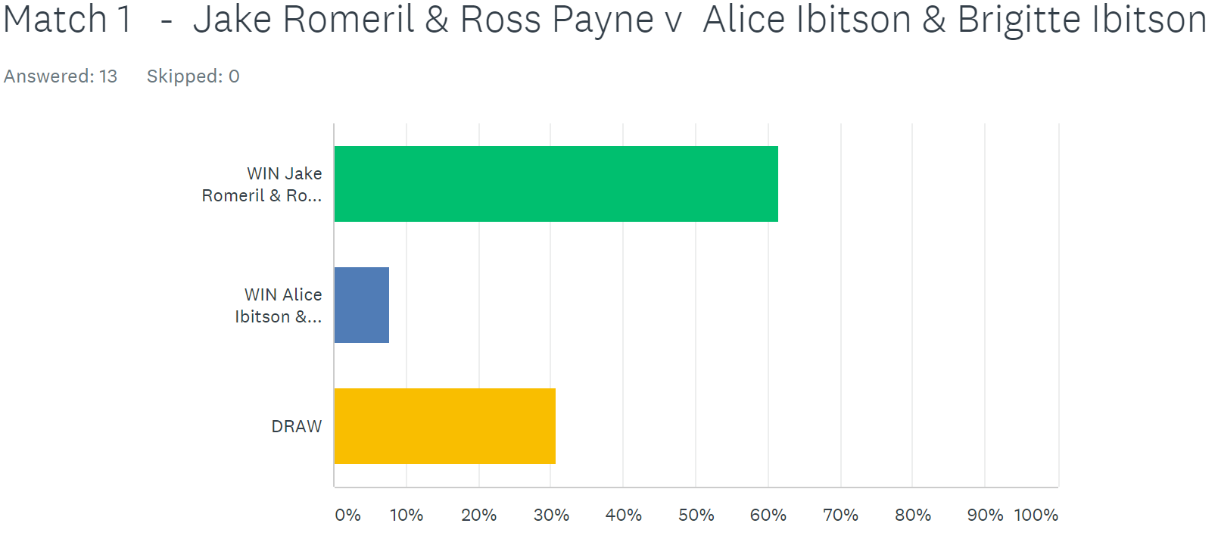

It was however a close affair with Brigitte & Alice taking the first game 13 – 12. But the champions came back to gain a valuable draw.

Joint favourites for the title though are now Andrew & Callum and James & Geoffroy, both on 4 points from two matches prior to today.

Andrew & Callum took on Cassie & Alex who had beaten Toby & Matt in the previous fixture to also move them to four points from two matches. Could Cassie & Alex gain another big scalp? Again Super 6 responses gave no chance of a Cassie & Alex win.

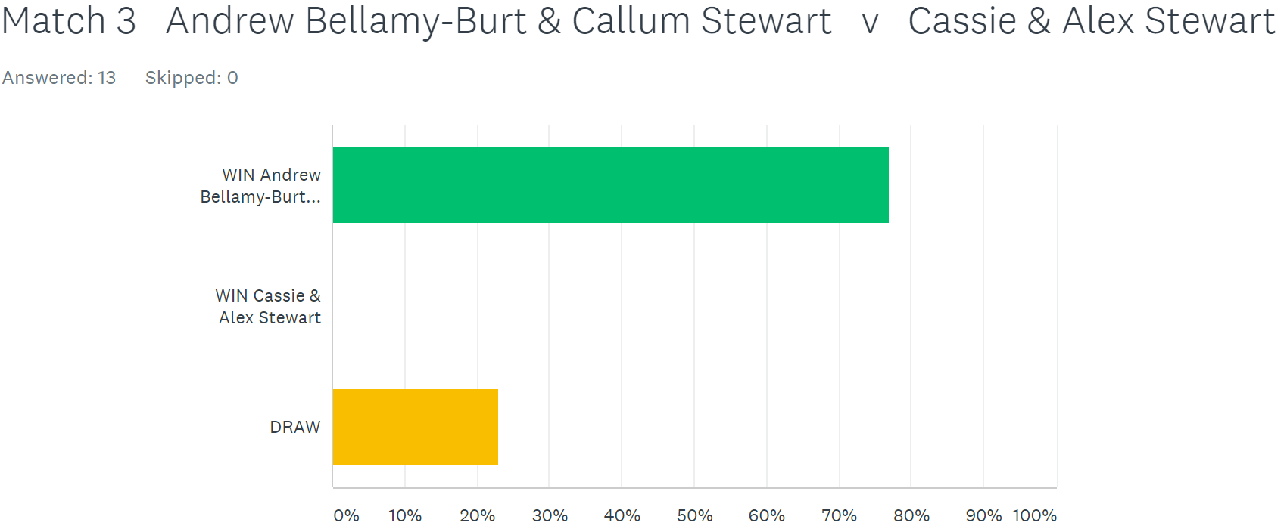

How wrong was everyone, as they took their second big scalp of the season with a fine win to move them into contention for the title.

James & Geoffroy played Keith & Sue who had just one point from two matches having lost to Colin & Steve in their last match and now look relegation candidates. Anything but a win for James & Geoffroy would result in a lot of unhappy Super 6 players as everyone predicated a win.

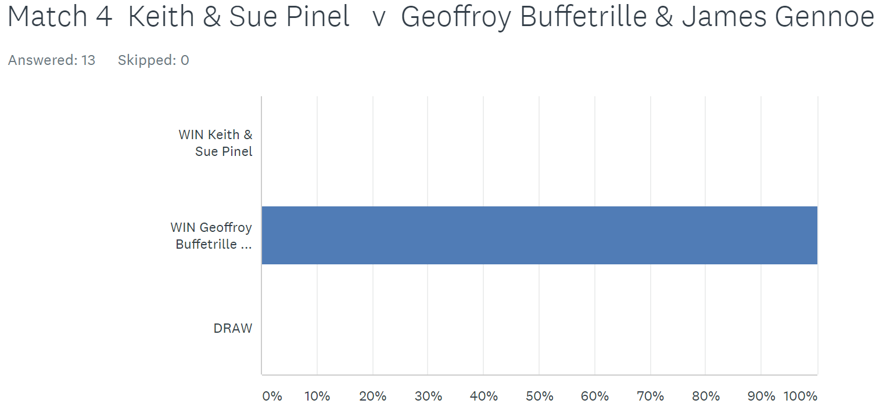

James & Geoffroy though did not disappoint as Keith & Sue scored just 12 points losing 13 – 5, 13 – 7.

James & Geoffroy then took advantage in the title race as they won a catch up match against Alex & Cassie to move three points clear at the top of the table.

Toby and Matt sitting third despite some poor performances needed to beat Alan & Craig to regain any hopes of a title win. Alan & Craig lost their only matches played to date to Ross & Jake, but it was close. Anything but a win for Toby & Matt would result in a lot of unhappy Super 6 players despite the quality of the opposition.

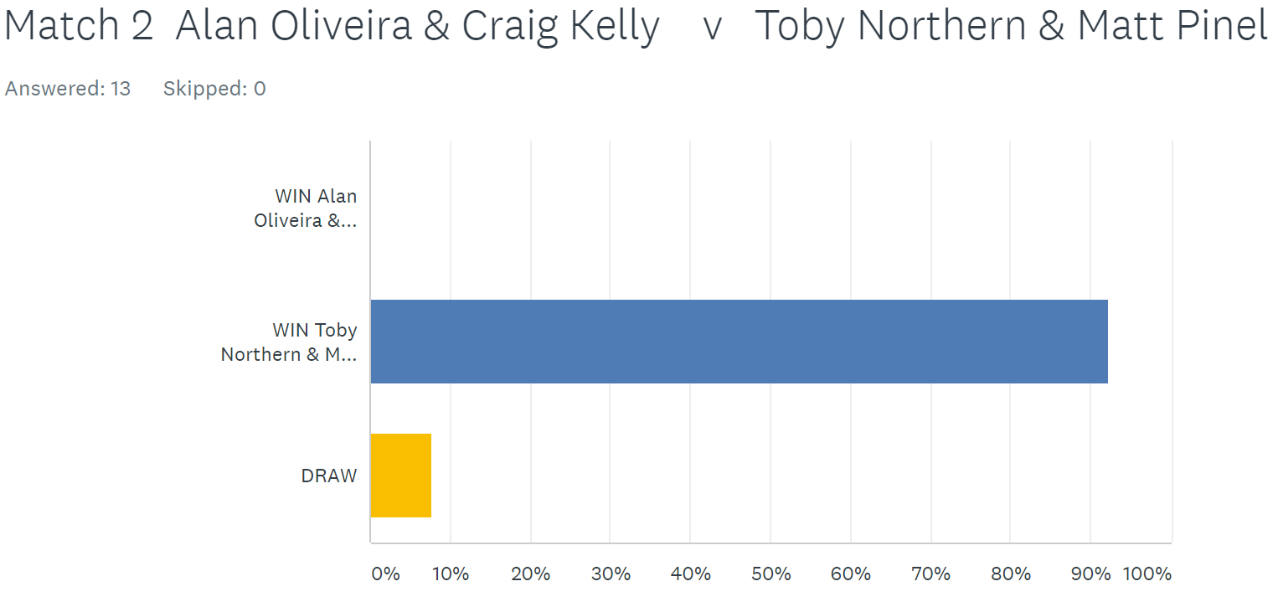

Alan & Craig built in big lead in the first game before being pegged back, but they eventually took the first game. Toby & Matt though don’t give up easily as they won the second game comfortably.

The only division 1 match played was between title rivals Matt & David and Brian & Paul. This was going to be a close affair with Super 6 confirming those suspicions. However Matt and a resurgent David Ibitson won easily 13 – 5, 13 – 6 to keep their 100% record.

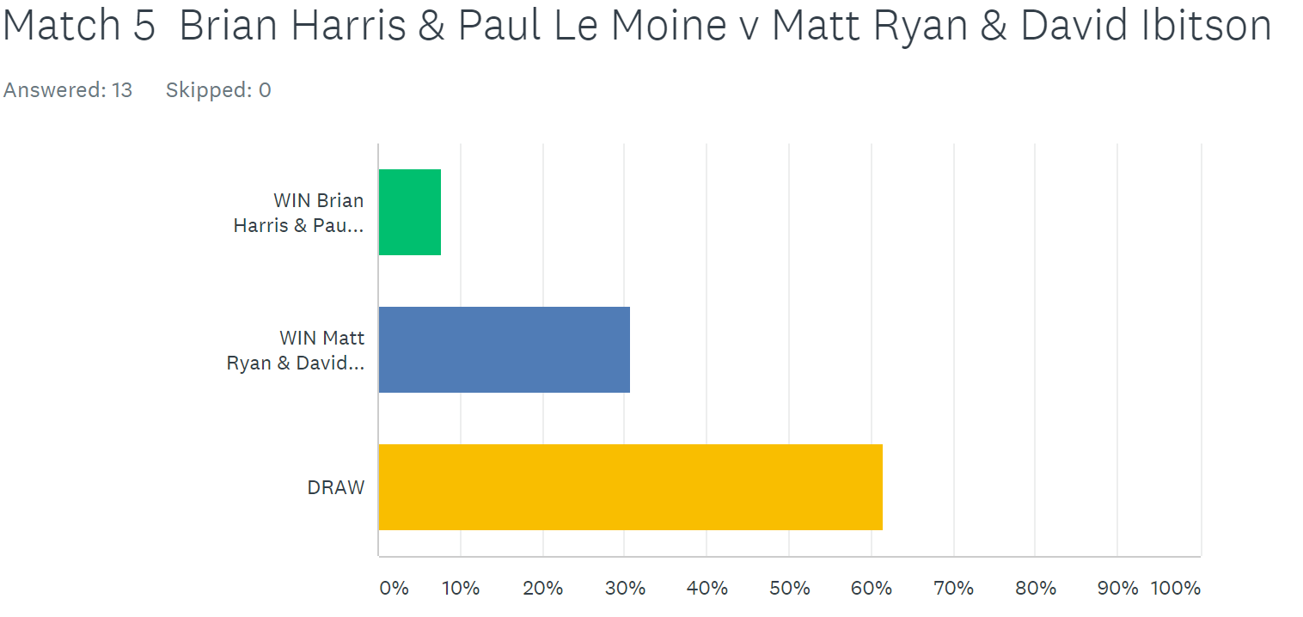

HAPPY NEW YEAR TO EVERYONE
BEST WISHES TO YOU AND YOUR FAMILIES IN 2018

COMING UP

Inaugural Super Sevens Cup - Saturday January 27th

NEXT WEEK

Singles League – DOUBLE FIXTURE WEEK for Premier League Only

WEBSITE www.liberationpetanque.co.uk
EMAIL liberationpc@gmail.com

Kind Regards
Report Editor
Toby Northern
Liberation Petanque Club

Winter 2017-2018 Season

Week 9

6th January 2018

Singles League

Just one match played in Division 1 this week, bottom two players Colin Myers and Alex Stewart. Most people went for either a draw or Alex to win on the Super 6 but it was Colin who took the first game 13 – 6. The second game went the other way as Alex took it 13 – 8.

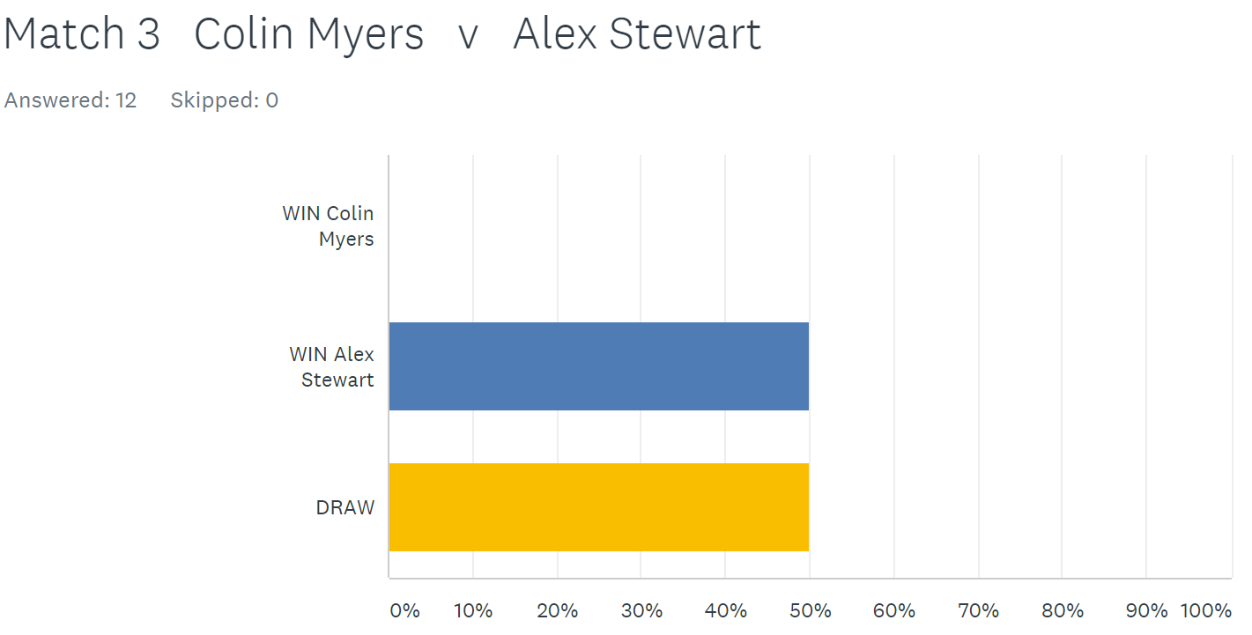

Richard Williams moved top of Division 2 with two wins. First up against Matt Hutchings 13 – 7, 13 – 8 and then and advance match against Mo De Gruchy 13 – 8, 13 – 6.

Jean Stewart also beat Mo De Gruchy to move one point off a promotion place. Below Super 6 responses.
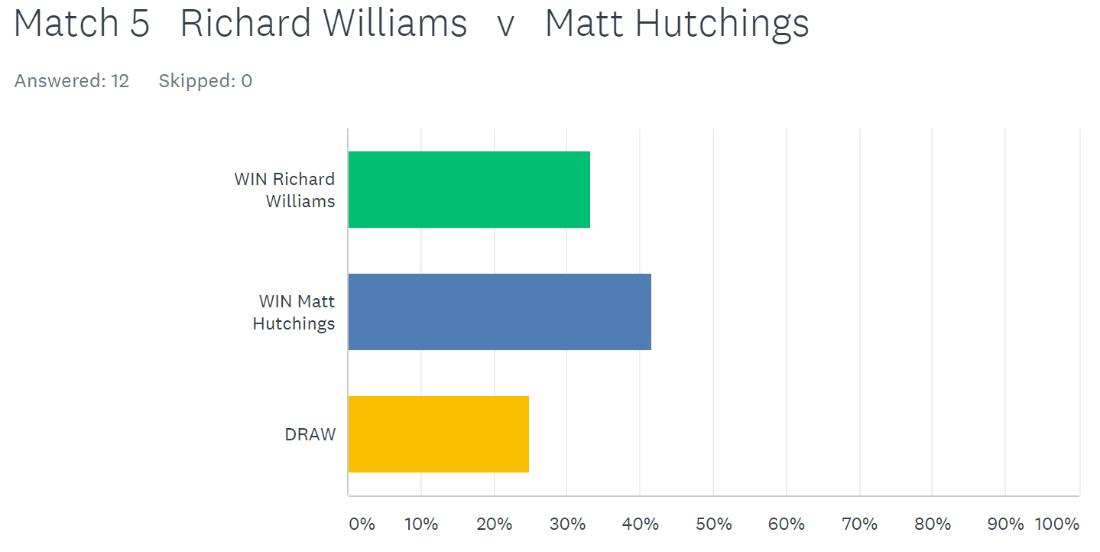

In the Premier League Matt Buesnel was looking to increase his lead at the top of the League. His first match was against Neil Selby who was without a win before today. Matt though was on top form winning comfortably 13 – 4, 13 – 6.

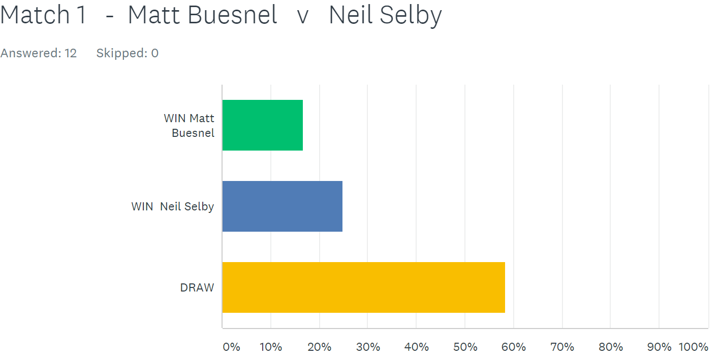

Well despite Keith handing Ross a 13 – 0 beating in his only match, no one gave him a chance against his son Matt. How wrong you were. Matt only scored 9 points losing 13 – 2, 13 – 7 as Keith remains in title contention.

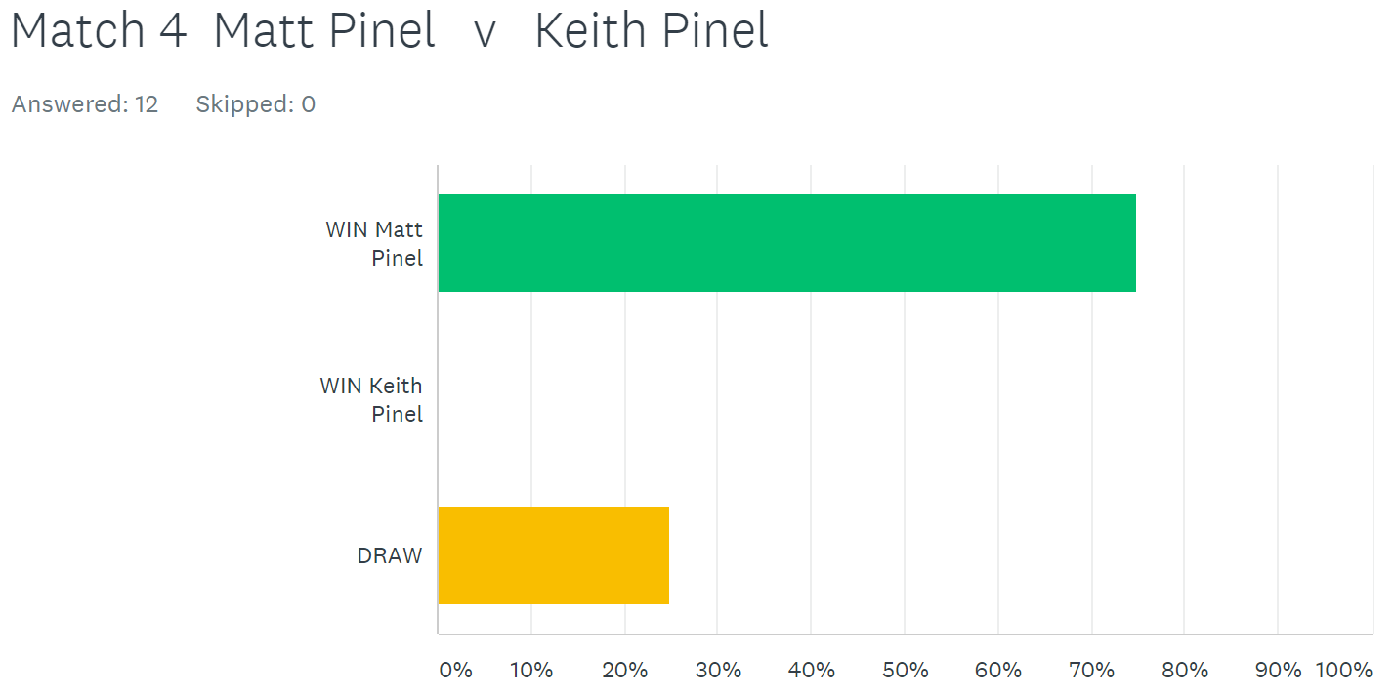

Before the start of play today David Ibitson had the advantage in the title race over Matt Buesnel just one point behind with a match in hand.

David continued his fine form at the start of the first game taking a 10 – 0 lead before eventually winning 13 – 6. The second game was much closer but David would end up rueing missed chances as Andrew took the second game 13 – 12 for a draw.

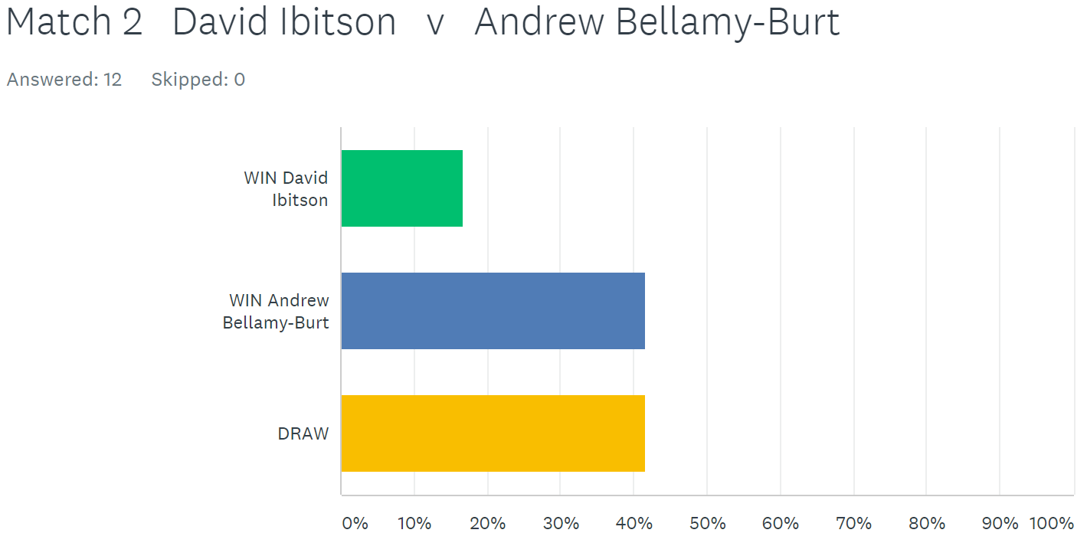

Andrews second match was against Toby and a change of terrain saw Andrew play a great game taking it comfortably 13 – 2. Andrew’s mistake though was to mention he didn’t like playing on the harder surfaces, so Toby moved him to one resulting in a big swing as Toby won 13 – 3 for a draw. Andrew has now drawn all 3 matches played but has 3 outstanding matches to play.

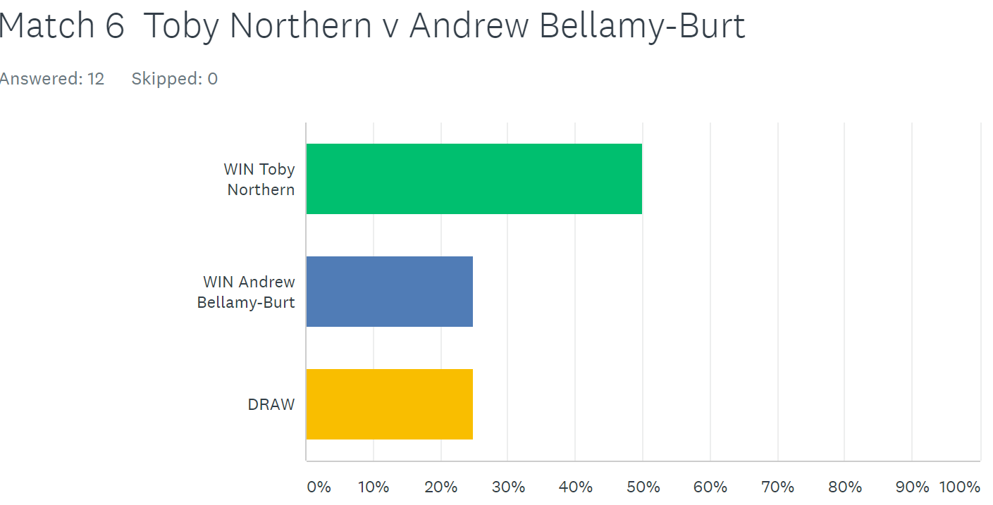

Alice Ibitson was the big winner on the day as she first beat Callum Stewart in a very close match 13 – 10, 13 – 11. Alice then moved into title contention by beating Matt Buesnel again two close matches 13 – 10, 13 – 10 coming back from 10 – 6 down in the second game and now sits on 10 points from 4 matches to become the new title favourite.

Keith Pinel took on Callum Stewart looking for 3 wins out of 3, but couldn’t do it losing 13 – 11 in the first game but recovered to get a draw 13 – 8 in the second. Keith last won the title in Winter 2013 / 14 season.

David Ibitson’s title chances took a bigger hit following his draw against Andrew then lost to Matt Pinel who recovered well from his thrashing by dad Keith. But another incredibly close match with Matt just winning 13 – 12, 13 – 11.

Toby had early beaten Ross taking 3 points on the first end of the match by firing all three of Ross’s boules out and never looked back winning 13 – 3, 13 – 4. Ross sits bottom of the league with just 1 point and minus 61 points difference. Ross needs 3 wins and 2 draws from his last 5 matches to have a chance of staying up.

NEXT WEEK - Doubles League

WEBSITE www.liberationpetanque.co.uk
EMAIL liberationpc@gmail.com

Kind Regards
Report Editor - Toby Northern
Liberation Petanque Club

Winter 2017-2018 Season

Week 10

13th January 2018

Doubles League

SUPER 7’s CUP SATURDAY 27TH JANUARY

Well the Winter is not being kind to Toby & Matt who surprisingly continue to struggle with either the wet or freezing cold temperature’s. This time drawing their forth match of the season against Relegation threatened Keith & Sue.

But this was not the only shock as Mike & Alan took the first game against James & Geoffroy 13 – 8. But order was restored as James & Geoffroy won the second game 13 – 1.

James & Geoffroy now lead by just one point over Alex & Cassie with some tough matches to play.

Mike & Alan also played a cath up match against Colin & Steve with another draw the result of the day.

James & Tom kept their hopes of a title up with a close win over Neil & Dawn who missed chances to win game one but ended up losing 13-12, Neil then took them on the muddiest terrain. James & Tom had our sponsors (Troubadour) to thank for loaning them some bar towels to help clean the boules after every end.

It didn’t turn out a good idea for Neil as James & Tom took the full 3 points to keep the pressure on David & Matt who comfortably beat Lauren & Paul to remain top. They are 6 points clear of second placed Brian & Paul.

NEXT WEEK

Singles

WEBSITE www.liberationpetanque.co.uk
EMAIL liberationpc@gmail.com

Kind Regards
Report Editor
Toby Northern
Liberation Petanque Club

Winter 2017-2018 Season

Week 11

20th January 2018

Singles League

The last of the double fixtures for the Premier League saw Matt Buesnel, take full advantage with the maximum 6 points beating both fellow title challengers Keith Pinel and David Ibitson.

Matt is 5 points clear of Matt Pinel who beat Toby Northern in a very close match 13 – 10, 13 – 11 before missing out on two wins losing the second game against Geoffroy 13 – 12!

Matt P now needs Matt B to lose both of his last matches (against Toby and Geoffroy) to have any chance of the title as Matt Buesnel has +65 against Matt Pinel -8.

However, Keith Pinel recovered from his loss against Matt Buesnel to beat fellow title rival Alice Ibitson 13-7, 13-6. Both Keith and Alice are on 10 league points, 7 behind Matt, but have 3 matches in hand due to outstanding matches and having had they Bye already.

Keith has catch up matches against: Geoffroy Buffetrille

Andrew Bellamy-Burt

Alice has catch up matches against: Neil Selby

Andrew Bellamy-Burt

Ross Payne remains bottom playing just one match this week, he again failed to win but did pick up a valuable point against Geoffroy. Geoffroy, despite two draws can also catch Matt Buesnel but needs to win every outstanding match.

Geoffroy has catch up matches against: Keith Pinel

Andrew Bellamy-Burt

Will the Premier league go down to the last week of the season. If it does, Matt Buesnel will be watching on the sideline as he has a bye that week. Would be a nervous watch if it does go to the last week.

Division 1 saw just two matches played and both were draws. Both Cassie Stewart and David Le Gresley are looking for promotion, but couldn’t take advantage over each other, but sit in the top 3. Paul Bell and Colin Myers played the other match which means they are both still searching for their first win of the season.

Division 2 also saw two matches played. Richard Williams moved top of the league as he ruined Brigitte Ibitson 100% record winning 13 – 12, 13 – 7. Brigitte though is still in third place and hoping for promotion.

Luke Canavan won his second match of the season to move into contention but another close one, taking the first game 13 – 12 against Mo De Gruchy before claim the win with a 13 – 5 second game score.

Mo still without a league point but getting ever so close this week its only a matter of time.

NEXT WEEK

Inaugural Super Sevens Cup - Saturday January 27th

WEBSITE www.liberationpetanque.co.uk
EMAIL liberationpc@gmail.com

Kind Regards
Report Editor
Toby Northern
Liberation Petanque Club

Winter 2017-2018 Season

SUPER 7’s CUP

27th January 2018

The Inaugural Super 7’s Cup saw 16 players take part in the quick fire matches, with the tournament lasting just 3 hours.

So 7 rounds of matches and for each match playing just 7 ends, with no time limit.

Round 1 saw Paul Bell take three points on the first end against Toby Northern, but Toby fought back to take the match 8 – 6. Andrew Bellamy-Burt had the biggest win against Cassie Stewart 13 – 1.

Matt Pinel just won by two points over Richard Williams and Geoffroy Buffetrille beat Jean Stewart 8 – 4 and Keith Pinel lost to Alan Oliveira 6 – 3 who joined the competition at the last minute.

Round two saw Toby fire 8 out of 9 boules including two carreaux to beat Brian Harris 8 – 4. Ross Payne also made it two wins beating Geoffroy 7 - 5.

Mo De Gruchy lost by just one point against Richard Williams 7 – 6 as did Keith Pinel against Laurent Pelllaton 6 - 5 with both of those results proving crucial to the finishing positions. Andrew also made it two wins over doubles partner Callum Stewart 8 – 4 and Paul Bell won 13 – 1 against Alex Stewart, the joint top result of the day.

Round Three saw Geoffroy lose his second match in a row losing to Matt Pinel by one point 6 - 5. Laurent continued to beat Premier League opposition taking out Brian Harris 6 – 4 and new singles player Paul Bell beat experienced Alan Oliveira 7 - 6.

Andrew beat Toby 7 – 3 and Callum returned to form handing Ross his first defeat 7 - 5.

Round four saw the pressure start to mount with Andrew beating Matt Pinel by one point 5 - 4, the same was for Callum Stewart over Paul Bell. Ross made it two straight losses against Cassie Stewart. Laurent also handed Toby his second straight loss winning 7 – 2. Geoffroy made it three losses out of four matches with a thrashing from Alan Oliveira 10 - 2. Ross Payne lost 10 – 4 to Cassie Stewart.

Brian Harris and Richard Williams moved into contention winning their respective matches against Keith 6 – 4 and Alex 6 – 4.

Round five saw the turning point for Geoffroy who was having an awful competition with just one win out of 4. This time he beat Alex Stewart 8 - 5. But top ranked player Andrew Bellamy-Burt lost 9 – 1 to Richard Williams and Callum Stewart beat Matt Pinel .

Ross Payne beat Toby 7 – 4 and Paul Bell impressed beating Brian Harris, but by just one point 7 - 6.

Round six saw Andrew just beat Laurent, by 1 point 7 – 6 and Callum Stewart beat Richard Williams 11 - 3. Brian Harris, Geoffroy Buffetrille and Keith Pinel all gave themselves outside chances with wins.

The final round saw Alan Oliveira make the top 8 with a win over Callum Stewart 6 – 5 to finish 4th on 5 wins. Callum finished 3rd also win 5 wins but the second highest BHN of 30.

Andrew Bellamy-Burt topped the rankings winning his final match against Mo De Gruchy 9 – 2 who on fortunately finished last. Andrew ending on 6 wins with just the 9 – 1 loss to Richard Williams.

Matt Pinel beat Laurent Pellaton 8 – 3 to finish second with 5 wins with the highest BHN of 31. Laurent did make the top 8 though finishing 5th with 4 wins and a BHN of 30.

The biggest match of the final round was Geoffroy against Brian with a win likely to take them through. Geoffroy won this one comfortably by 8 points to make it three straight wins and finish 8th curtosy of a BHN score of just 22 against Keith Pinel BHN of 20. What a turnaround from Geoffroy.

Final Rankings on next page.

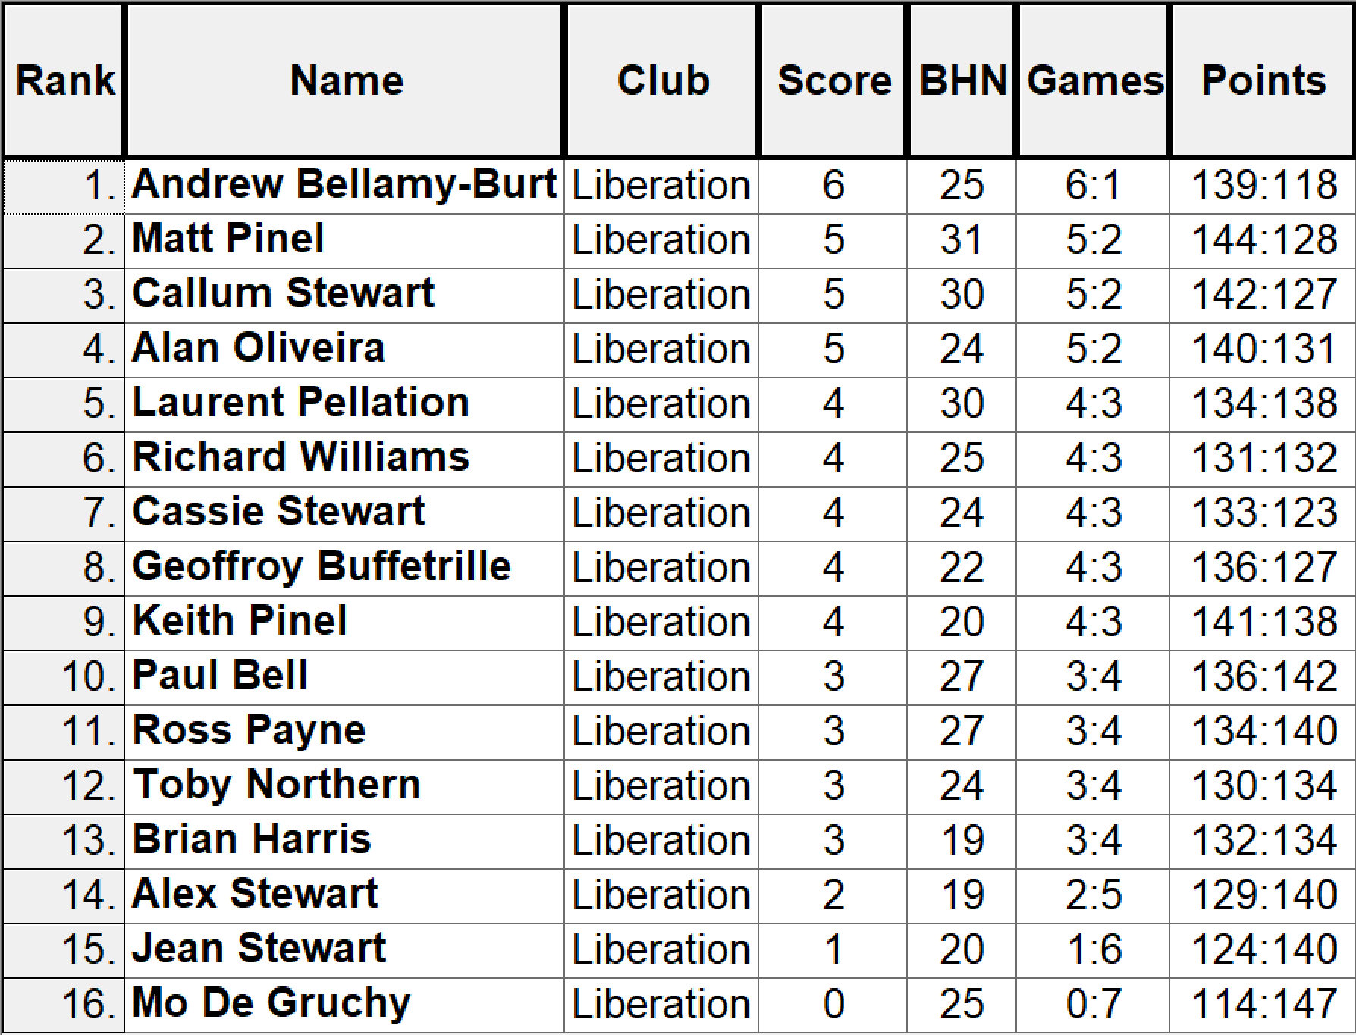

Quarter Finals

1st Andrew Bellamy-Burt v Geoffroy Buffetrille 8th
2nd Matt Pinel v Cassie Stewart 7th
3rd Callum Stewart v Richard Williams 6th
4th Alan Oliveira v Laurent Pellaton 5th

Well the curse of the top ranked player returned as Geoffroy made it four wins in a row to knockout Andrew winning comfortably 8 - 3.

Matt Pinel though did make it through against Cassie Stewart also with an 8 – 3 score.

Callum was 7 – 5 up with one end to play against Richard, but Richard score two points to tie the match. The extra end went Richards way as the division 2 player took another Premier League scalp to make the semi-finals winning 8 - 7.

Well it hadn’t happened all day, but in the quarter final between Alan and Laurent it did as Laurent another division 2 player beat Alan 9 – 0.

So the semi-finals saw two Division 2 players take on two Premier League players.

2nd Matt Pinel v Richard Williams 6th
8th Geoffroy Buffetrille v Laurent Pellaton 5th

This is where the quality and experience really shows and despite excellent tournaments for Richard and Laurent big game players Geoffroy and Matt took the wins to make the final.

Matt won easily 8 – 1 as Richard faulted at the crucial moment. Geoffroy won the closer of the two semi-finals 6 – 3.

It was a comfortable ride for Laurent in the 3rd/4th place play off as he took 3rd place and Bronze medal winning 9 – 1 against Richard, well done Laurent.

Matt Pinel had already beaten Geoffroy in round three, but only by one point.

Matt took two points on the first end, but Geoffroy came back with some excellent placing to take the first trophy of the year winning by a relatively big margin 8 - 4.

So despite only winning 4 out of 7 matches Geoffroy went on to win another tournament and on his birthday as well, well done Geoffroy. (Picture below holding the trophy!)



NEXT WEEK

Doubles League

WEBSITE www.liberationpetanque.co.uk
EMAIL liberationpc@gmail.com

Kind Regards
Report Editor
Toby Northern
Liberation Petanque Club

Winter 2017-2018 Season

Week 13

3rd February 2018

Doubles League

With just 5 weeks to go until the end of the wettest season on record and many outstanding matches to be played we are no closer to finding out the winners and losers of the season, which keeps it exciting.

Doubles Premier league saw three matches played, one of which was a catch up match between Alex & Cassie and Alice & Brigitte. Alex & Cassie needed a win to keep the pressure up on Geoffroy & James who didn’t play due to James being injured.

Alex & Cassie won in style and significantly improved their points difference with a 13 – 4, 13 – 4 win. Alice & Brigitte must have been disappointed especially after they had just beaten Andrew & Callum in their schedule fixture.

Last years Champions Ross & Jake defense of their title ended with a draw against Keith & Sue in an up and down match with Keith & Sue taking the first game 13 – 4, before losing the second 2 – 13.

Outstanding Matches

4th November Andrew & Callum v Alan & Craig

18th November Andrew & Callum v Keith & Sue

9th December Alan & Mike v Keith & Sue

Alan & Mike v Andrew & Callum

Alice & Brigitte v James & Geoffroy

Alan & Craig v James & Geoffroy

Ross & Jake v Cassie & Alex

13th January Andrew & Callum v Colin & Steve

3rd February James & Geoffroy v Colin & Steve

Alan & Craig v Cassie & Alex

Matt & Toby v Alan & Mike

Division 1 also saw three matches played including a catch up match.

James & Tom moved top of Division 1 with a win over Laurent & Matt conceeding just 10 points in the process. They only lead however by 1 point with David & Matt with a match in hand.

Brian & Paul just overcame Jean & Chris winning 13 – 12, 13 – 6 to remain in third place and on for a bronze medal. This was helped by Neil & Dawn drawing a catch up match against Laurent & Matt.

Outstanding Matches

18th November James & Tom v Jean & Chris

Harrison & Richard v Lauren & Paul

9th December Harrison & Richard v Laurent & Matt

3rd February Harrison & Richard v Matt & David

NEXT WEEK

Singles League

WEBSITE www.liberationpetanque.co.uk
EMAIL liberationpc@gmail.com

Kind Regards
Report Editor
Toby Northern
Liberation Petanque Club

Winter 2017-2018 Season

Week 15

10th February 2018

Singles League

DON’T FORGET YOUR MEMBERSHIP FORMS

(ASAP PLEASE)

Now just two scheduled Singles League fixtures left and the state of play after this weekkends fixtures is as follows:

Keith Pinel was looking for a win to to pile the pressure on Matt Buesnel at the top of the table as he bids to win the Winter Premier League title he first won in the 2013 / 14 season. Neil on the other hand was yet to win a match with four draws and two defeats.

The result w

Super 6 Analysis below

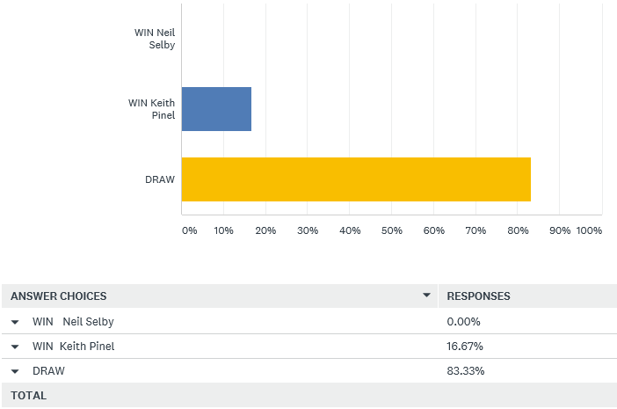

Two people at the bottom of the table Ross Payne and Andrew Bellamy-Burt played each other with a win needed by both, something they have failed to do all season. The result w

David Ibitson’s early season title form had disappeared in recent weeks seing him drop to 5th place and 8 points off top spot but still in with a chance of a medal position. He played his daughter Alice who lost her first match of the season to Keith Pinel in the last round of fixtures, but still in the title hunt being 6 points off Matt Buesnel but with two matches in hand. Which one came out on top, well the resull w

Super 6 Analysis below

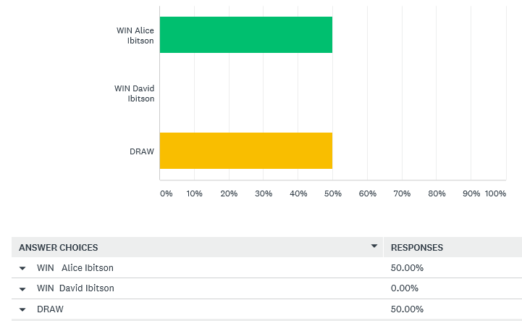

The man himself, Matt Buesnel knew with three other players able to catch him (Alice, Keith & Geoffroy) that he need to win his last two matches of the season to do it. This week he faced Toby who was looking for three points to guarantee a a Premier League spot next Winter as his grip on his title had already disappeared. The result w

Brian Harris constantly moving between the Premier League and Division 1 was looking odds on for a Winter Division 1 title he first won in the 2011 / 2012 season.

Brian was 5 points clear at the top before this weekend but played John McGaw who was on 4 points from just two matches so could catch Brian with a win and put him well within a chance of a medal. The result w

Super 6 Analysis below

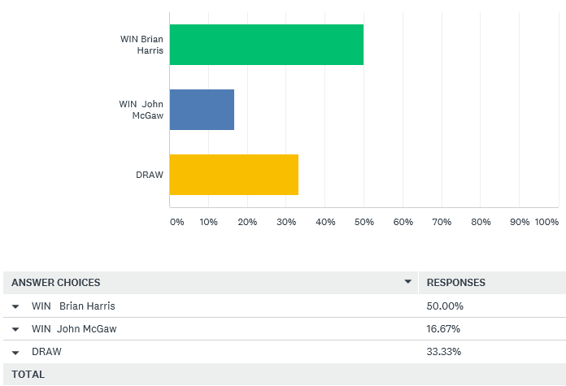

Paul Le Moine was in second position before the day still hoping to catch Brian for the title, he played Alex Stewart who was surprisingly at the bottom of the league with just two draws to his name. The result w

Super 6 Analysis below

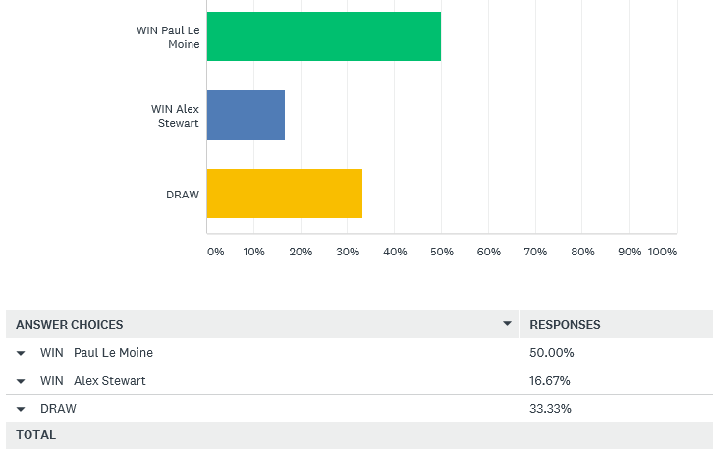

Colin Myers always strugglying for wins took on David Le Gresley who although was htree places higher in the league was only two points better off. The result w

Laurent Pellaton had three wins out of three but was still four points off top spot with Richard Williams leading the way.

Laurent took on Matt Hutchings who still had a chance of a top three finish, but needed to beat Laurent. The result w

Super 6 Analysis below

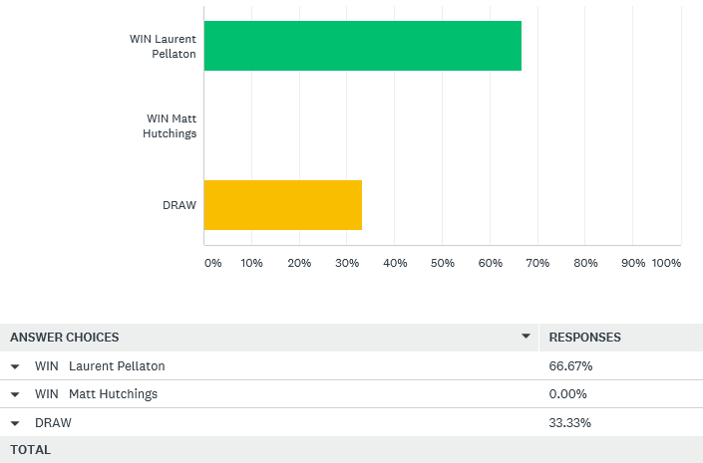

Luke Canavan could also jump into the top three, he needed to beat Harrison, who had only played 2 matches this season, both defeats. With both players playing in their first Winter League, were hoping for some unusually dry weather for their match.

The result w

Super 6 Analysis below

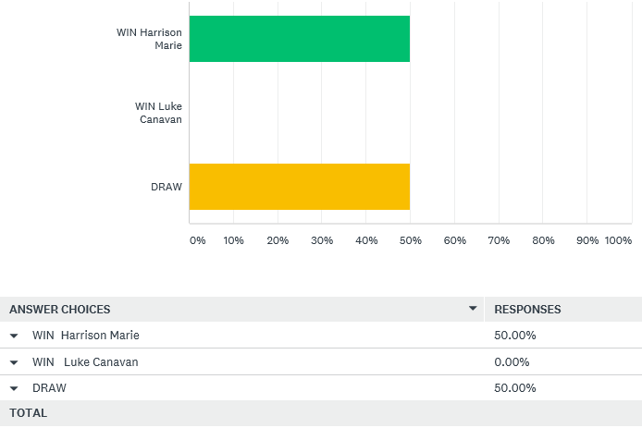

NEXT WEEK

Final scheduled Doubles League fixture

WEBSITE www.liberationpetanque.co.uk
EMAIL liberationpc@gmail.com

Kind Regards
Report Editor
Toby Northern
Liberation Petanque Club

Winter 2017-2018 Season

Week 15

17th February 2018

Doubles League

Well it was almost like a Summers day this week, but only 4 matches played, two of which were catch up matches.

OUTSTANDING PREMIER LEAGUE FIXTURES BELOW

4th November Andrew & Callum v Alan & Craig

18th November Andrew & Callum v Keith & Sue

9th December Alan & Mike v Keith & Sue

Alice & Brigitte v James & Geoffroy

Alan & Craig v James & Geoffroy

13th January Andrew & Callum v Colin & Steve

3rd February Alan & Craig v Cassie & Alex

17th February Andrew & Callum v James & Geoffroy

Alan & Craig v Alice & Brigitte

Keith & Sue v Alex & Cassie

Alan & Mike v Ross & Jake

Colin & Steve played Toby & Matt in the only scheduled Premier League fixture to be played. Toby & Matt quickly moved ahead 8 – 1, but two carreaux on one end by Colin to give them 5 points helped close the gap. It went to 10 – 10 before Toby & Matt took the game. The next match was also close with Steve placing really well but a change to the puddle’s affected Steve’s placing to all Toby & Matt to take 3 vital league points.

Toby & Matt then finished off their season with a win in the final match of the season against Alan & Mike, coming back from 6 – 10 down to win 13 – 10 with Toby firing their boule out to take the match and move into a medal position.

The other catch up match was Colin & Steve playing James & Geoffroy. James & Geoffroy looking to take advantage in the title race after Cassie & Alex losing to Ross & Jake last week. It didn’t start well though as Colin & Steve took 5 points on the first end. That was the only end they won though in the first game to get a technical fanny 5 – 13.

James & Geoffroy some how found themselves 12 – 8 up despite Colin & Steve having 5 boules left after James & Geoffroy had finished playing all their’s on several ends but Colin & Steve fought back to 12 all and with Colin placing next to the coche with his last boule had to wait on Geoffroy firing.

Geoffroy clipped Colin’s boule right onto the coche. The next fire hit it but just as it looked like Colin’s boule was still going to be holding, Geoffroy’s boule dropped in front to give them the win and move James & Geoffroy top of the table and odds on to take the title.

Only one match played in the first division as Brian & Paul took a big step into the medal positions only losing 3 points in two matches to move into third place. On the losing end was Laurent & Matt who suffered at the hands of Brian’s excellent firing.

18th November James & Tom v Jean & Chris

Harrison & Richard v Lauren & Paul

9th December Harrison & Richard v Laurent & Matt

3rd February Harrison & Richard v Matt & David

17th February Neil & Dawn v Matt & David

NEXT WEEK

Singles

WEBSITE www.liberationpetanque.co.uk
EMAIL liberationpc@gmail.com

Kind Regards
Report Editor
Toby Northern
Liberation Petanque Club

Winter 2017-2018 Season

Week 16

24th February 2018

Singles League

We have a new Winter Singles Premier League Champion. That man is Matt Buesnel who fought back against Geoffroy to win the second game 13-12 for a valuable draw.

This combined with Toby beating Alice and Andrew Bellamy-Burt drawing against both Keith Pinel and Neil Selby handed Matt his first ever Premier League title. Well Done Matt.

Andrew’s two draw’s leave him and Neil still in danger of relegation, especially with Callum Stewart beating Geoffroy in a catch-up match, giving him a great chance of survival.

Toby’s win against Alice moved him up to 5th with Ross knowing he needs to beat both Callum and Neil at least to stay up.

Division 1 saw a shock as Brian Harris lost his first match of the season but despite this Brian is 99.9% sure to be champion as only John McGaw can catch him now but he needs to win all three matches remaining and hope Brian loses his final match of the season against Cassie.

Cassie beat John McGaw comfortably but needs a result against Brian to guarantee a top three finish.

Alex Stewart also beat Paul Bell as both players finished the season early. These two results moved Alex into third place but he has a nervous wait to see if he gets a medal.

Paul Le Moines chances of promotion took a blow losing to Paul Bell who has had a great first ever singles season playing in Division 1 as well. Well Done Paul.

Division 2 saw Laurent Pellaton win again, now five in a row for Laurent who needs to beat Brigitte to guarantee the title on the final week of the season. Brigitte could only draw with Matt Hutchings but beat Luke Canavan in a catch up match to guarantee a top three finish and a medal, it just depends now which one it will be.

Just two weeks to go to the end of the season Sunday 11 March 2018.

Don’t Forget firing competition Saturday 10th March 2018.

NEXT WEEK

FINAL SINGLES LEAGUE FIXTURE

WEBSITE www.liberationpetanque.co.uk
EMAIL liberationpc@gmail.com

Kind Regards
Report Editor
Toby Northern
Liberation Petanque Club

Winter 2017-2018 Season

Week 17

3rd March 2018

Singles League

The final schedule week of fixtures saw titles and relegations confirmed despite several matches still to be played in the Premier League.

Matt Buesnel had already sealed his first ever Premier League title last week. Congratulations Matt.

The race though is on for medal positions which due to the following outstanding matches means we have to wait to find out final positions.

Andrew Bellamy-Burt v Alice Ibitson
Ross Payne v Neil Selby
Alice Ibitson v David Ibitson
Keith Pinel v David Ibitson
Matt Pinel v Ross Payne

Matches played saw Callum ensure safety with a win over Ross Payne who as a result suffers his first ever relegation. He must win his final two matches above to prevent him finishing bottom.

Callum also finally played his match against Andrew Bellamy-Burt from Week 1!!! Resulting in a draw to confirm his Premier league position. Who’d have guessed that result!!!

Another close match for David Ibitson against Neil Selby saw a draw which means Neil needs a win in his last match against Ross to stay up.

Andrew over came Matt Pinel who never seems to be able to beat Andrew and Geoffroy beat both Alice and Keith to move up into the medal places.

Toby and Keith was a very close match with Keith winning the first game 13 – 12 with a fire with the last boule. Toby reversed the roles to take the second game 13 – 12 with a boule in hand.

Division 1 saw heart break for Cassie Stewart as a heavy defeat against Brian Harris 13 – 8, 13 – 4 mean’t she dropped out of the top three on points difference by just 3 points. But not all the Stewarts were unhappy with this as Alex Stewart took Cassie’s place in third position.

Finishing in second place though was Paul Le Moine with a 13 – 3, 13 – 9 win over David Le Gresley. Well Done Paul.

Colin Myers ended the season with another draw this time against John McGaw. This unfortunately result in Colin’s relegation.

Division 2 had seen Laurent Pellaton win the title before this weekend, winning every match. Laurent played Brigitte who was looking to move back to Divison 1 after being relegated last Winter. Brigitte did that in style handing Laurent his first ever defeat as Brigitte took second spot with Richard Williams finishing third.

Matt Hutchings ended the season with his first (official) win of the season, beating Mo De Gruchy who unfortunately gets the wooden spoon (figuratively speaking) commiserations Mo. One match left to play is Jean Stewart v Luke Canavan.

NEXT WEEK

FIRING COMPETITION – 10AM

WEBSITE www.liberationpetanque.co.uk
EMAIL liberationpc@gmail.com

Kind Regards
Report Editor
Toby Northern
Liberation Petanque Club

