

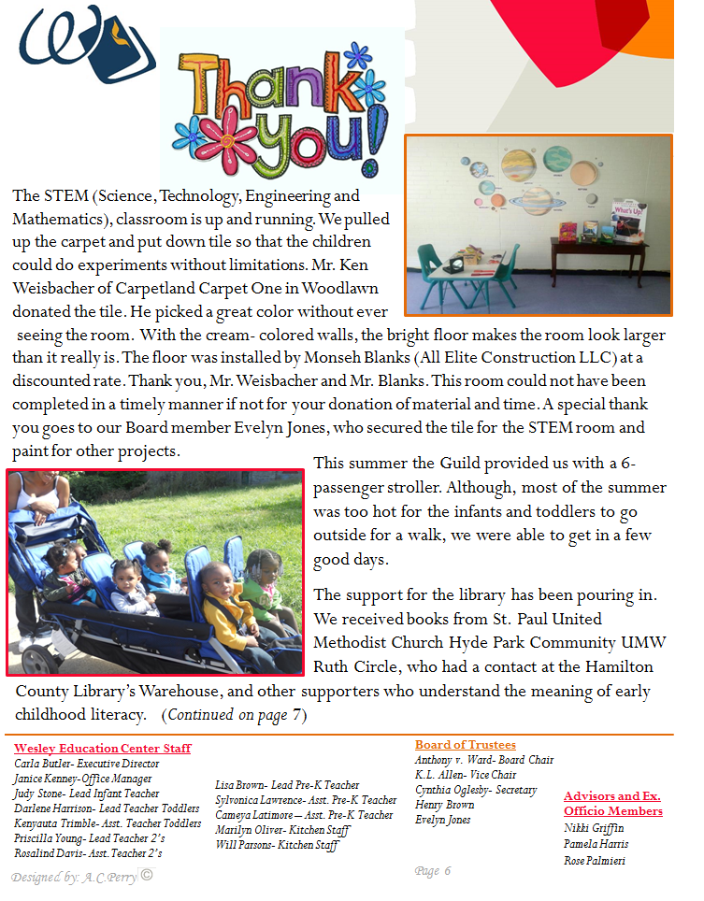

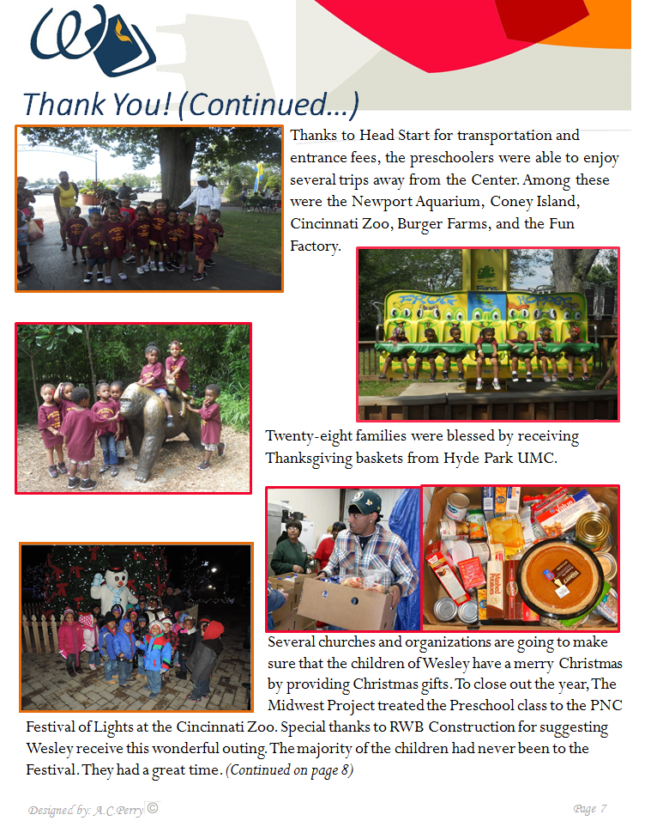

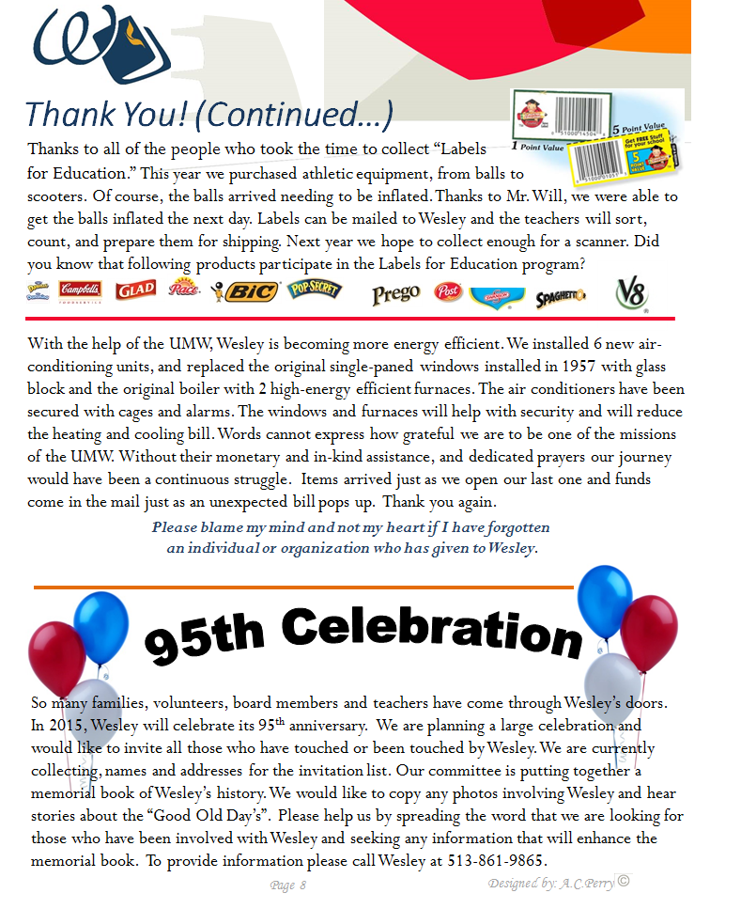

--

**Wesley Education Center**

**for Children & Families**

525 Hale Avenue, Cincinnati, OH 45229

(513) 861-9865

[www.wesleyeducationcenter.com](http://www.wesleyeducationcenter.com/)

Open Monday – Friday 6:30am – 5:30pm

