Give a Goat - Change a Life!
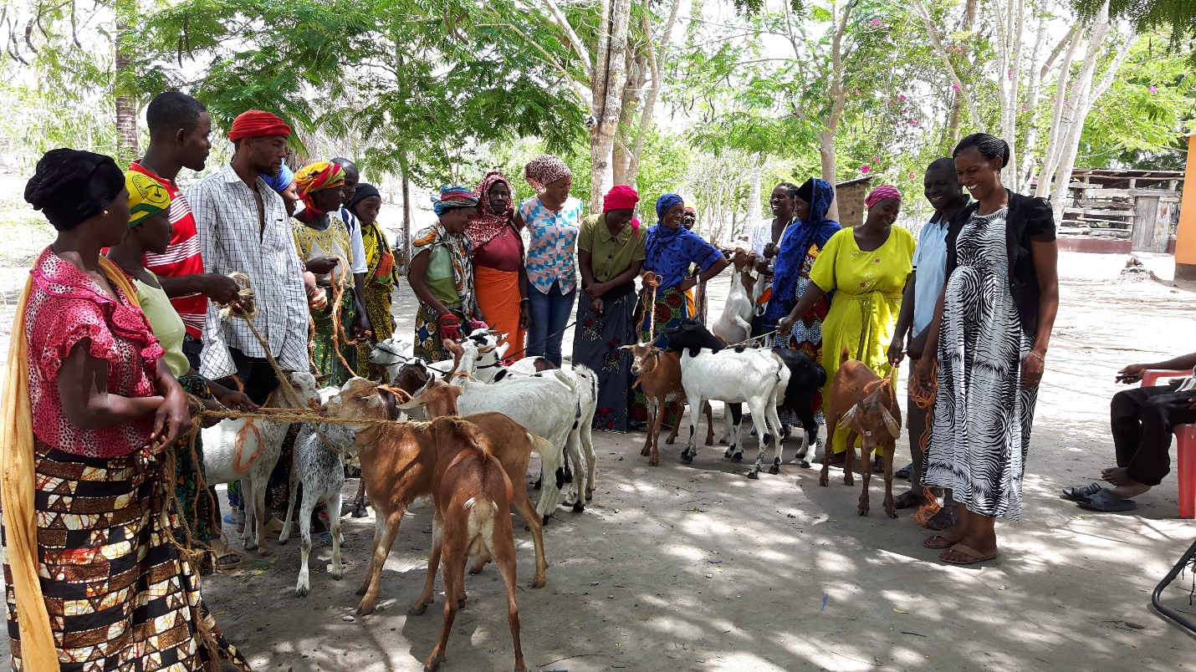

The donation of a pregnant goat will change lives. When a family receives a pregnant goat it is with the understanding that the first kid born will be donated to another family, who will in turn donate the first born kid of that goat to another family and so on…
Goats provide families with milk, meat & fertilizer.
A pregnant goat will be given to a family in Tanzania in your name.

