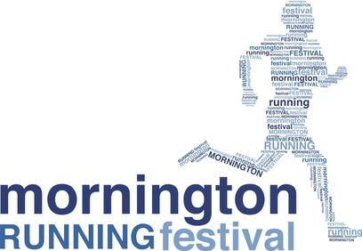
PUBLIC NOTICE:
FUN RUN EVENT IN MORNINGTON/MT MARTHA
Community Fun Run Event raising money for many charities for 10years now!
When: Sunday 28 April 2024
What: Mornington Running Festival www.morningtonrunningfestival.com
As a result there will be:
- Approximately 5000+ athletes, supporters, family and friends in the area over this weekend
- Competitors of all ages on The Esplanade
- Closure of Northbound lane only of The Esplanade between Main Street and Bradford Road.
- NEW FULL closure of The Esplanade (Wilson Rd Roundabout to Bentons Road) (From 7-8am only)
- Traffic Management Control by Miepol Traffic Control and Event Management by Event People
THE EVENT
The Mornington Running Festival is now in its 10th YEAR, and it attracts participants from all over Australia (+international visitors) and consists of a 5km Run/Walk, 10km Run, 21.1km Half Marathon and a Kids 1km Dash, raising money for many charities. This event will deliver a major economic benefit to the area, and we are excited we have been able to share this with the Mornington Peninsula local community for the past 10 years as it has grown from 300 participants in the first year to a sellout of 3500 this year. Detailed maps and information can be viewed on the website www.runthepen.com.au
ROAD CLOSURES
PHASE 1 - ONE LANE ONLY of the Esplanade will be closed (Northbound - beach side) between Main St (Mornington) and Bradford Rd (Mt Martha) on Sunday 28 April 2024. Southbound traffic will not be affected (refer Phase 2) during this time other than a reduced speed zone.
Stage 1 – Bradford Rd – Coolangatta Rd (NOTHBOUND only) will be closed from approx. 6:30am – 10:00am (21km runners)
Stage 2 Coolangatta Rd – Main St will be closed (NORTHBOUND only) from approx. 6:30am – 11:00am (10km and 5km Runners)
PHASE 2 – FULL ROAD CLOSURE from The Esplanade (Wilson Rd Roundabout to Bentons Rd) (from 7-8am only)

ACCESS IN AND OUT OF YOUR PROPERTY
Full Access in and out of all properties is via the Esplanade will be maintained during the event. You will only be able to turn left via your property onto The Esplanade during the event. To re-enter your property during these closure times you must turn onto The Esplanade via a northern street/road and turn left onto The Esplanade and head South to your property entrance. Traffic controllers and volunteers will be present at all times to assist pedestrians and residents if and when required.

SHOW YOUR SUPPORT!
We encourage local residents and businesses to show their support to participants, so join us at Mornington Park and cheer on participants as they complete this fun run and aim to raise money for their charities.
MARSHALL OPPORTUNITIES
Want to get involved in our event? We are searching for vibrant, enthusiastic, friendly people to join our Volunteer Crew. No experience required. To find out more please contact us at info@eventpeople.com.au.
We thank you in advance for your cooperation and apologise for any inconvenience caused during this time. If you have any concerns about the traffic management or the event please contact us: 0359884040 or info@eventpeople.com.au
Event People

