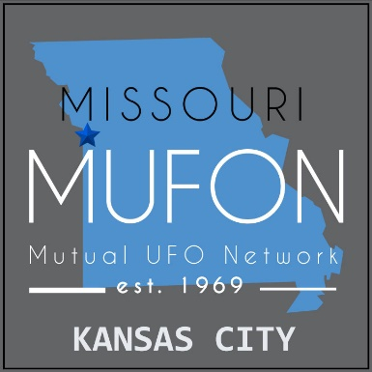
Missouri MUFON
Mutual UFO Network
PO Box 1166, Independence, MO 64051
Debbie Ziegelmeyer, State Director Margie Kay, Assistant State Director
www.missourimufon.org 816-365-9492

FOR IMMEDIATE RELEASE
The Missouri Chapter of the Mutual UFO Network will host a public Town Hall meeting at 7:00 PM on Tuesday, July 2, 2024 to commemorate World UFO Day, local UFO sightings, and the 77th anniversary of the Roswell New Mexico UFO crash.

Kansas City, Missouri June 17, 2024

A public session will be held at the Mid-Continent Public Library, 1665 S. Withers Road, Liberty, MO 64068 (across the street from the Liberty Community Center). Missouri MUFON Field Investigators will discuss MUFON (Mutual UFO Network), and show a presentation on local UFO sightings and the Roswell Crash. This event is Free to the public.

In addition, there are a limited number of private personal sessions for those who would like to speak with a UFO Investigator regarding their personal first-hand UFO experience. One-on-one Sessions will be held in private meeting rooms at the library on the afternoon on July 1 and the evening of July 2. Those interested can reserve a 15-min. session by e-mailing Ray Graham at MUFON57691@gmail.com. Early sign-up is important, as there are limited seats available. Sessions will remain confidential.

This is open to all but recommended for those 16 years of age and older. No infants or toddlers. Beverages are permitted but should be brought in a secure container with a lid. The site is handicap accessible.

The public is encouraged to come out for this free evening to learn about Missouri sightings, Roswell, and the Mutual UFO Network.

Missouri is consistently in the top ten states nationwide for UFO sightings and is a UFO hot spot. Sightings have been reported since the 1800’s. During the 1970’s southeast Missouri experienced a UFO Flap with over 500 sightings reported to local and county law enforcement, and other UFO flaps have occurred across the state, with the greater Kansas City and St. Louis areas receiving the most reports.
World UFO Day was created by UFO researcher Haktan Akdogan and the World UFO Day Organization in 2001. July 2 is the date of the UFO crash in the 1947 Roswell incident.
Media contact: Margie Kay, Assistant State Director for Missouri MUFON
816-365-9492
momufonasd@gmail.com
www.misourimufon.org

