***EBENEZER UNITED METHODIST CHURCH***

***Welcome and Announcements***

Announcement – please read and pin a copy to the refrigerator! Bridget Gillions

**Welcome The Light of Christ:**

Let us unite our voices with the prayer of John Chrysostom: #412

*Opening Hymn ***“Love Divine, All Loves Excelling”***  #384

Children’s Time Change for change…Kits for Conference Kristina Armbruster

Offering

*Doxology ***“Praise God from Whom all Blessings Flow”*** # 95

Anthem ***“Jesus, All for Jesus”*** Abundant Joy Choir

Joys and Concerns

Prayer

Scripture  **Psalm 105:1-6,** **Colossians 2:6-13, John 21:15-17**

*Hymn ***“This is My Father’s World”***  # 144

Message  ***“Stay in Love with God”*** Pastor Loretta

*Closing Hymn ***“Glorify Thy Name”*** Faith We Sing # 2016

*Benediction

*Please stand as you are able.

**ATTENDANCE: June 2nd = 44; 9th = 38;**

Three Simple Rules:

A Wesleyan Way of Living

**Announcements:**

**Next Sunday following worship, “Family Faith Forum”** Following worship we will gather for fun, food, and fellowship -- our discussion will focus on the Annual Conference and any particulars you want to discuss about the General Conference & what EUMC would like to do in moving outward and upward.

**Thank you for serving in the service!**

Worship opening – Bridget Gillions; Children’s story – Kristina Armbruster/children; Reading scripture –The children.

**Other Dates**

6/19--Pastor will leave by noon on Wednesday (19) for Annual Conference 20-22 in Hampton. In case of emergency, she can be reached on her cell phone – just give time for her to respond to your message.

6/23—4:00 PM Warsaw UMC Chosen – bible Study Season 1 – episode 2.

6/25—12:30 PM Coalition Meeting Andrew Chapel.

Please note there will be no children’s church during worship in July.

**Congratulations The Richmond County Jr. Beta Club**

Eddie Evans and some of his school mates competed at the National Convention in Savannah, GA this past week.  Their goals are set high and they are excited to compete and show off their talents. They are now one their way home.

*We had one person place 2nd in Solo singing, the rest of the kids gained experience and perspective.* We helped support them on their journey through the Change for Change! Way to go team!



**PRAYER LIST**

*I have not stopped giving thanks for you, remembering* you in my prayers.

Ephesians 1:16 (NIV)

Prayers for the family of Barbara Jean LeFon {joined the church triumphant on May 31st; also for the Kohari family.   Ginny & Lina Hahn (Cindy’s niece & great niece), Jennifer Clarke, Rachel Nice & Daphne, Linda & Ralph Fallin, Joan Balderson, Kacky Sanford, Kathy Davis, Betty Bailey, David Allison, Ian Duprey in the Coast Guard; for those battling cancer; for those battling sickness. Israel & Gaza, Russia & Ukraine; for the healing of the nations! For our country and its leaders, our Church, and the United Methodist Church.

We always thank God for all of you when we mention you constantly in our prayers

**Please** review the Prayer List and let us know of any people whose prayers have been answered. We will glean the list and start again on the first Sunday of every month. If you would like to keep a loved one on please advise pastor Loretta.

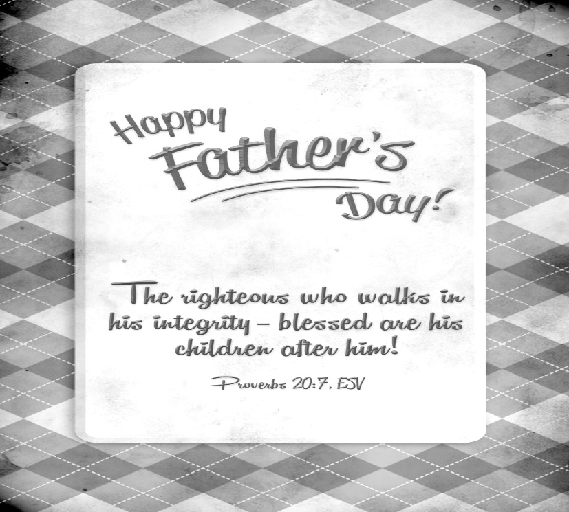

**Ebenezer United Methodist Church**

144 Ebenezer Church Road

P. O. Box 70

Oldhams, Virginia 22529

***Website:*** [*www.eumcoldhams.org*](http://www.eumcoldhams.org)

Reverend Loretta Benninghove

Pastor

Office (804) 472-4642; Cell (434) 480-9992

**Email:** [pastorlorettaumc@gmail.com](mailto:pastorlorettaumc@gmail.com) {preferred email}

[lorettabenninghove@vaumc.org](mailto:lorettabenninghove@vaumc.org)

**June 16thth, 2024**